Appendix
Appendix. 1 PRISMA 2020 Checklist
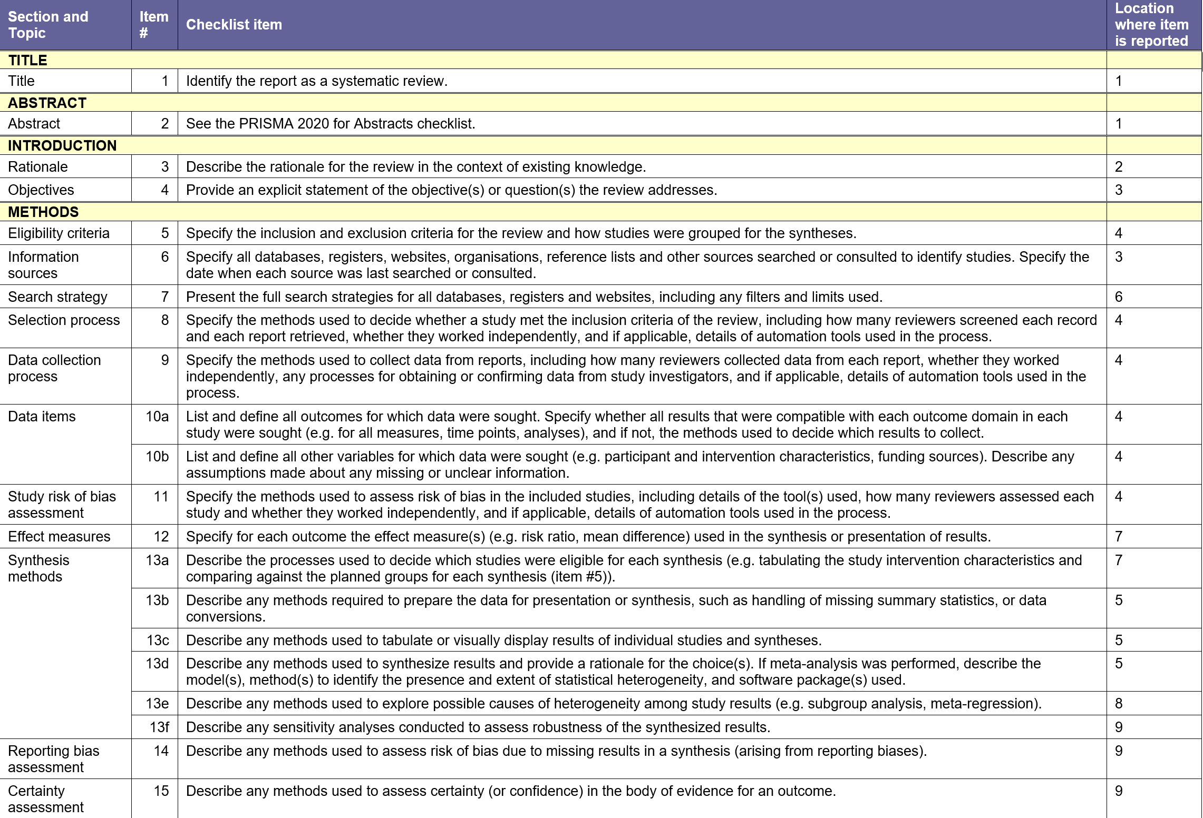
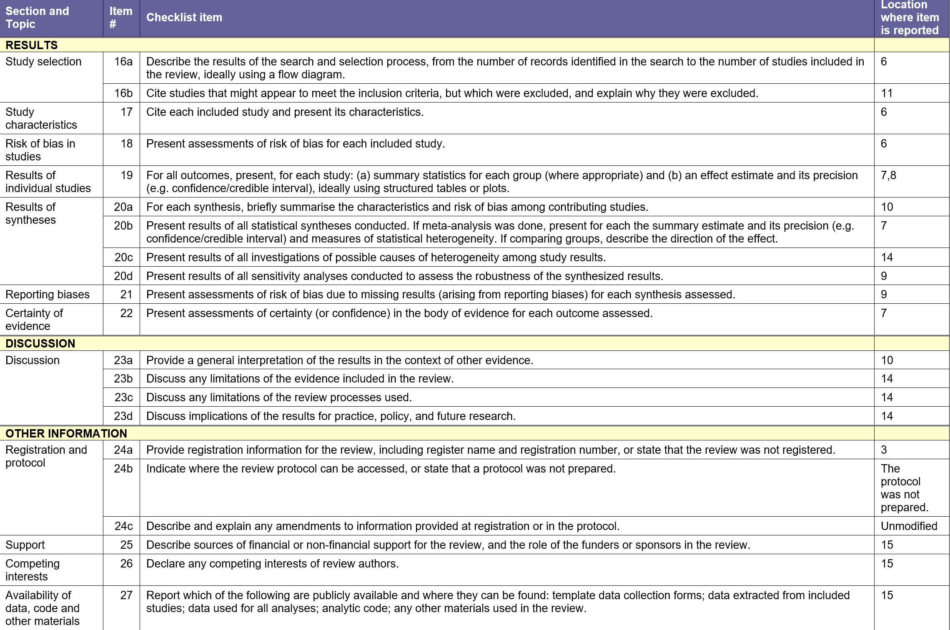

Appendix. 2 Retrieval strategy
Pubmed search strategy
Search Number | Search Details | Results
1 | "Urinary Bladder Neoplasms"[MeSH Terms] | 66,492
2 | "urinary bladder neoplasms"[Title/Abstract] OR "neoplasm urinary bladder"[Title/Abstract] OR "urinary bladder neoplasm"[Title/Abstract] OR "bladder tumors"[Title/Abstract] OR "bladder tumor"[Title/Abstract] OR "tumor bladder"[Title/Abstract] OR "tumors bladder"[Title/Abstract] OR "neoplasms bladder"[Title/Abstract] OR "bladder neoplasms"[Title/Abstract] OR "bladder neoplasm"[Title/Abstract] OR "neoplasm bladder"[Title/Abstract] OR "urinary bladder cancer"[Title/Abstract] OR "cancer urinary bladder"[Title/Abstract] OR "malignant tumor of urinary bladder"[Title/Abstract] OR "cancer of the bladder"[Title/Abstract] OR "bladder cancer"[Title/Abstract] OR "bladder cancers"[Title/Abstract] OR "cancer bladder"[Title/Abstract] OR "cancer of bladder"[Title/Abstract] | 57351
3 | "Urinary Bladder Neoplasms"[MeSH Terms] OR "Urinary Bladder Neoplasms"[Title/Abstract] OR "neoplasm urinary bladder"[Title/Abstract] OR "urinary bladder neoplasm"[Title/Abstract] OR "bladder tumors"[Title/Abstract] OR "bladder tumor"[Title/Abstract] OR "tumor bladder"[Title/Abstract] OR "tumors bladder"[Title/Abstract] OR "neoplasms bladder"[Title/Abstract] OR "bladder neoplasms"[Title/Abstract] OR "bladder neoplasm"[Title/Abstract] OR "neoplasm bladder"[Title/Abstract] OR "urinary bladder cancer"[Title/Abstract] OR "cancer urinary bladder"[Title/Abstract] OR "malignant tumor of urinary bladder"[Title/Abstract] OR "cancer of the bladder"[Title/Abstract] OR "bladder cancer"[Title/Abstract] OR "bladder cancers"[Title/Abstract] OR "cancer bladder"[Title/Abstract] OR "cancer of bladder"[Title/Abstract] | 82,858
4 | "Urinary Tract Infections"[MeSH Terms] | 52,780
5 | "urinary tract infections"[Title/Abstract] OR "infection urinary tract"[Title/Abstract] OR "infections urinary tract"[Title/Abstract] OR "tract infection urinary"[Title/Abstract] OR "tract infections urinary"[Title/Abstract] OR "urinary tract infection"[Title/Abstract] | 55,455
6 | "Urinary Tract Infections"[MeSH Terms] OR "Urinary Tract Infections"[Title/Abstract] OR "infection urinary tract"[Title/Abstract] OR "infections urinary tract"[Title/Abstract] OR "tract infection urinary"[Title/Abstract] OR "tract infections urinary"[Title/Abstract] OR "urinary tract infection"[Title/Abstract] | 79,894
7 | "Risk Factors"[MeSH Terms] | 1,027,119
8 | "risk factors"[Title/Abstract] OR "risk factor*"[Title/Abstract] OR "relevant factor*"[Title/Abstract] OR "root cause analysis"[Title/Abstract] OR "influence factor*"[Title/Abstract] | 881,161
9 | "Risk Factors"[MeSH Terms] OR "Risk Factors"[Title/Abstract] OR "risk factor*"[Title/Abstract] OR "relevant factor*"[Title/Abstract] OR "root cause analysis"[Title/Abstract] OR "influence factor*"[Title/Abstract] | 1,516,957
10 | ("Urinary Bladder Neoplasms"[MeSH Terms] OR "neoplasm urinary bladder"[Title/Abstract] OR "urinary bladder neoplasm"[Title/Abstract] OR "bladder tumors"[Title/Abstract] OR "bladder tumor"[Title/Abstract] OR "tumor bladder"[Title/Abstract] OR "tumors bladder"[Title/Abstract] OR "neoplasms bladder"[Title/Abstract] OR "bladder neoplasms"[Title/Abstract] OR "bladder neoplasm"[Title/Abstract] OR "neoplasm bladder"[Title/Abstract] OR "urinary bladder cancer"[Title/Abstract] OR "cancer urinary bladder"[Title/Abstract] OR "malignant tumor of urinary bladder"[Title/Abstract] OR "cancer of the bladder"[Title/Abstract] OR "bladder cancer"[Title/Abstract] OR "bladder cancers"[Title/Abstract] OR "cancer bladder"[Title/Abstract] OR "cancer of bladder"[Title/Abstract]) AND ("Urinary Tract Infections"[MeSH Terms] OR "infection urinary tract"[Title/Abstract] OR "infections urinary tract"[Title/Abstract] OR "tract infection urinary"[Title/Abstract] OR "tract infections urinary"[Title/Abstract] OR "urinary tract infection"[Title/Abstract]) AND ("Risk Factors"[MeSH Terms] OR "risk factor*"[Title/Abstract] OR "relevant factor*"[Title/Abstract] OR "root cause analysis"[Title/Abstract] OR "influence factor*"[Title/Abstract]) | 137

Appendix. 3 Quality evaluation detailed results table

Table 1 Results of methodological quality evaluation in case-control studies

Case-control study | Study population selection | Component comparability | Exposure factor measurement | Total score
Liang2019 | 4 | 2 | 2 | 8
Chen2024 | 4 | 1 | 2 | 7
Li2020 | 4 | 1 | 2 | 7
Wang2023 | 4 | 1 | 2 | 7
Li2019 | 3 | 1 | 2 | 7
Wangzhe2023 | 3 | 1 | 2 | 6
Zhu2022 | 4 | 1 | 2 | 7
Yao2023 | 4 | 1 | 2 | 7
Han2024 | 4 | 2 | 2 | 8
Hou2025 | 4 | 1 | 2 | 7
Chen Juan2024 | 3 | 1 | 2 | 6
Kim2016 | 4 | 1 | 2 | 7
Sharma2023 | 4 | 1 | 2 | 7
Zhu2024 | 4 | 1 | 2 | 7
Parker2016 | 2 | 1 | 2 | 7
Clifford2018 | 4 | 2 | 2 | 8

Table 2 Results of methodological quality evaluation of cross-sectional studies

Cross-sectional study | A | B | C | D | E | F | G | H | Total score
Liu2017 | 1 | 0 | 1 | 1 | 1 | 1 | 1 | 1 | 8
Zhang2016 | 0 | 0 | 1 | 1 | 1 | 1 | 1 | 1 | 6
Lu2022 | 1 | 0 | 1 | 1 | 1 | 1 | 1 | 1 | 7
Clifford2018 | 1 | 1 | 1 | 1 | 1 | 1 | 1 | 1 | 8
A= Whether the criteria for inclusion of samples are specified; B= whether the research object and environment are described in detail; C= exposed measurement side Whether the law is effective and reliable; D= Whether objective, standard criteria are used to measure the condition; E= whether confounding factors were found; F= The strategies for dealing with confounding factors are explained. G= Whether the measurement results are valid and reliable; H= Whether appropriate statistical analysis was used.

Appendix. 4 Forest plot of all risk factors
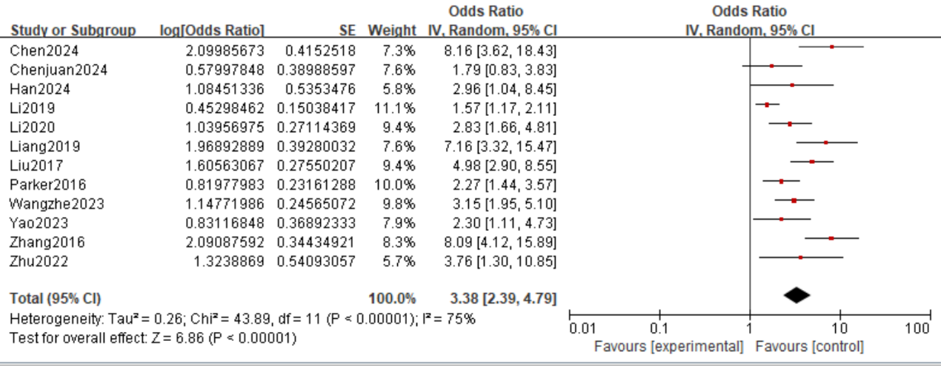
Fig.1 Forest Plot of Diabetes 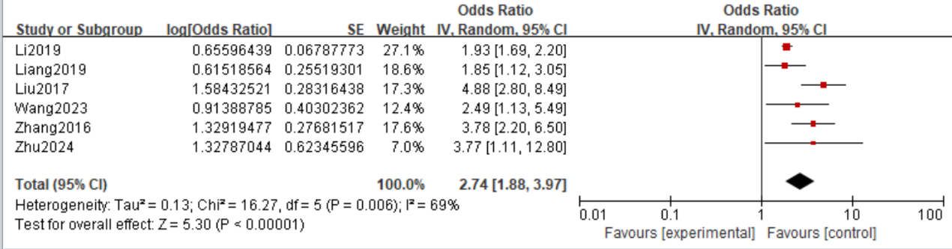
Fig.2 Forest Plot of Age 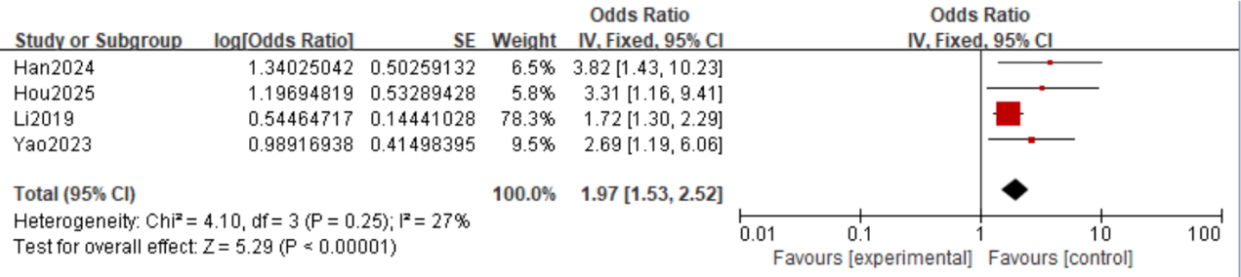
Fig.3 Forest Plot of Preoperative Catheter Indwelling
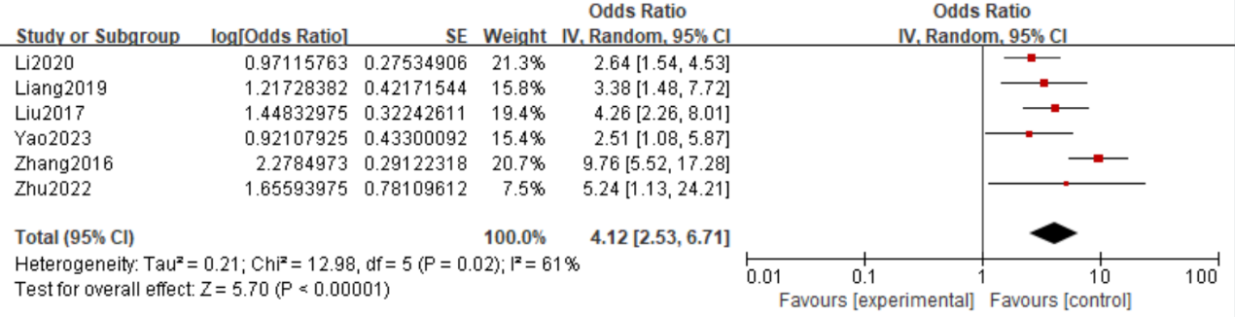
Fig.4 Forest Plot of Antibiotic Use Before Surgery
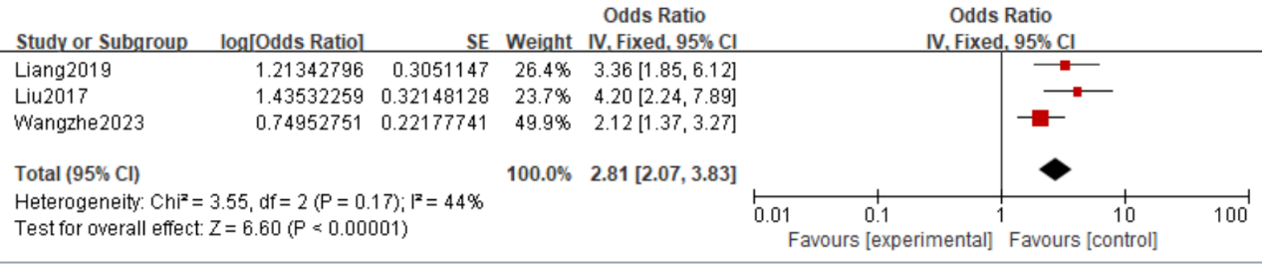
Fig.5 Forest Plot of Operation Time ≥90 Minutes

