Figure 2A Variables affecting SFR in univariate logistic regression
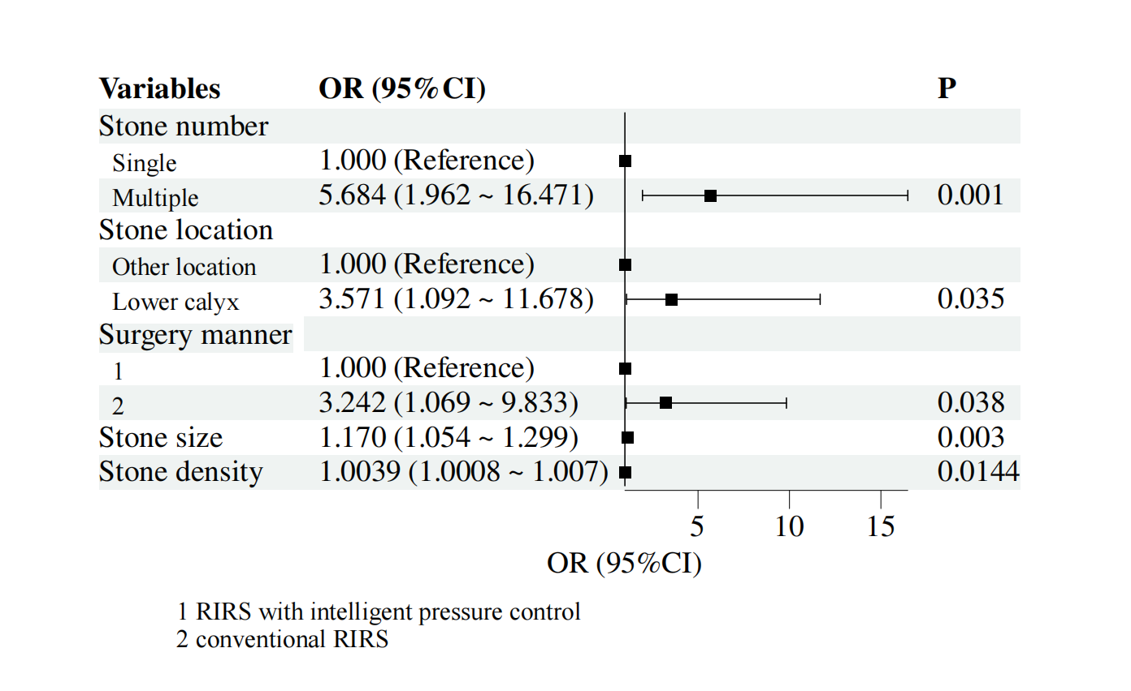

Figure 2B Variables affecting SFR in multivariate logistic regression
