Oxidative balance scores and overactive bladder: Mediating effects of oxidative stress and inflammatory factors
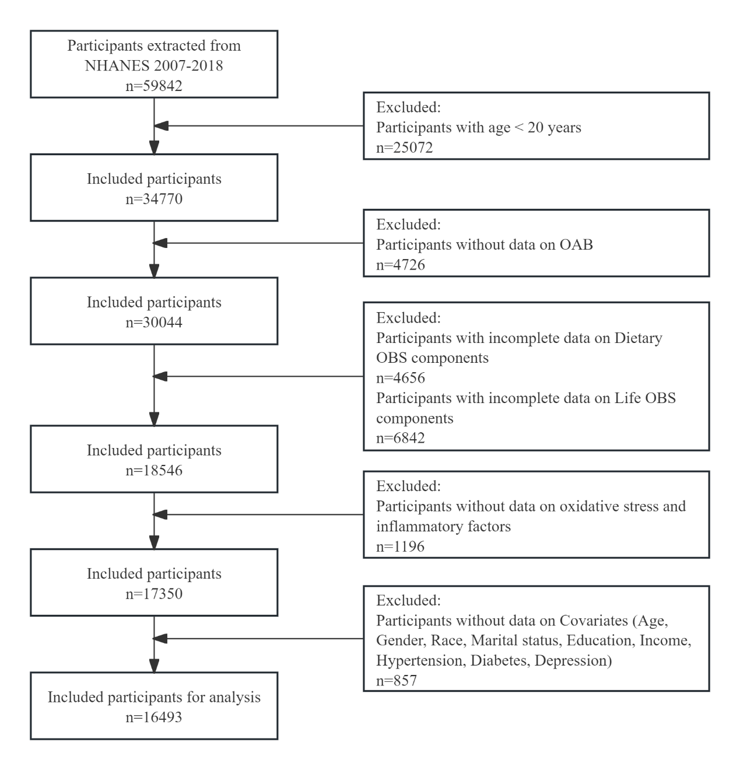
Supplementary figure 1. Flowchart of the study population.
Supplementary table 1. Oxidative Balance Score composition and score arrangement.
OBS component | Property | Male |  |  | Female
OBS component | Property | 0 | 1 | 2 | 0 | 1 | 2
Dietary OBS components
Dietary fiber (g/d) | A | <13.55 | 13.55-21.55 | ≥21.55 | <11.65 | 11.65-17.85 | ≥17.85
Carotene (RE/d) | A | <624.00 | 624.00-2019.50 | ≥2019.50 | <663.00 | 663.00-2245.50 | ≥2245.50
Riboflavin (mg/d) | A | <1.76 | 1.76-2.58 | ≥2.58 | <1.39 | 1.39-2.00 | ≥2.00
Niacin (mg/d) | A | <22.88 | 22.88-32.73 | ≥32.73 | <16.48 | 16.48-23.46 | ≥23.46
Total folate (mcg/d) | A | <330.50 | 330.50-500.50 | ≥500.50 | <261.50 | 261.50-389.00 | ≥389.00
Vitamin B6 (mg/d) | A | <1.77 | 1.77-2.62 | ≥2.62 | <1.31 | 1.31-1.94 | ≥1.94
Vitamin B12 (mcg/d) | A | <3.62 | 3.62-6.22 | ≥6.22 | <2.59 | 2.59-4.46 | ≥4.46
Vitamin C (mg/d) | A | <42.75 | 42.75-101.40 | ≥101.40 | <41.65 | 41.65-91.95 | ≥91.95
Vitamin E (ATE) (mg/d) | A | <6.23 | 6.23-9.84 | ≥9.84 | <5.26 | 5.26-8.25 | ≥8.25
Calcium (mg/d) | A | <759.00 | 759.00-1162.50 | ≥1162.50 | <632.00 | 632.00-940.50 | ≥940.50
Magnesium (mg/d) | A | <263.50 | 263.50-371.00 | ≥371.00 | <213.50 | 213.50-296.50 | ≥296.50
Zinc (mg/d) | A | <9.82 | 9.82-14.33 | ≥14.33 | <7.29 | 7.29-10.40 | ≥10.40
Copper (mg/d) | A | <1.05 | 1.05-1.50 | ≥1.50 | <0.87 | 0.87-1.24 | ≥1.24
Selenium (mcg/d) | A | <103.40 | 103.40-145.20 | ≥145.20 | <75.50 | 75.50-107.20 | ≥107.20
Total fat (g/d) | P | ≥101.96 | 69.26-101.96 | <69.26 | ≥76.34 | 52.28-76.34 | <52.28
Iron (mg/d) | P | ≥18.32 | 12.59-18.32 | <12.59 | ≥14.09 | 9.75-14.09 | <9.75
Lifestyle OBS components
Physical (MET-minute/week) | A | Low | Moderate | High | Low | Moderate | High
Smoke status | P | Current smoker | Former smoker | Never smoker | Current smoker | Former smoker | Never smoker
Alcohol (g/d) | P | ≥30 | 0-30 | 0 | ≥15 | 0-15 | 0
Body mass index (kg/m²) | P | Obesity | Overweight | Normal | Obesity | Overweight | Normal
A: antioxidant, P: pro-oxidant.
RE: retinal equivalent; ATE: alpha-tocopherol equivalent; MET: metabolic equivalent.
Supplementary table 2. Criteria for setting OAB based on NHANES and OABSS scores.
According to NHANES score | According to OABSS score
Urgency urinary incontinence frequency | Urgency urinary incontinence score
Never | 0
Less than once a month | 1
A few times a month | 1
A few times a week | 2
Every day and/or night | 3
Nocturia frequency Nocturia score | Nocturia frequency Nocturia score
0 | 0
1 | 1
2 | 2
3 | 3
4 | 3
5 or more | 4
NHANES: National Health and Nutrition Examination Survey; OABSS: Overactive Bladder Symptom Score.
Supplementary table 3. OABSS scores distribution of study participants from NHANES 2007-2018.
OABSS score
non-OAB (13543) |  |  | OAB (2950)
0 | 1 | 2 | 3 | 4 | 5 | 6 | 7
4695 | 5777 | 3071 | 1826 | 742 | 252 | 101 | 29
NHANES: National Health and Nutrition Examination Survey; OABSS: Overactive Bladder Symptom Score.
Supplementary table 4. Age and Sex Characteristics of Study Participants by NHANES Survey Cycle.
NHANES cycle | Characteristics |  | OAB |  | P value
2007-2008 |  |  | No (n=2095) | Yes (n=432)
2007-2008 | Age (years) |  | 43.54±15.69 | 57.39±16.43 | <0.001
2007-2008 | Age |  |  |  | <0.001
2007-2008 |  | <50 | 1170 (65.5%) | 119 (32.4%)
2007-2008 |  | ≥50 | 925 (34.5%) | 313 (67.6%)
2007-2008 | Gender |  |  |  | 0.012
2007-2008 |  | Male | 1112 (50.1%) | 192 (38.7%)
2007-2008 |  | Female | 983 (49.9%) | 240 (61.3%)
2009-2010 |  |  | No (n=2560) | Yes (n=491)
2009-2010 | Age (years) |  | 44.26±15.29 | 53.99±15.90 | <0.001
2009-2010 | Age |  |  |  | <0.001
2009-2010 |  | <50 | 1543 (62.4%) | 160 (38.2%)
2009-2010 |  | ≥50 | 1017 (37.6%) | 331 (61.8%)
2009-2010 | Gender |  |  |  | 0.056
2009-2010 |  | Male | 1363 (53.1%) | 208 (44.0%)
2009-2010 |  | Female | 1197 (46.9%) | 283 (56.0%)
2011-2012 |  |  | No (n=2288) | Yes (n=425)
2011-2012 | Age (years) |  | 44.20±15.92 | 54.82±16.61 | <0.001
2011-2012 | Age |  |  |  | <0.001
2011-2012 |  | <50 | 1410 (61.4%) | 127 (33.0%)
2011-2012 |  | ≥50 | 878 (38.6%) | 298 (67.0%)
2011-2012 | Gender |  |  |  | <0.001
2011-2012 |  | Male | 1250 (53.9%) | 182 (37.0%)
2011-2012 |  | Female | 1038 (46.1%) | 243 (63.0%)
2013-2014 |  |  | No (n=2476) | Yes (n=480)
2013-2014 | Age (years) |  | 44.48±16.12 | 56.03±16.66 | <0.001
2013-2014 | Age |  |  |  | <0.001
2013-2014 |  | <50 | 1501 (60.6%) | 142 (30.4%)
2013-2014 |  | ≥50 | 975 (39.4%) | 338 (69.6%)
2013-2014 | Gender |  |  |  | <0.001
2013-2014 |  | Male | 1285 (53.2%) | 204 (39.1%)
2013-2014 |  | Female | 1191 (46.8%) | 276 (60.9%)
2015-2016 |  |  | No (n=2072) | Yes (n=555)
2015-2016 | Age (years) |  | 45.53±16.36 | 54.87±16.46 | <0.001
2015-2016 | Age |  |  |  | <0.001
2015-2016 |  | <50 | 1234 (59.6%) | 158 (34.3%)
2015-2016 |  | ≥50 | 838 (40.4%) | 397 (65.7%)
2015-2016 | Gender |  |  |  | 0.015
2015-2016 |  | Male | 1104 (53.2%) | 245 (42.3%)
2015-2016 |  | Female | 968 (46.8%) | 310 (57.7%)
2017-2018 |  |  | No (n=2052) | Yes (n=567)
2017-2018 | Age (years) |  | 45.47±16.54 | 55.70±15.99 | <0.001
2017-2018 | Age |  |  |  | <0.001
2017-2018 |  | <50 | 1132 (57.7%) | 141 (32.9%)
2017-2018 |  | ≥50 | 920 (42.3%) | 426 (67.1%)
2017-2018 | Gender |  |  |  | 0.001
2017-2018 |  | Male | 1093 (53.4%) | 235 (36.8%)
2017-2018 |  | Female | 959 (46.6%) | 332 (63.2%)
NHANES: National Health and Nutrition Examination Survey; OABSS: Overactive Bladder.

