Supplementary Material

Table S1. Predictor variables and measurements used for model development

Predictor | Definition | Unit / Coding | Measurement timing
Age | Age of patient at time of surgery | Years (continuous) | Preoperative
Body mass index (BMI) | Body mass index calculated as weight/height² | kg/m² (continuous) | Preoperative
BMI category: underweight | Indicator for BMI < 18.5 | Binary (0/1) | Preoperative
BMI category: overweight | Indicator for BMI 25–29.9 | Binary (0/1) | Preoperative
BMI category: obese | Indicator for BMI ≥ 30 | Binary (0/1) | Preoperative
Diabetes status | Presence of diabetes mellitus | Binary (0/1) | Preoperative
Surgical technique | Type of circumcision performed | Binary (0 = traditional, 1 = laser-based) | Intraoperative
Intraoperative blood loss | Estimated blood loss during procedure | mL (continuous) | Intraoperative
Operative time | Duration of surgical procedure | Minutes (continuous) | Intraoperative
Intraoperative heart rate | Mean heart rate recorded during surgery | Beats per minute | Intraoperative
Pulse oximetry | Mean oxygen saturation during surgery | Percentage (%) | Intraoperative
Systolic blood pressure | Mean systolic BP during surgery | mmHg | Intraoperative
Diastolic blood pressure | Mean diastolic BP during surgery | mmHg | Intraoperative

Table S2. Hyperparameter tuning configurations for evaluated machine learning models
Model | Algorithm Type | Resampling Method | Hyperparameters Tuned | Tuning Range/Options | Final Selected Hyperparameter Configuration
Logistic Regression | Linear Classifier | None, SMOTE, ROS | Penalty (penalty) | L2 | Resampling method = SMOTE  penalty = L2  C = 1.0
Logistic Regression | Linear Classifier | None, SMOTE, ROS | Inverse Regularization Strength (C) | 0.0001, 1.0 | Resampling method = SMOTE  penalty = L2  C = 1.0
Random Forest | Ensemble Classifier | None, SMOTE, ROS | Number of Estimators (n_estimators) | 10, 50 | Resampling method = SMOTE  n_estimators = 50  max_depth = None  min_samples_split = 5
Random Forest | Ensemble Classifier | None, SMOTE, ROS | Maximum Depth (max_depth) | None, 10
Random Forest | Ensemble Classifier | None, SMOTE, ROS | Minimum Samples Split (min_samples_split) | 2, 5
Support Vector Machines | Kernel-based Classifier | None, SMOTE, ROS | Kernel Type (kernel) | Linear, rbf, poly, sigmoid | Resampling method = None  Kernel = rbf  C = 100  gamma = auto
Support Vector Machines | Kernel-based Classifier | None, SMOTE, ROS | Cost Parameter (C) | 0.0001 to 100 (log scale)
Support Vector Machines | Kernel-based Classifier | None, SMOTE, ROS | Gamma (gamma) | 0.001, 0.01, 0.05, 0.1, 0.2, 0.5, scale, auto

Note: SMOTE: Synthetic Minority Oversampling Technique; ROS = Random Oversampling.

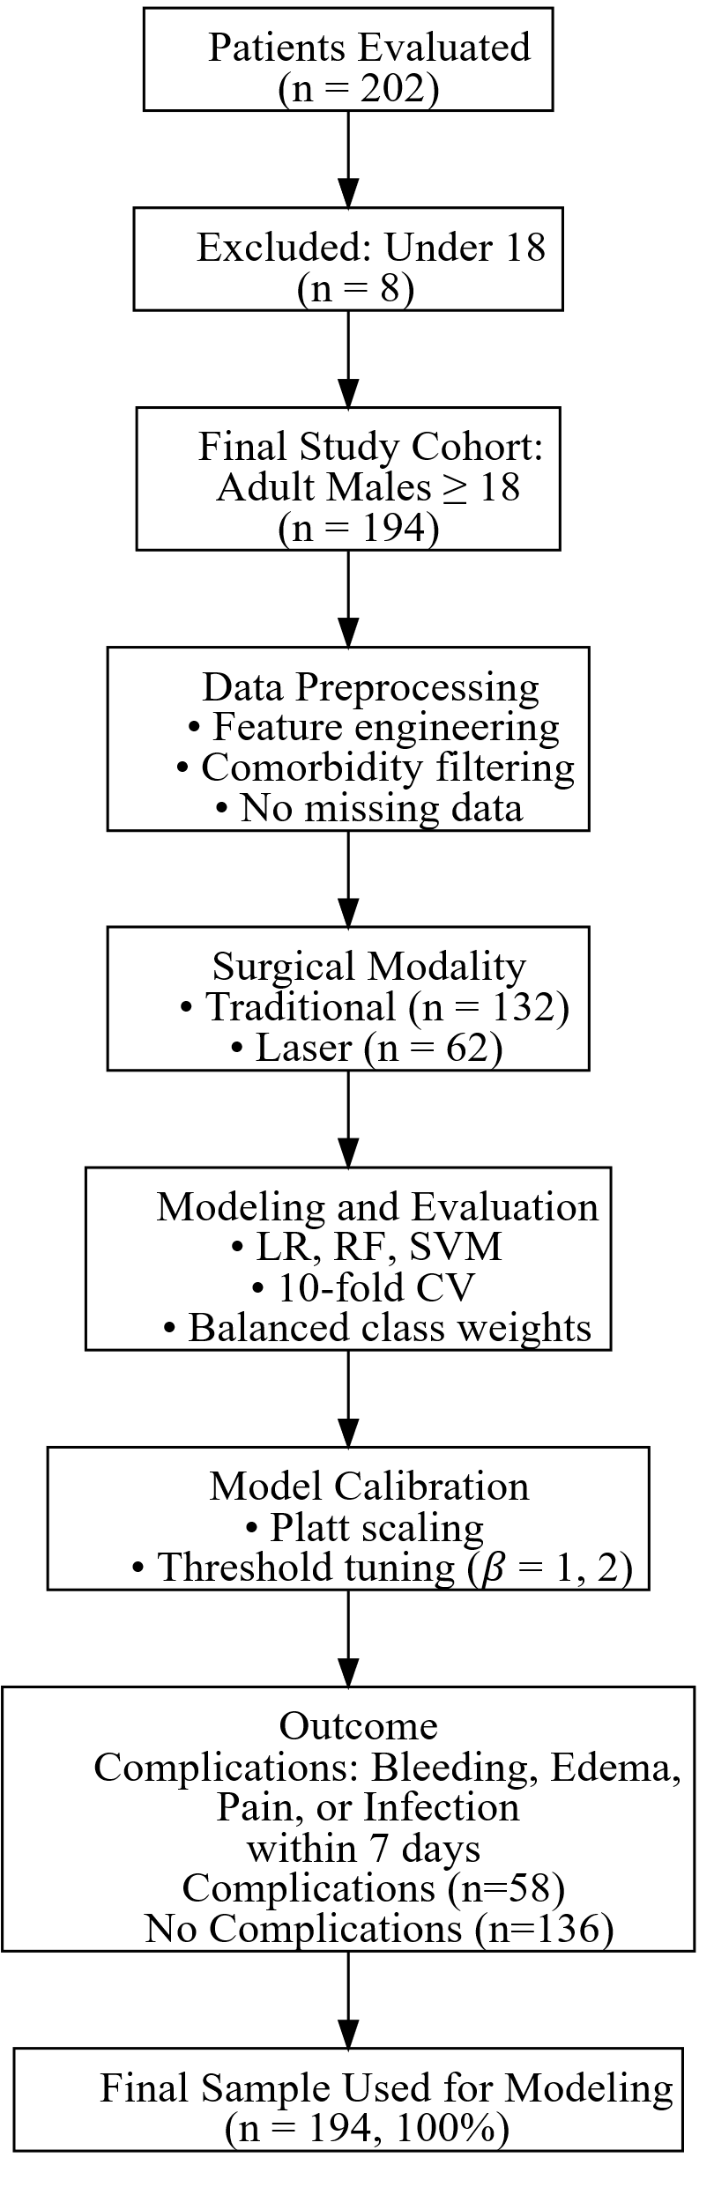

Figure S1. Cohort inclusion, preprocessing, and modeling flow: STROBE Diagram summarizes patient inclusion, exclusion, data preprocessing, and modeling workflow. Surgical technique was included as a predictive feature and not analyzed as a separate arm. All 194 adult patients were processed through a unified pipeline and included in final model training and evaluation.

