Additional file 1: Cloning and schematic representation of hμPlg cloning.
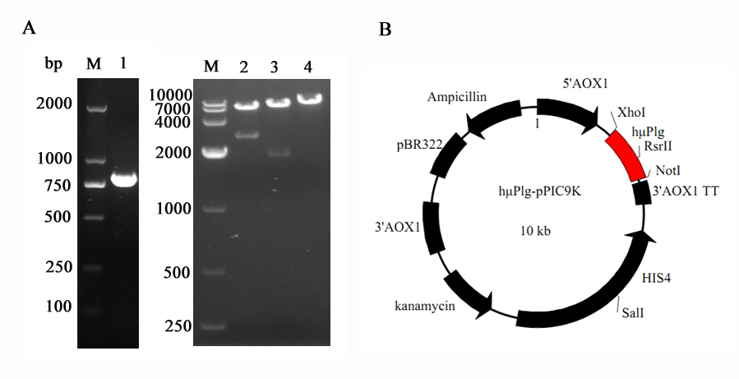
Additional file 1: Cloning and schematic representation of hμPlg cloning. Figure (A) represents cloning of hμPlg from plasmid pUC57 to pPIC9K vector. M – DNA Marker, 1- PCR with gene specific primers using pUC57 as template, 2- restriction digestion of pPIC9K-hμPlg with XhoI and SalI, 3- restriction digestion of pPIC9K-hμPlg with NotI and SalI, 4- restriction digestion of pPIC9K-hμPlg with RsrII. Figure (B) represents the schematic diagrams of pPIC9K-hμPlg.

