Additional file 1
Targeted optimization of central carbon metabolism for engineering succinate production in Escherichia coli

Ying Zhao^{a,b,c}, Chang-Song Wang^{a,b,c}, Fei-Fei Li^{a,b,c}, Zhen-Ning Liu^{a, b, c}, Guang-Rong Zhao^{a.b.c,}*
ªDepartment of Pharmaceutical Engineering, School of Chemical Engineering and Technology, Tianjin University, Tianjin 300072, China;
^{b}Key Laboratory of Systems Bioengineering, Ministry of Education Tianjin 300072, China;
^{c}SynBio Research Platform, Collaborative Innovation Center of Chemical Science and Engineering , Tianjin 300072, China.

The document contains:
Supplementary Figure S1………………………………………………………………2
Supplementary Figure S2………………………………………………………………4
Supplementary Table S1 ………………………………………………………………5
Supplementary Table S2 ………………………………………………………………6
Supplementary Table S3 ………………………………………………………………7
Supplementary Table S4 ………………………………………………………………8
Abbreviations ………………………………………………………………14

Supplementary figures
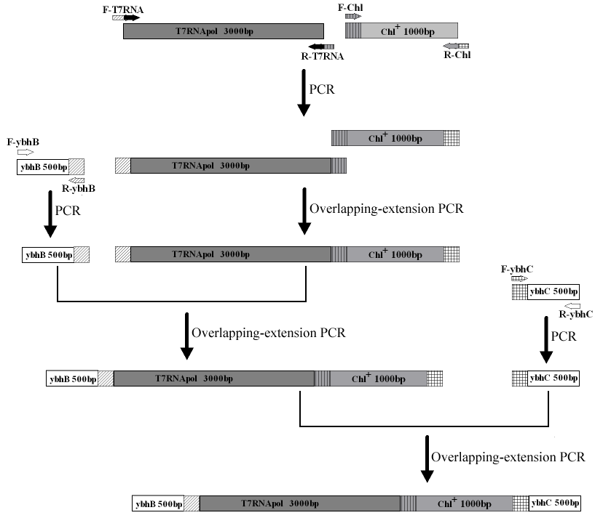
Figure S1. Assembly of DNA fragment for inserting the T7 RNA polymerase into BW25113 genome.
T7 RNA polymerase gene with lacUV5 promoter was amplified from E. coli BL21(DE3) with primers F-T7RNA and R-T7RNA. Chloramphenicol resistance cassette was amplified from plasmid pKD3 with primers F-Chl and R-Chl. 500 bp upstream of the ybhB gene and 500 bp downstream of the ybhC gene as homologous regions were amplified from genome of E. coli BW25113 using primers F-ybhB, R-ybhB and F-ybhC, R-ybhC, respectively. All the annealing temperature for PCR procedures of these four DNA fragment were 56℃. After obtaining the four individual DNA fragment, T7 RNA polymerase fragment and chloramphenicol resistance cassette were first assembled into one fragment by overlapping extension PCR using primers F-T7RNA and R-Chl, resulting in DNA fragment T7RNA-Chl. Using primers F-ybhB and R-Chl, DNA fragment 500 bp upstream of the ybhB gene and T7RNA-Chl were extended into one DNA fragment ybhB-T7RNA-Chl, followed by overlaping extension RCR procedure with DNA fragment ybhC using primers F-ybhB and R-ybhC, resulting in the final homologous recombination DNA fragment ybhB-T7RNA-Chl-ybhC.

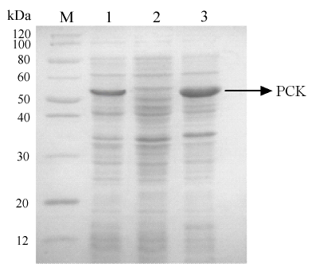
Figure S2. SDS-PAGE of protein expression of strain BKS1, BKS2 and BKS3.
1.total cell protein of strain BKS1, 2.totel cell protein of strain BKS2, 3.total cell protein of strain BKS3, M. marker standards. All of the three strains were induced with 1mM IPTG.

Supplementary tables
Table S1 The simplified central metabolic reaction of engineered E.coli anaerobically grown in glucose
metabolic reactions | gene names
1. Glucose+PEP=glucose 6-P+pyruvate (for wildtype E. coli)  1. Glucose +ATP=glucose 6-P+ADP (for strains with deltion of ptsG) | PTS sysytem  glk
2. Glucose 6-P+ATP=2 glyceraldehyde 3-P+ADP | pgi, pfkA, fda, tpia
3. Glyceraldehyde 3-P+NAD⁺+Pi+ADP=PEP+NADH+H⁺+ATP+H₂O | gapA, pgk, pgm, eno
4. PEP+ADP=pyruvate+ATP | pyk
5. PEP+CO₂=OAA+P | pck
6. Pyruvate+NADH=lactate+NAD⁺ | ldhA
7. Pyruvate+ubiquinone+H₂O=acetate+CO₂+ubiquinol | poxB
8.Pyruvate+NAD⁺=NADH+CO₂+acetyl-CoA | pdh
9. Malate+NAD⁺=PYR+CO₂+NADH | maeAB
10. Acetyl-CoA+Pi+ADP=acetate+HSCoA+ATP | pta，ackA
11. 2 Acetyl-CoA+OAA+H₂O=succinate+malate+CoA+HSCoA | gltA, acnAB, aceBAK
12. Oxaloactetate+NADH=malate+NAD⁺ | mdh
13. Malate=fumarate+H₂O | fumABC
14. Succinate+FAD=fumrate+FADH₂ | sdh
15. Fumarate+NADH+Pi+ADP=succinate+NAD⁺+ATP | frd
16. Succinate=excreted succinate

Table S2 Stoichiometric relationships for fluxes of metabolic reactions in anaerobic growth of E.coli
Metabolite | Net conversion
Glucose consumption | V1
Excreted succinate | V16
Excreted lactate | V6
Excreted acetate | V7+V10
G6P | V1-V2=0
G3P | V3-2V2=0
PEP | V3-V4-V5=0
PYR | V4+V9-V6-V7-V8 =0
Acetyl-CoA | V8-2V11-V10=0
OAA | V5-V11-V12=0
Malate | V11+V12-V13-V9=0
Fumarate | V13+V14-V15=0
Succinate | V14+V16-V11-V15=0

Table S3 Metabolic fluxes (mM gDCW⁻¹ h⁻¹) of engineered strains based on the anaerobic fermentation results at 40h
Flux | To | BW25113  (DE3) | BKS8 | BKS9 | BKS10 | BKS11 | BKS15
V1 | Glucose uptake | 2.11±0.15 | 2.11±0.18 | 2.18±0.16 | 2.27±0.11 | 2.71±0.24 | 3.46±0.31
V2 | G3P | 2.11±0.15 | 2.11±0.18 | 2.18±0.16 | 2.27±0.11 | 2.71±0.24 | 3.46±0.31
V3 | PEP | 4.22±0.30 | 4.22±0.36 | 4.36±0.32 | 4.54±0.22 | 5.42±0.48 | 6.92±0.62
V4 | PYR | 4.09±0.29 | 3.86±0.33 | 3.79±0.34 | 3.92±0.24 | 2.92±0.22 | 3.3±0.25
V5 | OAA | 0.13±0.01 | 0.36±0.03 | 0.54±0.02 | 0.62±0.02 | 2.49±0.26 | 3.62±0.37
V6 | Lactate | 0.99±0.10 | 0.82±0.05 | 0.87±0.07 | 0.83±0.06 | 0.92±0.05 | 1.03±0.04
V7 | Acetate | 1.63±0.06 | 1.49±0.10 | 1.26±0.06 | 1.54±0.14 | 1.00±0.08 | 0
V8 | Acetyl-CoA | 1.63±0.06 | 1.62±0.10 | 1.65±0.15 | 1.54±0.14 | 1.00±0.08 | 2.27±0.21
V9 | PYR | 0.02±0.002 | 0 | 0 | 0 | 0 | 0
V10 | Acetate | 1.63±0.06 | 1.62±0.10 | 1.65±0.15 | 1.54±0.14 | 1.00±0.08 | 2.07±0.19
V11 | Glyoxylase succinate | 0 | 0 | 0 | 0 | 0 | 0.1±0.007
V12 | Malate | 0.13±0.01 | 0.35±0.03 | 0.55±0.02 | 0.62±0.02 | 2.49±0.26 | 3.52±0.36
V13 | Fumatate | 0.11±0.007 | 0.35±0.03 | 0.55±0.02 | 0.62±0.02 | 2.49±0.26 | 3.62±0.37
V14 | Fumatate | 0.04±0.002 | 0.06±0.004 | 0 | 0 | 0 | 0
V15 | Intracellular succinate | 0.15±0.005 | 0.41±0.03 | 0.55±0.02 | 0.62±0.02 | 3.01±0.31 | 4.64±0.47
V16 | Excreted succinate | 0.11±0.007 | 0.35±0.03 | 0.55±0.02 | 0.62±0.02 | 3.01±0.31 | 4.65±0.47

Table S4 Primers used in this study
Name | Sequence 5’-3’ | Use
F-T7RNA | TTTACCTTCCCGTTTCGCTCGTATCAAGGTATTTTATGCG | cloning T7 RNA polymerase
R-T7RNA | GAAGCAGCTCCAGCCTACTCACTCATTAGGCACCCC | cloning T7 RNA polymerase
F-Chl | GTAGGCTGGAGCTGCTTC | cloning chloramphenicol resistance cassette
R-Chl | CTGCTTTTTTATACTAACTTGTAGGCTGGAGCTGCTTC | cloning chloramphenicol resistance cassette
F-ybhB | AGAAAGGAGGGTTCATGAAA | 500 bp upstream of the ybhB gene
R-ybhB | GAGCGAAACGGGAAGGTAAA | 500 bp upstream of the ybhB gene
F-ybhC | AAGTTAGTATAAAAAAGCAG | 500 bp downstream of the ybhC gene
R-ybhC | ATCAAGGGAAAGCCCAATCT | 500 bp downstream of the ybhC gene
F-ptsG-Q | CCATACTCAGGAGCACTCTCAATTATGTTTAAGAATGCATTTGCTAACCTGTGTAGGCTGGAGCTGCTTC | cloning DNA fragment for insertional inactivation of ptsG gene
R-ptsG-Q | GCCTTAGTCTCCCCAACGTCTTACGGATTAGTGGTTACGGATGTACTCATCATGGGAATTAGCCATGGTCC
F-ptsG | ATCGGTTACTGGTGGAAACTG | confirming the insertional inactivation of ptsG gene and removal of chloramphenicol resistance
R-ptsG | GTGGATGGGACAGTCAGTAAAG
F-pykA-Q | TCAGTCAACGGAGTATTACATGTCCAGAAGGCTTCGCAGAACAAAAATCGGTGTAGGCTGGAGCTGCTTC | cloning DNA fragment for insertional inactivation of pykA gene
R-pykA-Q | TTACTCTACCGTTAAAATACGCGTGGTATTAGTAGAACCCACGGTACTCATGGGAATTAGCCATGGTCC
F-pykA | TGGTGGTGCTGATTTCTCAC | confirming the insertional inactivation of pykA gene and removal of chloramphenicol resistance
R-pykA | ACCGCTGTTTCCGATTTATG
F-ppc-Q | GATAAGATGGGGTGTCTGGGGTAATATGAACGAACAATATTCCGCATTGCGTGTAGGCTGGAGCTGCTTC | cloning DNA fragment for insertional inactivation of ppc gene
R-ppc-Q | CACGAGGGTTTGCAGAAGAGGAAGATTAGCCGGTATTACGCATACCTGCATGGGAATTAGCCATGGTCC
F-ppc | CGACCGACAGTGACTCAAA | confirming the insertional inactivation of ppc gene and removal of chloramphenicol resistance
R-ppc | ATAGCACCACGCCGATTA
F-maeA-Q | GATATTCAAAAAAGAGTGAGTGACATGGAACCAAAAACAAAAAAACAGCGGTGTAGGCTGGAGCTGCTTC | cloning DNA fragment for insertional inactivation of maeA gene
R- maeA-Q | GCCTTCACTACCGGGCGCAGGC TTAGATGGAGGTACGGCGGTAGTCGCGGCATGGGAATTAGCCATGGTC
F- maeA | CAGACACGGAGAATCACTAT | confirming the insertional inactivation of maeA gene and removal of chloramphenicol resistance
R- maeA | AGACCATCTGGCACTTTTAC
F-maeB-Q | GTTACGTGAAAGGAACAACCAAATGGATGACCAGTTAAAACAAAGTGCACGTGTAGGCTGGAGCTGCTTC | cloning DNA fragment for insertional inactivation of maeB gene
R- maeB-Q | GGTAAGCGTGAGAGTTAAAAAAAATTACAGCGGTTGGGTTTGCGCTTCTACATGGGAATTAGCCATGGTCC
F- maeB | CTCGTTCATAGGAAATACTC | confirming the insertional inactivation of maeB gene and removal of chloramphenicol resistance
R- maeB | GGTTTGTGATAACGCTTCTT
F-sdh-Q | TGTGTGATGAAATTGCCAGTCAGAGAATTTGATGCAGTTGTGATTGGTGCGTGTAGGCTGGAGCTGCTTC | cloning DNA fragment for insertional inactivation of sdh gene
R-sdh-Q | GCTTGCGCGTCTTATCAGGCCTACGGTTTACGCATTACGTTGCAACAACACATGGGAATTAGCCATGGTC
F-sdh | GCAGGAGTCCTCGTATGGTA | confirming the insertional inactivation of sdh gene and removal of chloramphenicol resistance
R-sdh | CGCCAGAGAGGTAAGAAGAG
F-iclR-Q | GATACAGAAAAAAGAGACTGTC  ATGGTCGCACCCATTCCCGCGAAACGCGGTAGGCTGGAGCTGCTTC | cloning DNA fragment for insertional inactivation of iclR gene
R-iclR-Q | TATTGCCTCTGCCCGCCAGAAAAAGTCAGCGCATTCCACCGTACGCCAGCCATGGGAATTAGCCATGGTC
F-iclR | CCGACAGGGATTCCATCTGG | confirming the insertional inactivation of iclR gene and removal of chloramphenicol resistance
R-iclR | TATGACGACCATTTTGTCTA
F-pck | CGCGGATCCGATGCGCGTTAACAATG | constructing pCDF-pck-ecaA
R-pck | CGCGGATCCATCATTACAGTTTCGGA | constructing pCDF-pck-ecaA
F-ecaA | CCAATTCCATATGAGTAGTAC | constructing pCDF-pck-ecaA
R-ecaA | CGGGGTACCTTAAATGGCTTC | constructing pCDF-pck-ecaA
F-pRSF | CTAGACTAGTCTGGTAAAGAAACC | constructing pRSFM1
R-pRSF | CTAGACTAGAACAAAATTATTTCTACAGGGG | constructing pRSFM1
F-RSF-anti-pykF | CTAGACTAGTGCAAACAATTTTGGTCTTTTTCATTTTCTGTTGGGCCATTGCATTGC | constructing pRSF-anti-pykF
R-RSF-anti-pykF | CTAGACTAGTAAAAAAAGCCCGGACGACTGTTC | constructing pRSF-anti-pykF
ACYCDuetUp1 | GGATCTCGACGCTCTCCCT | confirming the correct ligationof pRSF-anti-pykF
F-Bldg-anti-pykF | CCCAAGCTTGCAAACAATTTTGGTCTTTTTCATTTTCTGTTGGGCCATTGCATTGC | constructing pBldg-anti-pykF
R-Bldg-anti-pykF | CATGCCATGGAAAAAAAGCCCGGACGACTGTTC | constructing pBldg-anti-pykF

Abbreviations
Genes coding the corresponding enzymes: ybhB, putative kinase inhibitor protein; ybhC, acyl-CoA thioesterase; ptsG, glucose phosphotransferase; pykA, pyruvate kinase II; ppc, PEP carboxylase; maeAB, malic enzyme; sdh, succinate dehydrogenase; iclR, transcriptional repressor IclR; pck, PEP carboxykinase; ecaA, carbonic anhydrase; pykF, pyruvate kinase I; glk, glucokinase; pgi, glucosephosphate isomerase; pfkA, 6-phosphofructokinase I; fda, fructose-bisphosphate aldolase; tpia, triosephosphate isomerase; gapA, glyceraldehyde-3-phosphate dehydrogenase A; pgk, phosphoglycerate kinase; pgm, phosphoglucomutase; eno, enolase; ldhA, lactate dehydrogenase; poxB, pyruvate oxidase; pdh, pyruvate dehydrogenase; pta, phosphotransacetylase; ackA, acetate kinase; gltA, glutamate; acnAB, aconitate hydratase; aceA, isocitrate lyase; aceB, malate synthase; aceK, isocitrate dehydrogenase kinase/phosphatase; mdh, malate dehydrogenase; fumABC, fumaraseABC; frd, fumarate reductase.

