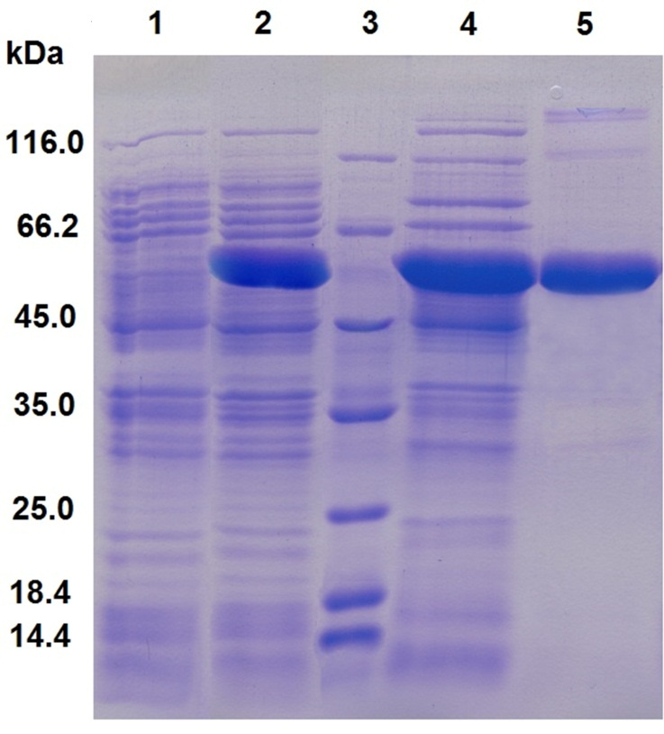
Figure S1 SDS-PAGE analysis of the proteins from different purification steps. Lane 1: negative control, crude extract of E. coli BL21 (DE3) cells harboring plasmid pETDuet-1; Lane2: crude extract of induced E. coli BL21 (DE3) containing pETDuet-araA; Lane 3: protein marker; Lane 4: the sample from Lane 2 after heat treatment at 60ºC; Lane 5; the sample from Lane 4 after Ni-chelating affinity chromatography.

Figure S2 Native-PAGE analysis of purified BCAI. Lane 1,2,3: Non-denatured BCAI proteins; Lane M: protein standard (20 kDa-1236 kDa) purchased from ThermoFisher (USA). 4%-16% non-denaturing gel was used for the electrophoresis.

Experimental details related to Figure S2
Materials:
The seperating gel contained 12.5 M Tris-HCl (pH 6.8), 4%/0.11% - 16%/0.43% (w/v) Acrylamide/Bis-acrylamide, 0.05% (w/v) ammonium persulfate (APS) and 0.01% TEMED. The stacking gel contained 12.5 mM Tris-HCl (pH 6.8), 3.25%/0.09% (w/v) Acrylamide/Bis-acrylamide, 0.05% (w/v) ammonium persulfate (APS) and 0.01% TEMED. The (2×) sample buffer contained 8% (v/v) Glycerol, 0.125 M Tris-HCl (pH 6.8) and 0.02% (w/v) Bromophenolblue. The running buffer contained 25 mM Tris, 200 mM Glycine.
The protein standard (NativeMark™ Unstained Protein Standard) which consisted of 8 protein bands ranging from 20-1236kDa was purchased from Thermofisher (USA). Storage and use of this protein standard was according to the protocol provided by Thermofisher (https://tools.thermofisher.com/content/sfs/manuals/ NativeMarkUnstainedProteinStnd_man.pdf).

Gel running method:
- The gradient separating gel (4% - 16% Acrylamide) was prepared in the gap between the glass plates of gel casting. The rest space was filled with water. 30-40 min was allowed for a complete gelation.
- The water in the first step was poured out. The stacking gel was pipeted into the gap and the comb was inserted. 30-40 min was allowed for a gelation.
- Protein sample was mixed with (2×) sample buffer (10 μl sample/ 10 μl buffer). Then, the protein standard and protein sample mixture were loaded to gel wells.
- The running buffer was poured into the electrophoresis chamber. The electrophoresis was run at 4 ºC and 120 V for about 60 - 90 min.
- The gel was immersed with staining solution containg 0.3 % Coomassie Brilliant Blue R-250 (w/v), and was shaken slowly on horizontal rotator for about 20-30min.
- The gel was then immersed in destaining solution and put it on the same shaker for about 20-30min. The destaining solution was changed for 3-5 times until clear bands could be seen.

