Additional file1
Table S1. Primers used in this studyª
No | Name | Sequence (5’-3’) | Description
1 | Pf1 | RTTYTCMAAYGARAAYAAACTTGTT | degenerate primer used for cloning BPLO
2 | Pr1 | AAWGTRTAWGGAGCWGGYCC | degenerate primer used for cloning BPLO
3 | 5’RACE-F | CTTAAGGAACTGGGGAAGCAAC | for cloning BPLO in 5’RACE-PCRs
4 | 5’RACE-R | GTCCGGCCACCAGGCAGTTA | for cloning BPLO in 5’RACE-PCRs
5 | 3’RACE-F | GGAGTGCGGAATACTTCCCAGA | for cloning BPLO in 3’RACE-PCRs
6 | 3’RACE-R | CCGAGTAGATTTGAAGGAAGGG | for cloning BPLO in 3’RACE-PCRs
7 | BPLO-RT-F | AGTAGATTTGAAGGAAGGGGAC | for amplifying BPLO transcripts in qRT-PCRs
8 | BPLO-RT-R | TGAGGGTAAAGGCGAACGGG | for amplifying BPLO transcripts in qRT-PCRs
9 | Be-Actin-F | CATCTCTGATCGGAATGGAAG | for amplifying actin transcripts in qRT-PCRs
10 | Be-Actin-R | AGATCCTTTCTGATATCCACG | for amplifying actin transcripts in qRT-PCRs
11 | BFF | CGCGAATTCATGGAGCATTTCTACCTC | for the expression of BPLO in yeast cells
12 | BFR | GAAGCGGCCGCTCACGCTTTGTGAGGGTA | for the expression of BPLO in yeast cells
13 | V15F | CTTGCGGCCGCATGGAGGTGTTCTTCCTC | for the expression of CYP716A15 in yeast cells
14 | V15R | ACCAGATCTCTATGGTTTGTGAGGATG | for the expression of CYP716A15 in yeast cells
15 | CF | GGCGGATCCATGGAGATCTTCTATGTC | for the expression of CrAO in yeast cells
16 | CR | CGCGGTACCTTATGCATTAATGTGAGG | for the expression of CrAO in yeast cells
17 | YIP-F | TCTCTGCAGGAGCGACCTCATGCTATACCTG | for amplifying the betulinic acid expression cassette
18 | YIP-R | TCTTCTAGACTTCGAGCGTCCCAAAACCT | for amplifying the betulinic acid expression cassette
19 | P-ATR1-SalI | GTCGACCTTCAATTTAATTATATCAG | for amplifying the ATR1 expression cassette
20 | T-ATR1-ClaI | ATCGATGTATGTTGTCTTTGAAGATGCA | for amplifying the ATR1 expression cassette
21 | PUG6-KAN-F | cgaccagcgtatacaatctcgatagttggtttcccgttctttccactcccgtc AGGTCGACAACCCTTAATAT | for amplifying“LoxP-kanMX-loxP”
22 | PUG6-KAN-R | ttcgtttttataacgttcgctgcactgggggccaagcacagggcaagatgctt TATAGGGAGACCGGCAGATC | for amplifying“LoxP-kanMX-loxP”
23 | 80UP-F | GGATCCCCAATGCTAATCCGGTCACTG | for amplifying 5'-Gal 80 sequence
24 | 80DOWN-R | GAATTCATCAGTTTTTGAAGGCAGCCT | for amplifying 3'-Gal 80 sequence
25 | 80DOWN-5 | GCCCTGTGCTTGGCCCCCAGTGCAGCGAACGTTATAAAAACGAA | for amplifying 3'-Gal 80 sequence
26 | 80UP-3 | GACGGGAGTGGAAAGAACGGGAAACCAACTATCGAGATTGTAT | for amplifying 5'-Gal 80 sequence
ªRestriction enzyme recognition sites are underlined.

Fig. S1
Fig. S1 The mass fragmented patterns of the products lupeol (LUP), betulin (BN) and betulinic acid (BA) as well as their corresponding chemical standards.

Fig. S2
Fig. S2 The MS spectrums of the unknown peaks 1-3 shown in the Fig. 1 of the main text.

Fig. S3
Fig. S3 GC-MS analysis of the products extracted from the lupeol C28-oxidase (LO) alone-expressed yeast cultures fed with lupeol. Each LO enzyme (BPLO, CrAO and CYP716A15) was individually expressed in the WAT11 yeast strain, and resultant each transgenic yeast culture was then fed with lupeol at a final concentration of 50 µM upon the induction by 2% galactose. After the induction, the compounds were extracted from the mediums and cells, respectively. Trace amounts of betulin (BN) and betulinic acid (BA) were detected in the culture mediums while were almost undetectable in the cells. A, Total ion chromatograms were shown for the products by expressing BPLO (purple line), CrAO (black line), CYP716A15 (blue line) and the empty vector control (red line). The inset is the enlarged chromatograms from 17.5 to 19.5 minutes. B, the relative amounts of the products (BN and BA) produced by the transgenic yeast cells expressing the individual LO (BPLO, CrAO and CYP716A15). BN, betulin; BA, betulinic acid; UA, ursolic acid, which was used as an internal standard.

Fig. S4

Fig. S4 The production of betulinic acid (BA) was mostly found in the yeast culture mediums of the both CEN.PK-ATR1-LB and WAT11-406-LB strains with relatively much less BA being detected inside their cells. Error bars represent the standard errors of the means calculated from three biological replicates.

Fig. S5
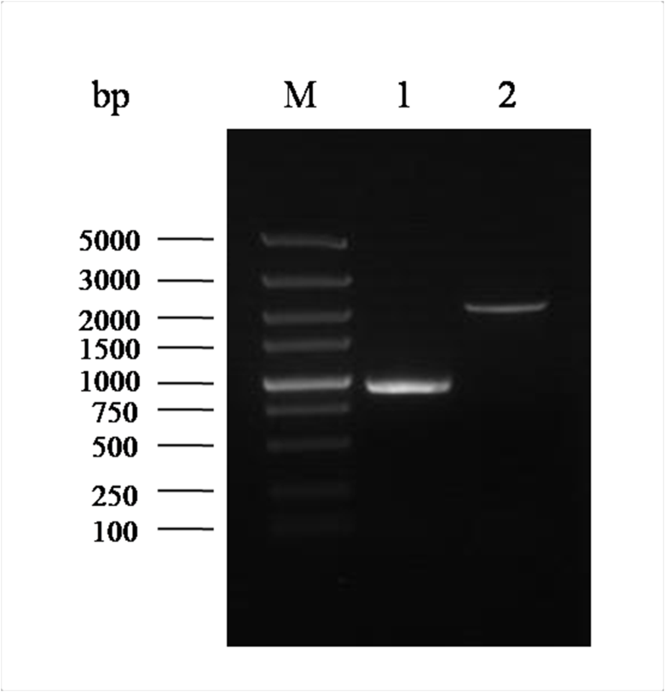
Fig. S5 Confirmation of the Gal80p gene disruption by diagnostic PCRs. The PCRs were carried out using primers 23/24, which would yield the 897-bp amplified product for the wild type strain while 2094-bpamplified product for the Gal80p mutant strain. Lane 1, the amplified product using the genomic DNA of the wild strain WAT11-LB as the template; Lane 2, the amplified product using the genomic DNA of the Gal80p mutant strain as the template.

Fig. S6
Fig. S6 Comparison of the BPLO transcripts between the wild type strain WAT11-LB and the mutant WAT11-LB-△Gal80 under 2% galactose as the carbon source. The yeast cells collected at the static growth period were used for the gene expression analysis. Error bars represent the standard errors of the means calculated from three biological replicates.

