Additional file 6: Figure S2. ¹H NMR of the isolated (R)-CHBE (500 MHz, CDCl₃).
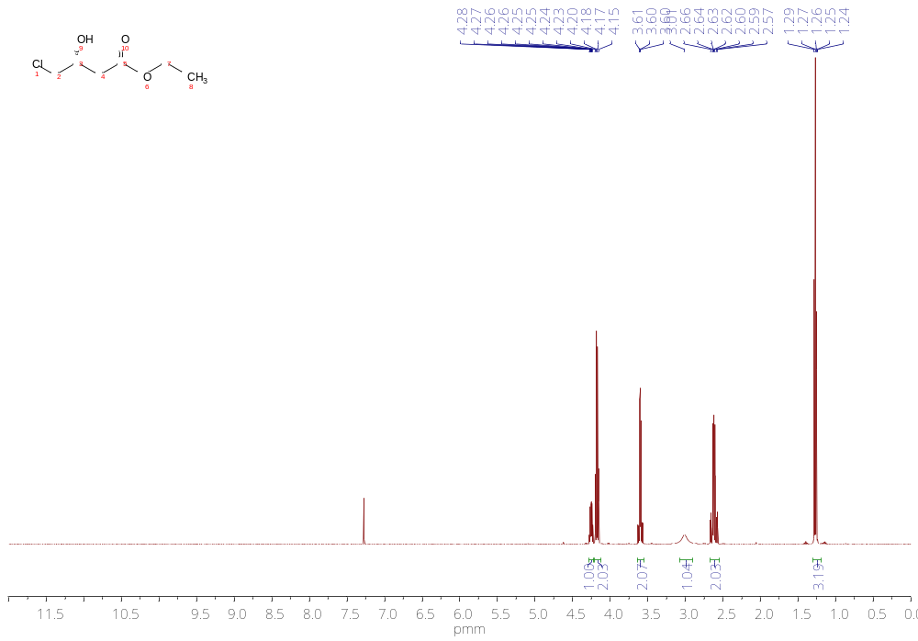

Additional file 6: Figure S3. ¹³C NMR of the isolated (R)-CHBE (126 MHz, CDCl₃).
