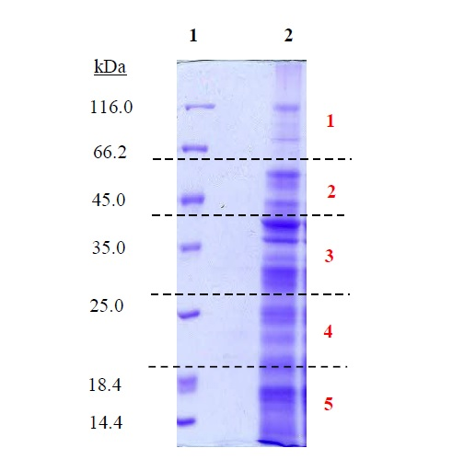

Figure S1. SDS-PAGE analysis of the BCC5776 crude enzyme extracts. Lane 1- Marker proteins; Lane 2 –the CG-Cel crude enzyme extracts stained with Coomassie brilliant blue.

