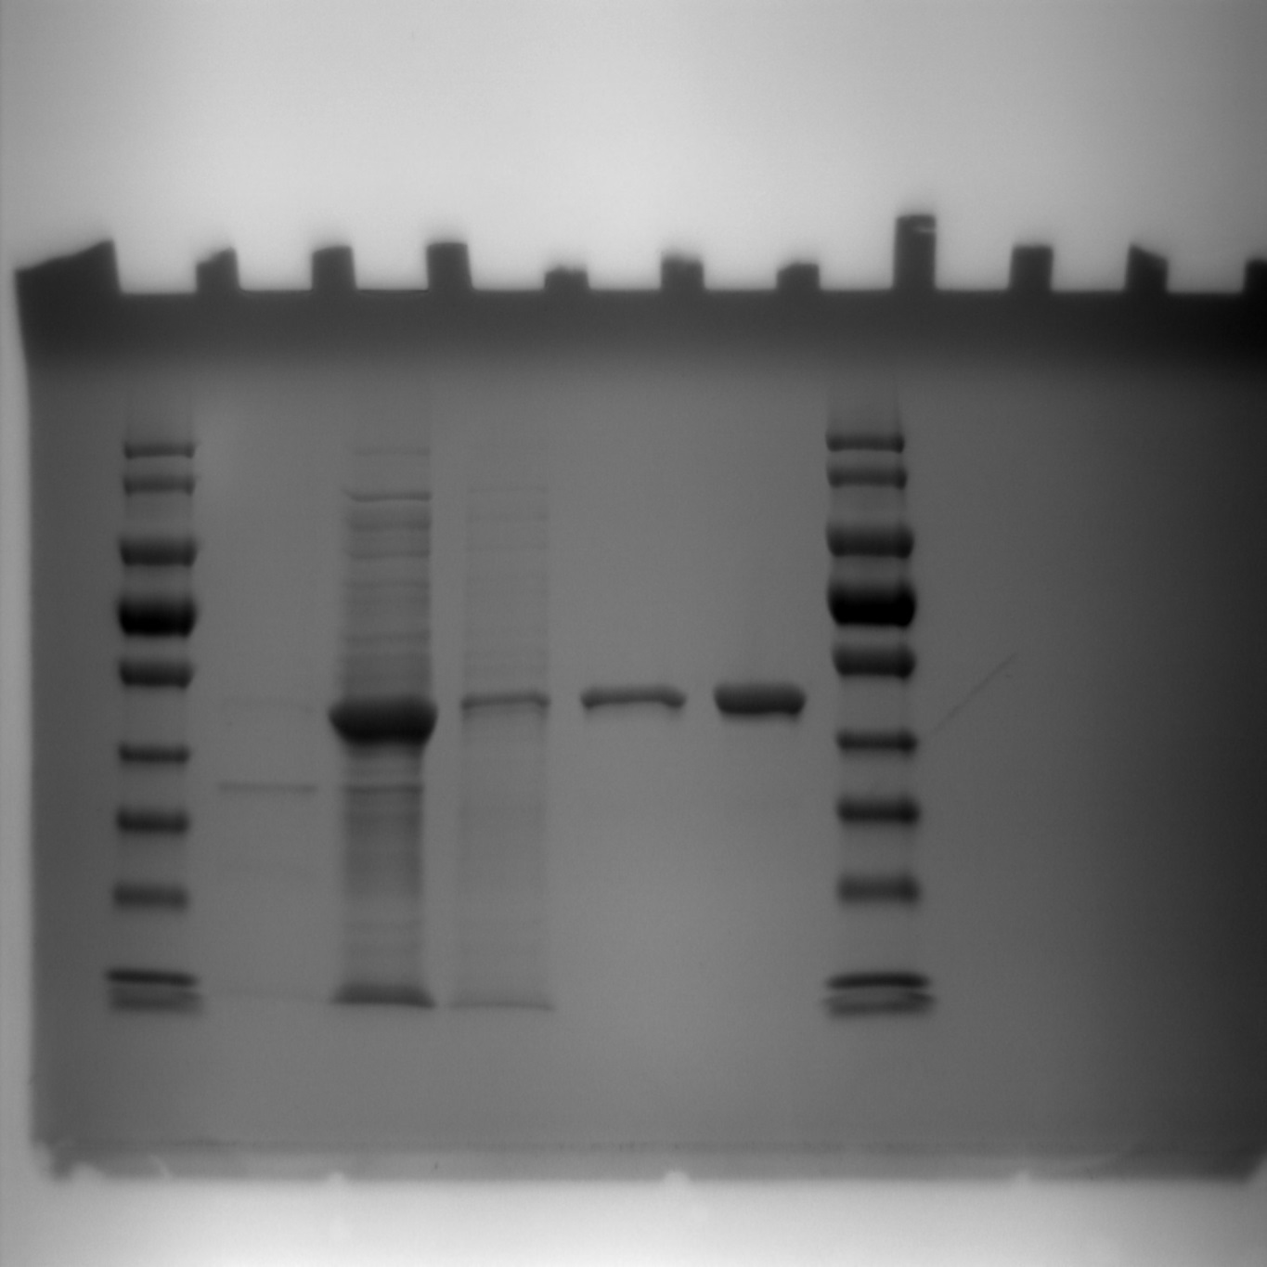
40 -
180 -
kDa
55 -
70 -
130 -
100 -
35 -
25 -
10 -
4
5
6
3
2
1
7

Fig. S2 10% SDS-PAGE of purified endo-xylanase from G. thermodenitrificans T12 followed by PageBlue staining. Lane 1: Protein marker; Lane 2: Pellet fraction; Lane 3: cell-free extract; Lane 4: non-binding protein fraction from FPLC; Lane 5: Purified recombinant GtXynA1; Lane 6: Purified and desalted recombinant GtXynA1; Lane 7: Protein marker

