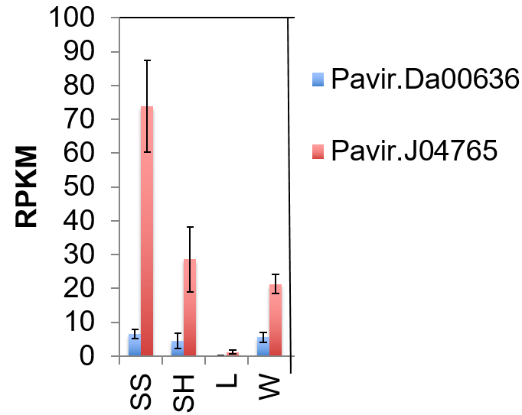

Additional file 1: Fig. S1. Gene expression levels of the two PvAT10 genes from different switchgrass tissues. Pavir.J04765 is the gene ID for PvAT10 (Pavir.J252500.1) used in Figure 1. All samples are from the E4 stage. SS – lower part of 2nd internode; SH - upper part of 2nd internode; L- leaf with sheath from 2nd internode; W- whole tiller. Error bars represent standard deviation of three replicates. RPKM: reads per kilobase per million mapped reads.

