Additional file 1: Figure S1
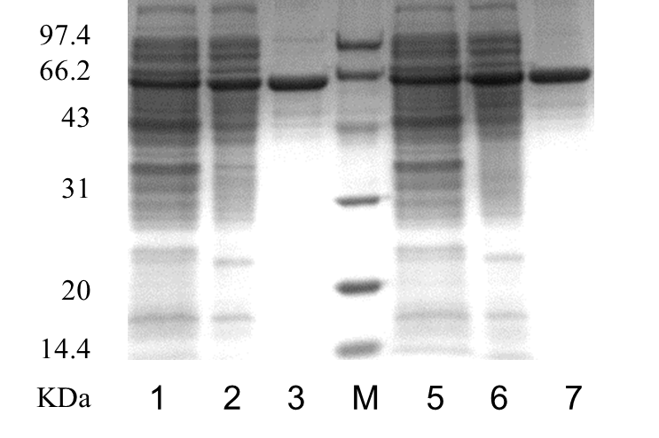
SDS-PAGE analysis of the purification of soluble, extracellular γ-CGTase expression by E. coli with and without added β-cyclodextrin. Lanes: 1–3, no β-cyclodextrin added (1, crude enzyme; 2, purified by 25% (NH₄)₂SO₄; 3, purified by MonoQ); M, molecular mass markers. Lanes 4–6, β-cyclodextrin added (4 crude enzyme; 5, purified by 25% (NH₄)₂SO₄; 6, purified by MonoQ).

