Additional File 1
Mucosal delivery of an anti-TNF scFv expression vector carried by Lactococcus lactis ameliorates experimental colitis in mice

Maria José Chiabai¹,
Juliana Franco Almeida²,
Mariana Gabriela Dantas de Azevedo¹,
Suelen Soares Fernandes¹,
Vanessa Bastos Pereira³
Raffael Júnior Araújo de Castro⁴,
Márcio Sousa Jerônimo⁴,
Isabel Garcia Sousa¹,
Leonora Maciel de Souza Vianna⁵,
Anderson Miyoshi³,
Anamelia Lorenzetti Bocca⁴,
Andrea Queiroz Maranhão¹,
Marcelo de Macedo Brigido¹

Correspondence: Marcelo Macedo Brigido: brigido@unb.br

Additional Figures

(A) (B)
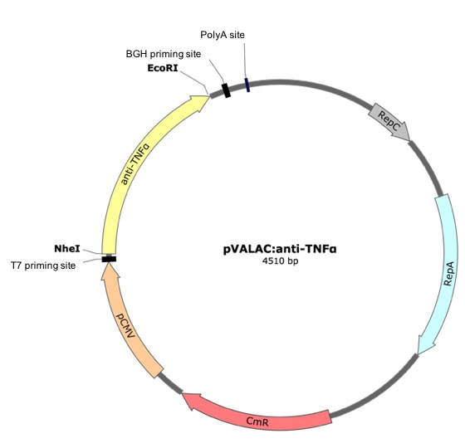

Figure S1 Structure of the eukaryotic expression vector pValac::anti-TNFα and scFv protein expression by HEK-293 on transfection assays. (A) Schematic representation of pValac::anti-TNFa plasmid harboring a cytomegalovirus promoter (pCMV), anti-TNFα ORF of Mus musculus, a polyadenylation signal of bovine growth hormone (BGH polyA), which are essential for expression of gene by eukaryotic host cells; E. coli (RepC) and L. lactis (RepA) origins of the replication to the prokaryotic region and chloramphenicol resistance gene (Cm) for bacterial selection. (B) Western blot shows the presence of scFv anti-TNFα (31 kDa) produced in the posttransfected supernatant of HEK-293 cell cultures. C+, scFv positive control; 1, supernatant of HEK-293 producing anti-TNFα; 2, scFv anti-IL1β positive control (30 kDa); and 3, BenchMarkTM Pre-Stained Protein Ladder (Invitrogen, Carlsbad, CA, USA).

Figure S2 MUC-3 mRNA levels in colonic tissue. Levels of mRNA were normalized to RPS9 mRNA. Experimental groups: NC, negative control group; DSS, DSS group; LL-F, L. lactis MG1363 FnBPA+ group and LL-FT, L. lactis MG1363 FnBPA+ (pValac::anti-TNFα) group. Data are expressed as the means ± SEM from an experiment using 4-5 animals per group. Statistical analysis was performed using the Mann-Whitney test.

- (B) (C)
Figure S3 Effect of the treatment of colitis with LL-FT on systemic cytokines production. Systemic (A) IL-6, (B) TNF, and (C) IL-10 production levels in the serum of mice were analyzed by CBA. Experimental groups: NC, negative control group; DSS, DSS group; LL-F, L. lactis MG1363 FnBPA+ group and LL-FT, L. lactis MG1363 FnBPA+ (pValac::anti-TNFα) group. Data are expressed as the means ± SEM from an experiment using 4-5 animals per group. Statistical analysis was performed using the Mann-Whitney test. *p < 0.05.

Figure S4 Changes in fecal IgA after oral administration of LL-FT. A pool of feces per group was collected 30 min before euthanasia, and the levels of fecal extract IgA were measured by ELISA. Experimental groups: NC, negative control group; DSS, DSS group; LL-F, L. lactis MG1363 FnBPA+ group and LL-FT, L. lactis MG1363 FnBPA+ (pValac::anti-TNFα) group. Data are expressed as the means ± SEM from an experiment using 4-5 animals per group. Statistical analysis was performed using the Mann-Whitney test.

Additional Tables

Table S1 Primer sequences used in qPCR assay.

Gene Target | Sequence 5’- 3’
tbx21 | FW TCAGGACTAGGCGAAGGAGA
tbx21 | RV GCCTTCGGTTTCCTTATCAA
stat1 | FW TCACAGTGGTTCGAGCTTCAG
stat1 | RV GCAAACGAGACATCATAGGCA
rorc | FW TGCAAGACTCATCGACAAGG
rorc | RV AGGGGATTCAACATCAGTGC
arg1 | FW GTTCCCAGATGTACCAGGATTC
arg1 | RV CGATGTCTTTGGCAGATATGC
nos2 | FW CGAAACGCTTCACTTCCAA
nos2 | RV TGAGCCTATATTGCTGTGGCT
foxp3 | FW ACTCGCATGTTCGCCTACTT
foxp3 | RV AGGGATTGGAGCACTTGTTG
Il6 | FW TAGTCCTTCCTACCCCAATTTCC
Il6 | RV TTGGTCCTTAGCCACTCCTTC
Il10 | FW CGCAGCTCTAGGAGCATGTG
Il10 | RV GCTCTTACTGACTGGCATGAG
tgfb | FW CTGACGTCACTGGAGTTGTACGG
tgfb | RV GGTTCATGTCATGGATGGTGC
il1b | FW CTGACGTCACTGGAGTTGTACGG
il1b | RV CAGCACGAGGCTTTTTTGTTG
tnfa | FW GTACCTTGTCTACTCCCAGGTTCTCT
tnfa | RV GTGGGTGAGGAGCACGTAGTC
muc3 | FW 5CGTGGTCAACTGCGAGAATGG
muc3 | RV 5CGGCTCTATCTCTACGCTCTC
il22 | FW GGTGACGACCAGAACATCCA
il22 | RV CCCAATCGCCTTGATCTCTC
rps9 | FW CGCCAGAAGCTGGGTTTGT
rps9 | RV CGAGACGCGACTTCTCGAA
il17a | FW TTTAACTCCCTTGGCGCAAAA
il17a | RV CTTTCCCTCCGCATTGACAC

Table S2 Histological Score.

Histological findings | Absent | Mild | Moderate | Severe
Mucosal infiltrate | 0 | 1 | 2 | 3
Submucosal infiltrate
Muscle infiltrate
Serous infiltrate
Eosinophils
Muscle herniation
Inflammatory activity of glands
Abscesses of crypts
Erosion of mucosa
Mucosal ulceration without injury Muscularis mucosae
Long base ulcer
Muscle thickening
Depletion of goblet cells

