Additional file 5: Figure. S5 Standard curves of gap and mtg gene

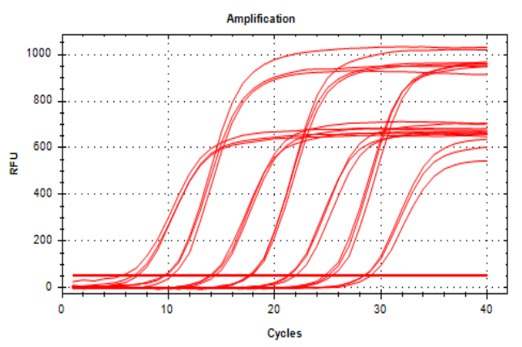
1、standard curve of gap gene

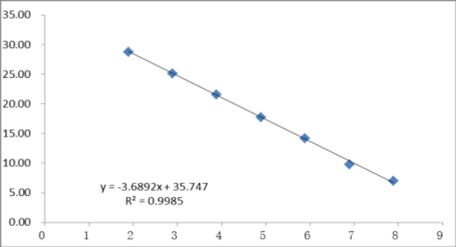

Fig. S5-1 amplification curve and standard curve gap gene

2、standard curve of mtg gene
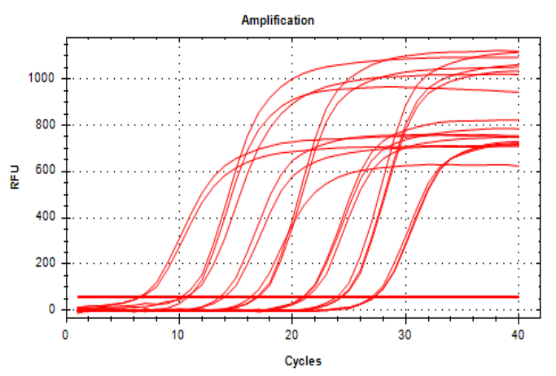
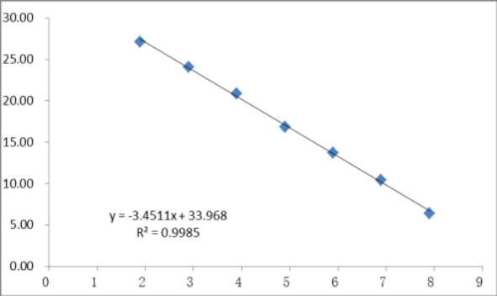

Fig. S5-2 amplification curve and standard curve mtg gene

