Supplementary material

Effectiveness of recombinant Escherichia coli for the production of (R)-(+)-perillyl alcohol
Chao Sun^{1,2}, Xianjuan Dong², Rubing Zhang^{2,*}, Congxia Xie^{1,*}
¹A State Key Laboratory Base of Eco-Chemical Engineering, College of Chemistry and Molecular Engineering, Qingdao University of Science and Technology, Qingdao, China
²CAS Key Laboratory of Bio-based Materials, Qingdao Institute of Bioenergy and Bioprocess Technology, Chinese Academy of Sciences, Qingdao, China
*Corresponding author.
Rubing Zhang
CAS Key Laboratory of Bio-based Materials, Qingdao Institute of Bioenergy and Bioprocess Technology, Chinese Academy of Sciences,189 Songling Rd., Qingdao 266101, China. E-mail: zhangrb@qibebt.ac.cn

Congxia Xie
A State Key Laboratory Base of Eco-Chemical Engineering, College of Chemistry and Molecular Engineering, Qingdao University of Science and Technology, 53 Zhengzhou Rd., Qingdao 266042, China.
E-mail: xiecongxia@126.com

Table S1 Strains and plasmids used in this study
Name | Relevant characteristics |  | References
Strains
E.coli DH5α |  | F⁻ recA endA1Φ80dlacZ△M15hsdR17(r_{k}⁻m_{k}⁺)λ⁻ | Invitrogen
E.coli BL21(DE3) |  | F- ompT hsdSB (rB – mB - ) gal dcm rne131 λ(DE3) | Invitrogen
SC00 |  | E.coli BL21(DE3) /pSC00 | This study
SC01 |  | E.coli BL21(DE3) /pSC01 | This study
SC02 |  | E.coli BL21(DE3) /pSC02, pYJM14 | This study
SC03 |  | E.coli BL2 (DE3) /pSC03 | This study
SC04 |  | E.coli BL21(DE3) /pSC04, pYJM14 | This study
SC05 |  | E.coli BL21(DE3) /pSC05, pYJM14 | This study
Plasmids
pTrcHis2B | pBR322 origin, Amp |  | Invitrogen
pET28a(+) | Kan^{r}oripBR322lacI^{q}T7p |  | Novagen
pCOLADuet-1 | Kan^{r} ColA lacI T7lac |  | Novagen
pYJM14 | pTrcHis2B carrying ERG12, ERG8, ERG19 and IDI from Saccharomyces cerevisiae |  | [1]
pSC00 | pET28a(+) carrying LHBS from Bacillus stearothermophilus BR388 |  | This study
pSC01 | pET28a(+) carrying cymAa and cymAb from Pseudomonas putida |  | This study
pSC02 | pET28a(+) carrying mvaE and mvaS from Enterococcus faecalis, GPPS from Abies grandis, ClLS from Citrus limon. |  | This study
pSC03 | pET28a(+) carrying GPPS from Abies grandis, ClLS from Citrus limon. |  | This study
pSC04 | pET28a(+) carrying mvaE and mvaS from Enterococcus faecalis, GPPS from Abies grandis, ClLS from Citrus limon, cymAa and cymAb from Pseudomonas putida |  | This study
pSC05 | pCOLADuet-1 carrying mvaE and mvaS from Enterococcus faecalis, GPPS from Abies grandis, ClLS from Citrus limon, cymAa and cymAb from Pseudomonas putida |  | This study

Table S2 Primers used in this study for plasmids construction. The restriction sites in the primers were underlined
Primers | Sequences(5’-3’)
mvaE-F-BamHI | GGGTCGCGGATCCAGGAGGTAAAAAA
mvaE-R | CCTTATATCTCCTTTTATTGTTTTC
mvaS-F | AAAGGAGATATAAGGAGGTAAAA
mvaS-R-ECORI | AGAGCTCGAATTCTTAGTTTCGATAAGAG
GPPS-F-SacI | ACTAAGAATTCGAGCTCTAATACGA
GPPS-R | TTATATCTCCTTTTAGTTCTGAC
ClLS-F | AGCTACTCATTATATCTCCTTTTAGTTCTG
ClLS-R-AaTII | AATTCCCCTATAGTGAGTCGTATTAGACGTCTTAACCTTTGG
LHBS-F-EcoRI | CGCGGATCCGAATTCATGGGCAGCAAATAT
LHBS-R-XhoI | GGTGGTGGTGCTCGAGTTAACTAA
cymAa-F-AaTII | GTTAAGACGTCTAATACGACTCACTATAGGGGAATTGTGAG
cymAa-R | GGTCCGAGCCTGGCACGTGGTTAAAAGGAG
cymAb-F | GTGGTTAAAAGGAGATATAATGCGCAGCTTTTTTCA
cymAb-R-PacI | TGGTGGTGGTGTTAATTAATTAGCTATTACGGCCATCGG
mvaE-mvaS-2-F-BamHI | CAGCCAGGATCCGAGGAGGTAAAAA
mvaE-mvaS-2-R-SacI | AGGCGCGCCGAGCTCTTAGTTTCGA
GPPS-ClLS-2-F-BagII | CATATGGCAGATCTATGGAATTCGACTTCAACAAATAC
GPPS-ClLS-2-R-XhoI | ATTCCTATAGTGAGTCGTATTACTCGAGTTAACCTTTGGTGCCCGGACTT
cymAa-cymAb-2-F-XhoI | CACCAAAGGTTAACTCGAGTAATACGACTCACTATAGGAATTGTGAGCG
cymAa-cymAb-2-R-PacI | CGGTGGCAGCAGCCTAGGTTAATTAATTAGCTATTACGGCCATCGG

Table S3 Primers for RT-PCR used in this study
Primers | Sequences(5’-3’)
rpoD-F | AGCGTGGAATCTGAAATCGG
rpoD-R | GCAACGGAGCATTGAACCTG
mvaE-1 | GAGAAAGATGAAGGGATTCG
mvaE-2 | CACGATTGAAGTTGCTGC
mvaS-1 | CTGAAGCCAGAAATGTAGACC
mvaS-2 | AACGATGTAAGACAACTGCG
GPPS-1 | GCAAACCCTGGAATGGAT
GPPS-2 | TTCAGCAGTTCGTCAGAGAA
ClLS-1 | GAAGCCCGTTGGTTTATTC
ClLS-2 | CAATGCCCATACTCCACAG
cymAa-1 | GGGAACTGAAACTGGATGC
cymAa-2 | GGCAATAATGCTCGGAATG
cymAb-1 | CTGAGCAAAGCAGAACTGG
cymAb-2 | ATTCGCCACCTGGAACTT
ERG8-1 | CAGAGTTGAGAGCCTTCAGTG
ERG8-2 | ACGATGTTCGGTAACGCTA
ERG12-1 | CTGCTAATAAGCGAGTCATCTG
ERG12-2 | GTAGTGGAAGGATTCGGATAGT
ERG19-1 | GCAAGATGACCTCAGAACG
ERG19-2 | TTTCGGAGACAATGTGGAG

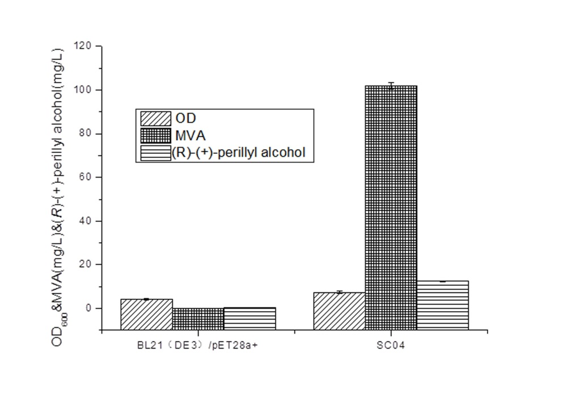

Figure S1 Mevalonate and (R)-(+)-perillyl alcohol production engineered MVA pathway. The total production of MVA and (R)-(+)-perillyl alcohol was measured after 48 h of IPTG induction .

1. Yang J, Zhao G, Sun Y, Zheng Y, Jiang X, Liu W, Xian M: Bio-isoprene production using exogenous MVA pathway and isoprene synthase in Escherichia coli. Bioresour Technol. 2012, 104:642-647.

