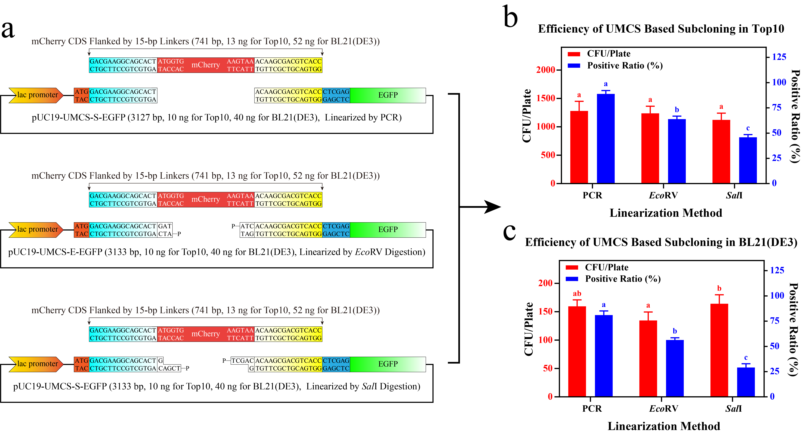
Fig. S3 Efficiency evaluation of UMCS based subcloning for Top10 and BL21(DE3). Dedicated vectors were first linearized (a) by PCR, EcoRV digestion, or SalI digestion, then co-transformed into Top10 (b) and BL21(DE3) (c) chemically competent cells with the mCherry sequence flanked by 15-bp homologous linkers (n=4).

