Expansion of targetable sites for the ribonucleoprotein-based CRISPR/Cas9 system in the silkworm Bombyx mori
Yun-long Zou¹, Ai-jun Ye¹, Shuo Liu¹, Wen-tao Wu¹, Li-feng Xu¹, Fang-yin Dai¹, Xiao-ling Tong^{1,}*
1, State Key Laboratory of Silkworm Genome Biology; Key Laboratory of Sericultural Biology and Genetic Breeding, Ministry of Agriculture and Rural Affairs; College of Sericulture, Textile and Biomass Sciences; Southwest University, Chongqing 400715, P. R. China

*Correspondence: Xiao-ling Tong
Email address: xltong@swu.edu.cn
Telephone：+86-23-68250551

Figure S1. Genotypes of three G₀ BmGR66 knockout silkworms generated by co-injection of sgRNAs T1, T2, T3, and T4 complexed with Cas9 protein
Mutations were detected in three male G₀ silkworms by PCR-amplification of regions surrounding the four sgRNA targeting sites. Amplified products were then subcloned and sequenced. Nucleotides shown in red are base substitutions; boldface represents insertions; dashes represent deletions; blue indicates an inversion. For large deletions, the size of the deleted region is shown in parentheses. The numbers of specific mutations detected in subclone sequencing are shown to the right of each sequence.

Figure S2. Genotypes of two G₀ BmGR66 knockout silkworms generated by co-injection of sgRNA T1, T2, T3 and T4 with Cas9 protein
Mutations were detected in one male G₀ and one female G₀ silkworm by PCR-amplification of regions surrounding the four sgRNA targeting sites. Amplified products were then subcloned and sequenced. Nucleotides shown in red are base substitutions; boldface represents insertions; dashes represent deletions. The numbers of specific mutations detected in subclone sequencing are shown to the right of each sequence.

Figure S3. Uncropped original PAGE gel image. The cropped area is indicated by a red dashed rectangle.

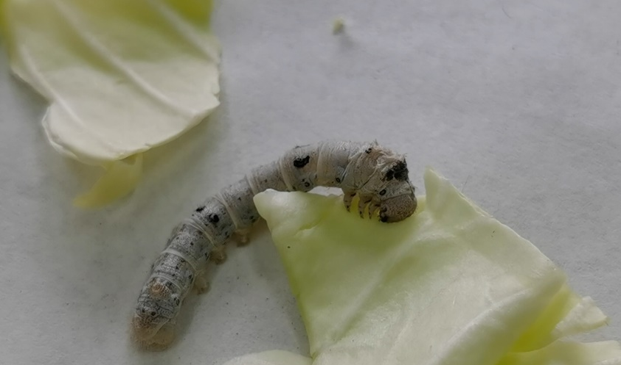

Video S1. A compound heterozygous mutant of BmGR66 eating cabbage leaves.

