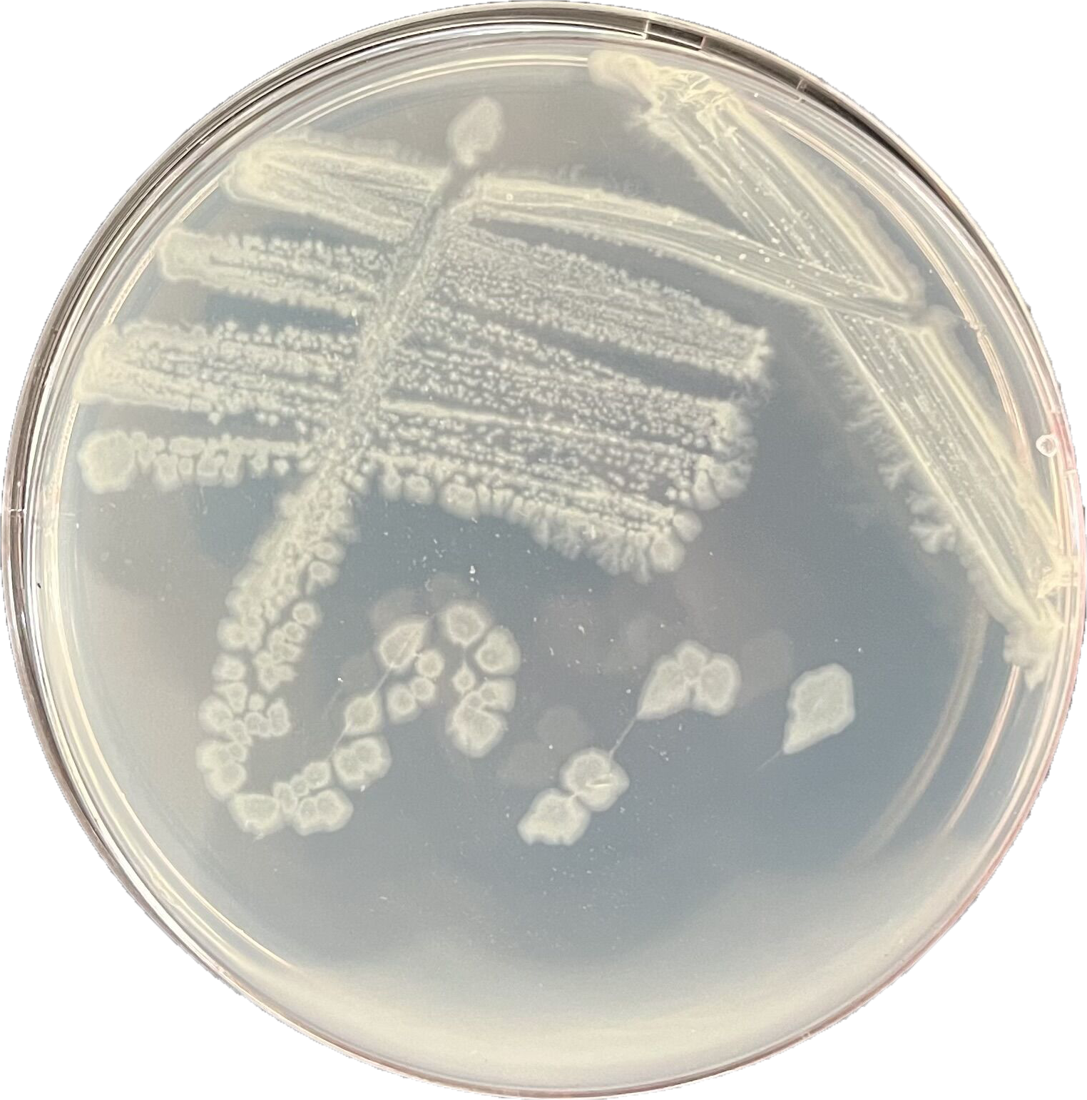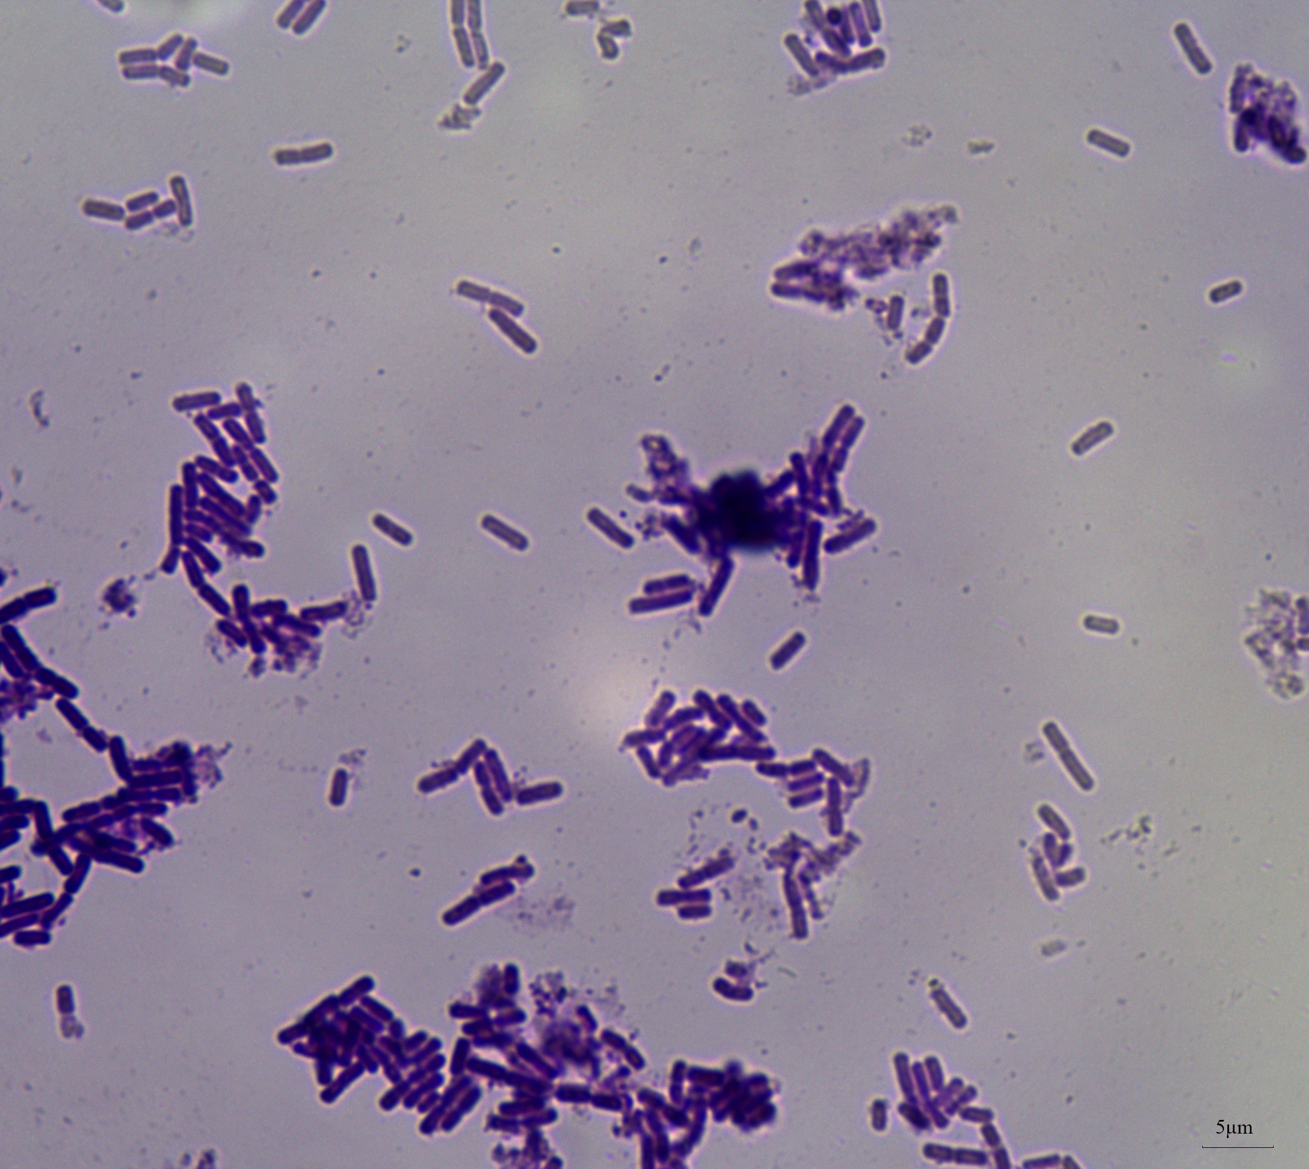
a
b
c
Fig. S1 Morphological characteristics of the isolate Gxun-17: a. Growth on the casein plate; b. Gram’s staining image; c. Scanning electron microscope image

