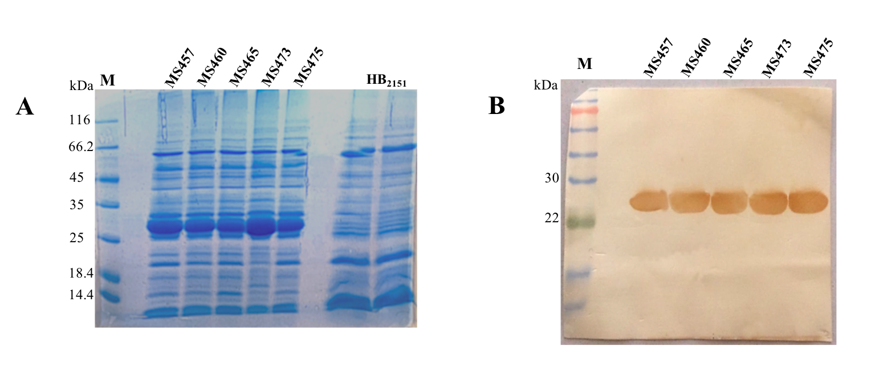
Additional file 1: Supplementary Fig. S1. The expression of five soluble scFvs in E. coli HB₂₁₅₁. The expression of five scFvs, MS457, MS460, MS465, MS473, and MS475, in E. coli HB₂₁₅₁, was evaluated by (A) SDS-PAGE and (B) western blot analysis. (A) The expression level of MS457, MS460, MS465, MS473, and MS475 (~ 27 kDa) in the periplasmic extract of E.coli HB₂₁₅₁ infected with the selected phagemids and the periplasmic extract of uninfected E.coli HB₂₁₅₁ (control) induced by 0.1 mM IPTG were assessed by an SDS-PAGE gel (12 %). Lane M: Unstained protein marker. (B) A single band of the expected size (~ 27 kDa), related to the scFv, was detected by probing with mouse anti-human scFv polyclonal antibody, followed by goat anti-mouse IgG-horseradish peroxidase (HRP)-conjugated antibody. Lane M: pre-stained protein marker.

