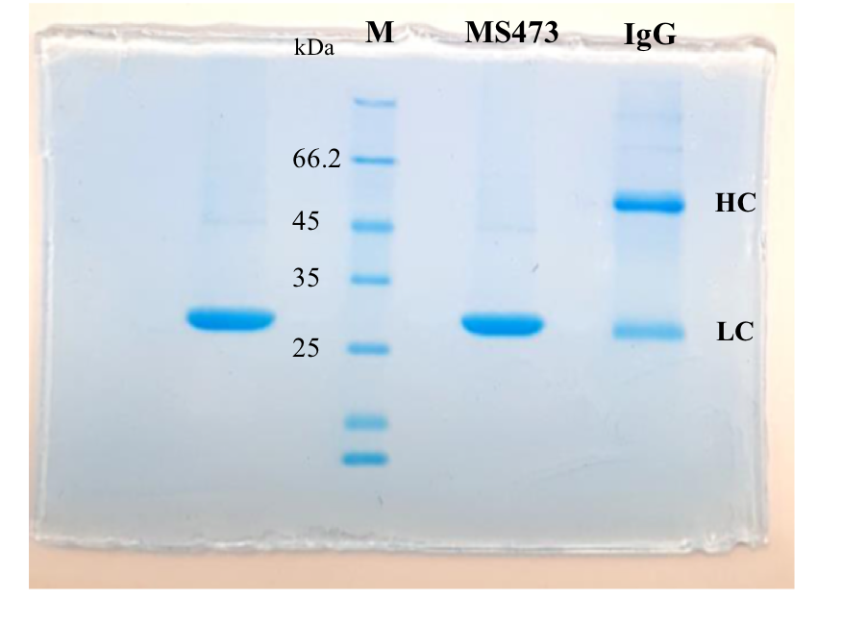
Additional file 3: Supplementary Fig. S3. The purity of MS473 was evaluated by SDS-PAGE. A single protein band at approximately 27 kDa related to the purified scFv is seen on a 12% SDS-PAGE gel stained with Coomassie® blue. IgG: human immunoglobulin G, Lane M: unstained protein marker. The red box on the original SDS-PAGE denoted the region cropped for the Fig. 3A shown in the manuscript.

