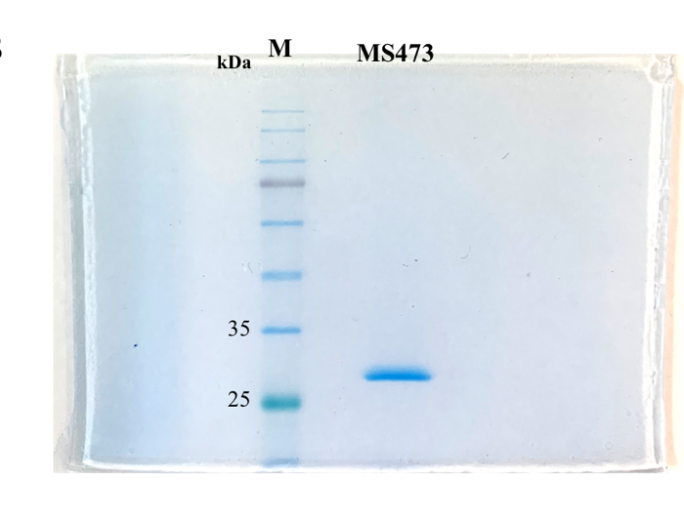
Additional file 4: Supplementary Fig. S4. SDS-PAGE analysis of the SEC elution profile of MS473 scFv shows the presence of a highly pure band of 27 kDa, corresponding to the scFv protein. Lane M: pre-stained protein marker. The red box on the original SDS-PAGE denoted the region cropped for the Fig. 3C shown in the manuscript.

