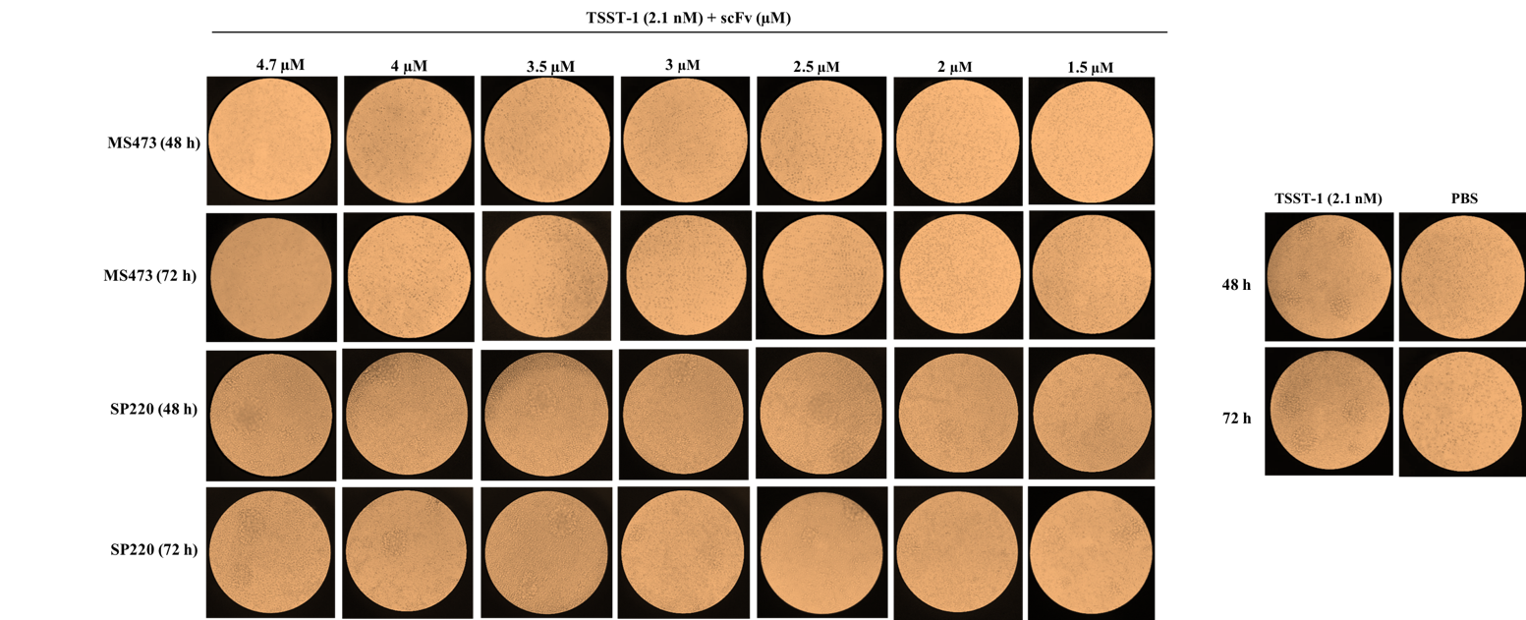
Additional file 5: Supplementary Fig. S5. Inhibition of the mitogenic response of human peripheral blood mononuclear cells (PBMCs) to TSST-1 by MS473. Fresh human PBMCs (~ 10⁶ cells/ml) were incubated simultaneously with the TSST-1 protein (2.1 nM), and the serial dilutions of MS473 or SP220 for 48 and 72 hours at 37°C, 5% CO2. The cells incubated with the TSST-1 protein (2.1 nM) and PBS or PBS alone served as the controls. The proliferation of PBMCs and the formation of cell clumps induced by TSST-1 were investigated using an inverted microscope.

