Raw Data

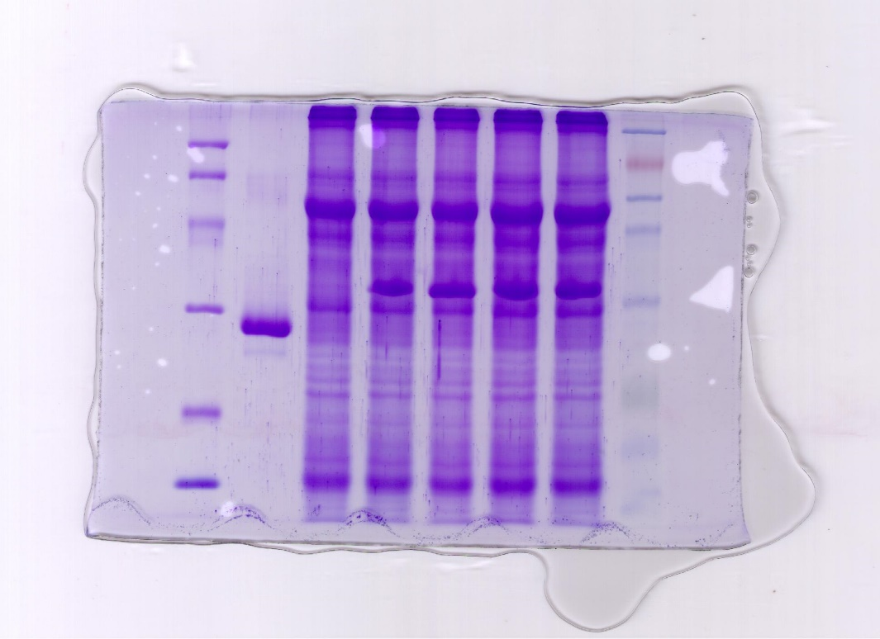
Fig. RD1 GFP-EGF SDS-PAGE gel
Fifteen micrograms of TSPs for each were used to carry out the SDS-PAGE analysis with a 12% separate gel and, the gel was later stained with Coomassie brilliant blue R250. The picture was shot by a digital camera.

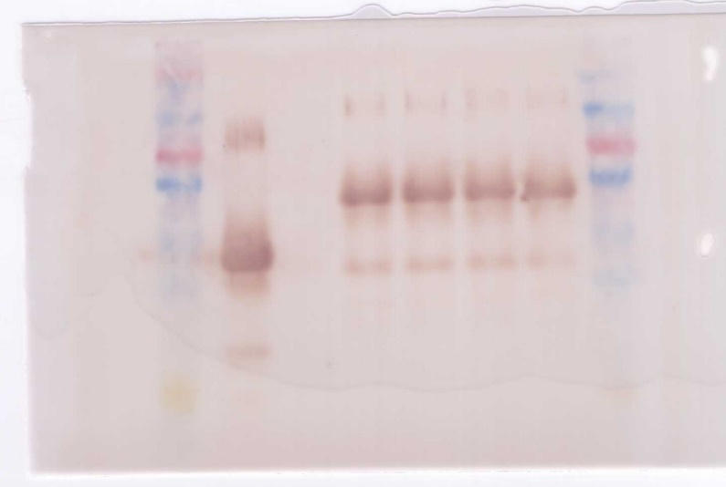
Fig. RD2 GFP-EGF Western blotting image

Fifteen micrograms of TSPs per sample was used for Western blotting and the monoclonal antibody against GFP (rabbit derived) and the horse radish peroxidase-labeled anti-rabbit IgG antibody (goat derived) was used.
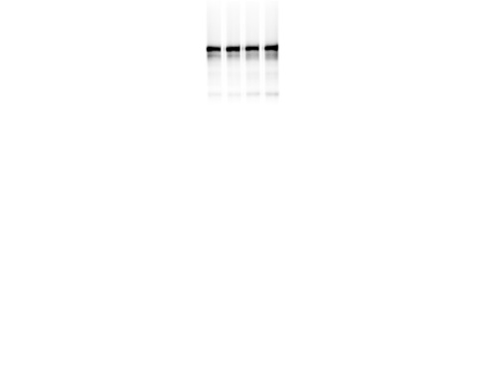
170kDa——
170kDa——

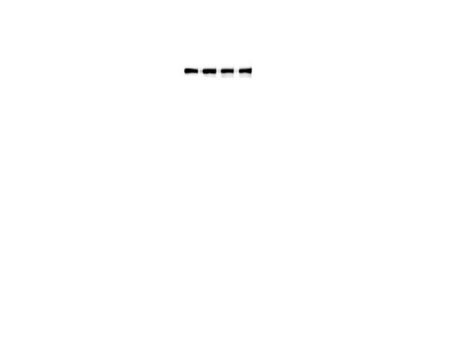
170kDa——
170kDa——
Fig. RD3 EGFR Western blotting images
The western images with different exposures for the amount of EGFR testing in the treated NSCLC cell line A549.

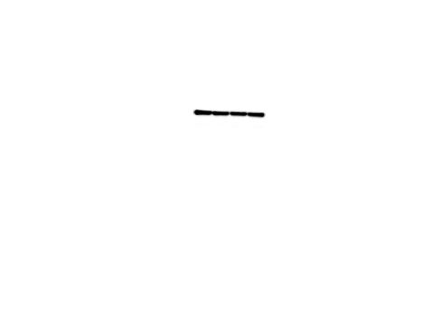
36kDa——
36kDa——

Fig. RD4 GADPH Western blotting images
The western images with different exposures for the amount of GADPH testing in the treated NSCLC cell line A549.

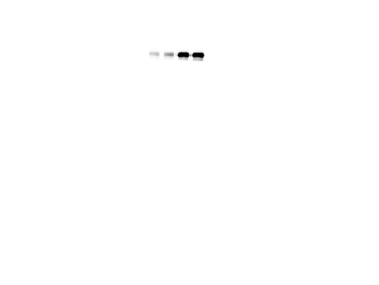
~175kDa——
~175kDa——

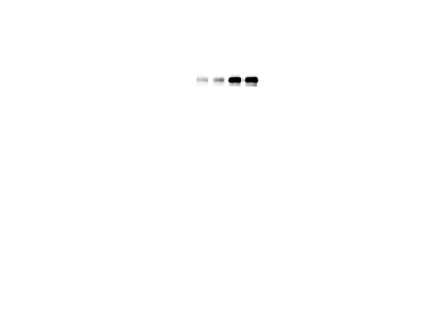
~175kDa——
~175kDa——

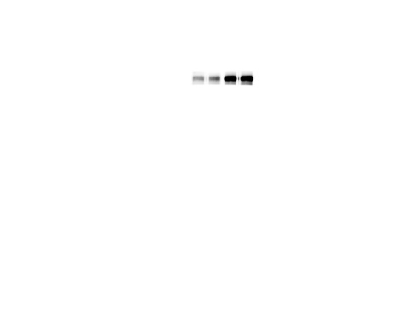
~175kDa——
~175kDa——
Fig. RD5 phosphorylated EGFR (p-EGFR) Western blotting images

The western images with different exposures for the amount of p-EGFR testing in the treated NSCLC cell line A549.

