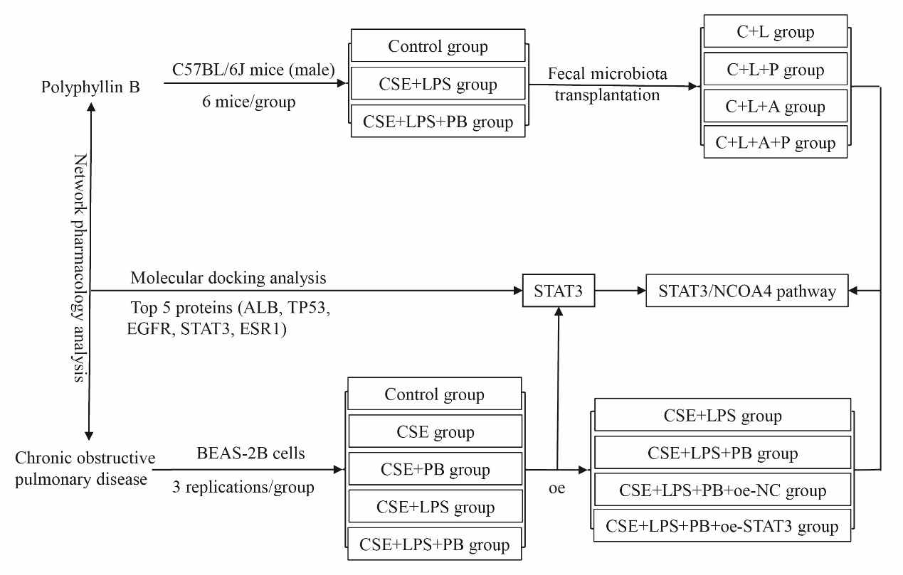
Supplementary Figure 1. The flowchart of the study.
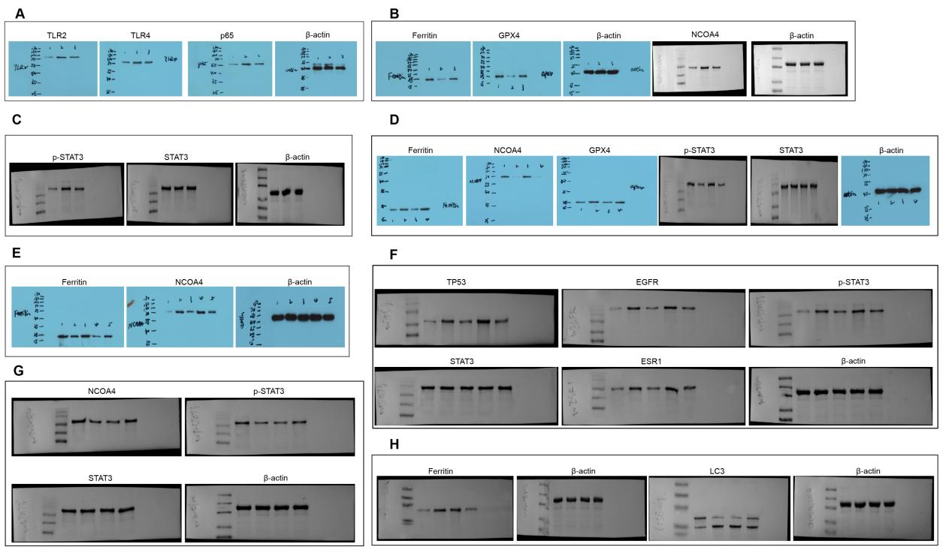
Supplementary Figure 2. Full-length blots of each western blot. (A) Full-length blots of Figure 2F. (B) Full-length blots of Figure 3B. (C) Full-length blots of Figure 3C. (D) Full-length blots of Figure 7E. (E) Full-length blots of Figure 8A. (F) Full-length blots of Figure 8G. (G) Full-length blots of Figure 9B. (H) Full-length blots of Figure 9E.

