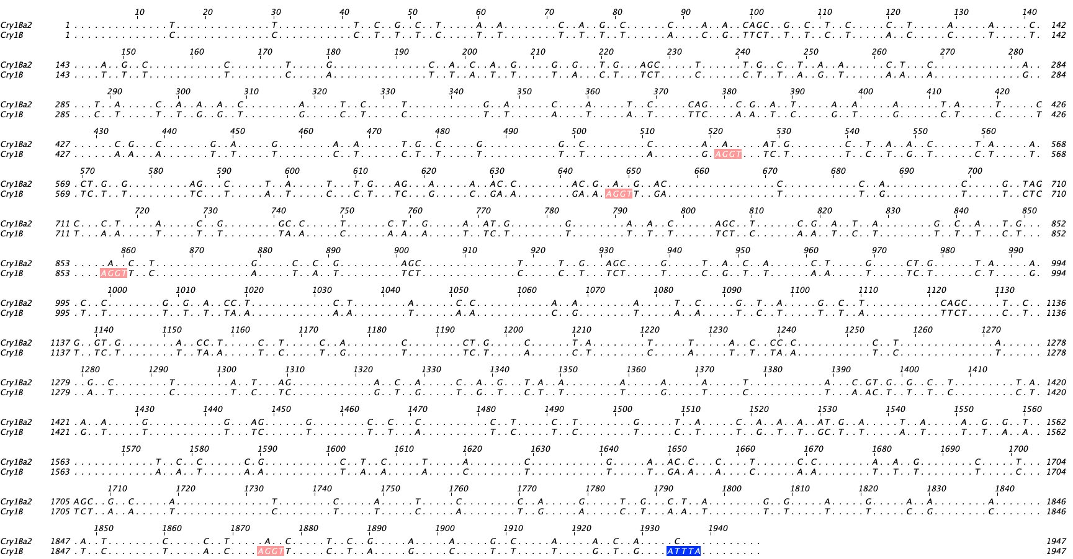

Supplementary Figure 1. Pairwise alignment of unmodified Cry1Ba2 (bottom) and the modified Cry1B^{M} (top) sequences using Jalview [33]. Sequences that may function as splice sites in Cry1B are shown in red color and the instability motif is shown with blue color. Splice sites are indicated with red color, whereas the ATTTA instability motif is indicated with blue color.

