Table S1: Diagnostic tests for melanin identification produced by different filamentous fungi
Test | Producer fungal strain
Test | A. flavus | A. carbonarius
Solubility in water | In Soluble | In Soluble
Color | Dark Brown | Black
Solubility in KOH | Soluble | Soluble
Precipitation in 3N HCL | Precipitated readily | Precipitated readily
Solubility in organic acid solvent (chloroform, acetone, ethyl acetate) | In Soluble | In Soluble
Reaction with H₂O₂ | Decolorized | Decolorized
Reaction with Fecl₃  (Reaction for polyphenols test) | Brown precipitate | Brown precipitate
Reaction with sodium dithionite and potassium ferricyanide | Decolorized and turned brown with addition of potassium ferricyanide | Decolorized and turned brown with addition of potassium ferricyanide
Table S2: FTIR for control melanin and melanin (15 mg) adsorption Cd
Peaks | Control | Sample | Shift | Functional group
1 | 3736 | 3785 | 49 | Alcohol group (O-H) stretch, free, strong and sharp
2 | 3434 | 3408 | 26 | Alcohol group (O-H), stretch, H-bonded, strong and broad
3 | 2924 | 2922 | 2 | Alkane group C-H (stretch, strong)
4 |  | 2853 | - | Alkane group C-H (stretch, strong)
5 | 2363 | 2361 | 2 | C≡ N stretching mode
6 | 1632 | 1623 | 10 | C=C stretching mode, N-H bending in primary amine, or C=o stretching mode (amide)
7 |  | 1710 | - | C=O stretching mode (Ketone)  Or C=O stretching mode (carboxylic acid)
8 | 1456 | 1406 | 50 | C=C stretching mode (Aromatic ring)
9 | 1260 | 1252 | 8 | C-O-H bending mode  C-O stretching mode (Alcohol)  C-O stretching mode (ether)  C=O bending mode  C-O carboxylic acid
10 | 1147 | 1148 | 1 | C-O stretching mode (Alcohol)  C-O stretching mode (ether)  C-O stretching mode
11 | 1028 | 1037 | 9 | C-O stretching mode (Alcohol)  C-O stretching mode (ether)  C-O stretching mode  C- F stretching mode
12 | 928 |  | - | C=C bending, alkene,
13 | 873 | 849 | 24 | Halo compound C-Cl, stretching
14 | 815 |  | - | =C-H out of plane bending mode (Aromatic ring) or N-H, bending mode
15 |  | 596 | - | C- Cl, C-Br, C-I (halo compound)
16 | 541 | 542 | 1 | C- Cl, C-Br halo compound
17 | 471 | 473 | 2 | C-Br, C-I (halo compound)
18 |  | 447 | - | C-Br, C-I (halo compound)

Table S3: FTIR for control melanin and melanin (15 mg) adsorption Cr
Control | sample | Shift | Functional group
3736 | 3785 | 49 | Alcohol group (O-H) stretch, free, strong and sharp
3434 | 3430 | 4 | Alcohol group (O-H), stretch, H-bonded, strong and broad
2924 | 2923 | 1 | Alkane group C-H (stretch, strong)
 | 2853 | - | Alkane group C-H (stretch, strong)
2363 | 2361 | 2 | C≡ N stretching mode
 | 1712 | - | C=O stretching mode (ketone)  C=O Stretching mode (carboxylic group )
1632 | 1626 | 6 | C=C stretching mode , N-H bending in primary amine , or C=o stretching mode (amide)
1456 | 1405 | 51 | C=C stretching mode (Aromatic ring)
1260 | 1258 | 2 | C-O-H bending mode  C-O stretching mode (Alcohol)  C-O stretching mode (ether)  C=O bending mode  C-O carboxylic acid
1147 | 1151 | 4 | C-O stretching mode (Alcohol)  C-O stretching mode (ether)  C-O stretching mode
 | 1081
1028 | 1038 |  | C-O stretching mode (Alcohol)  C-O stretching mode (ether)  C-O stretching mode  C- F stretching mode
928 |  |  | C=C bending , alkene,
873 |  |  | Halo compound C-Cl , stretching
815 |  |  | =C-H out of plane bending mode (Aromatic ring) or N-H, bending mode
 |  |  | C- Cl , C-Br , C-I ( halo compound )
541 |  | - | C- Cl, C-Br halo compound
 | 601 | - | C- Cl , C-Br , C-I ( halo compound
 | 538 | - | C-Br, C-I ( halo compound )
471 | 448 | 23 | C-Br, C-I ( halo compound )

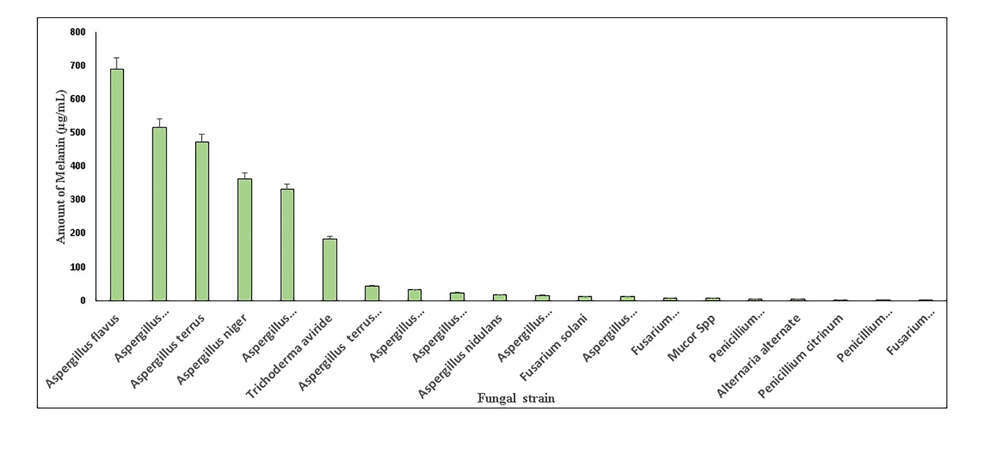
Fig. S1 Melanin productivity by the isolated fungal strains. Data are presented as mean ±SEM from three independent experiments P ≤ 0.05.

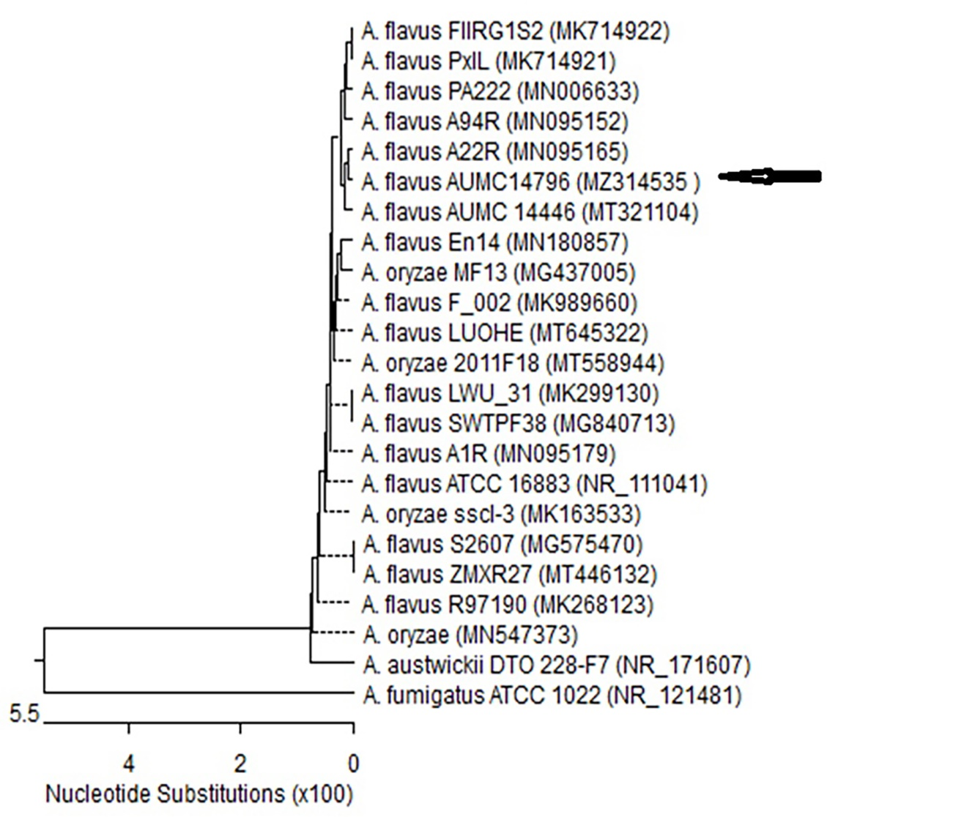
Fig. S2 Phylogenetic tree based on ITS sequences of 18S rDNA of the fungal strain isolated in the present study (AUMC14796-MZ314535, arrowed) aligned with closely related sequences accessed from the GenBank. (A. = Aspergillus).

