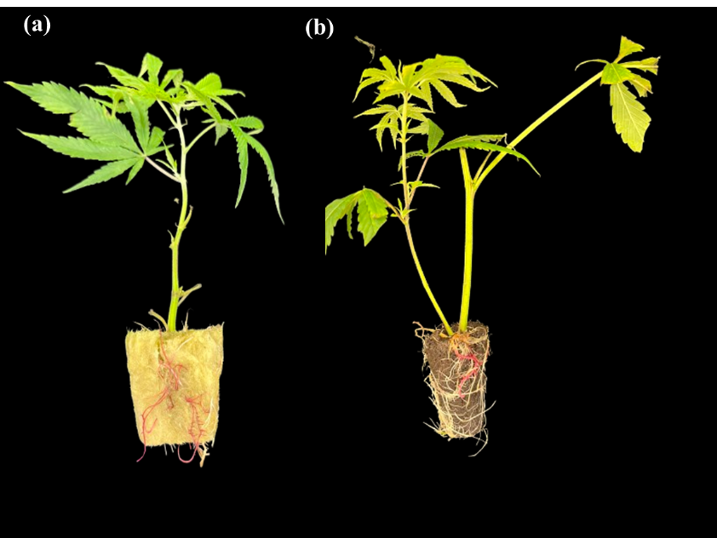
Figure S2. One-step hairy root induction and RUBY gene expression in cuttings of cannabis. (a) The emergence of red hairy roots in Rock wool and (b) Jiffy pot at the end of the experiment (30 day).

