Supporting Figures and Tables

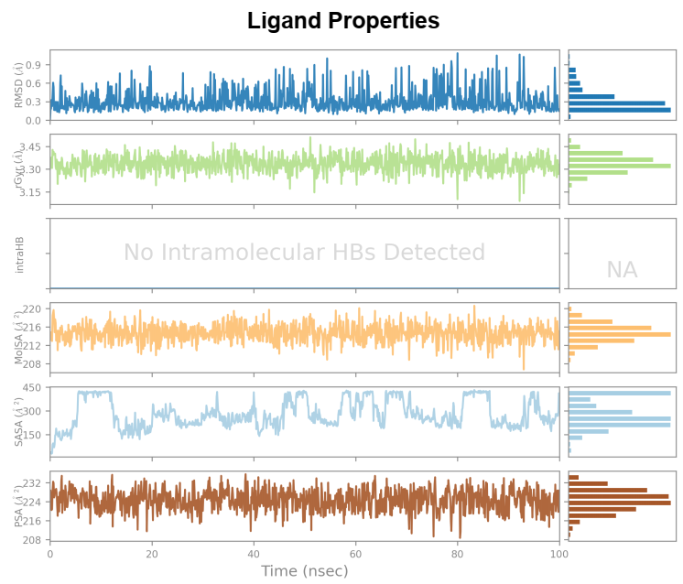
Figure S.1. Gemcitabine RMSD, Radius of gyration (rGyr), intramolecular hydrogen bonding, molecular surface area, solvent accessible surface area and polar surface area throughout MD simulations.

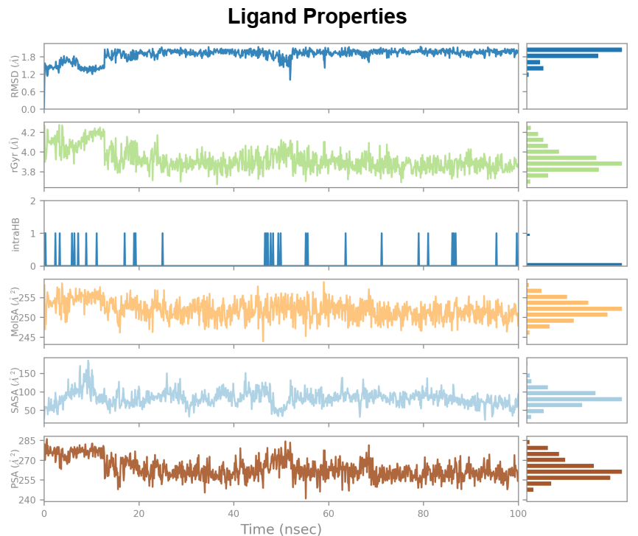

Figure S.2. Queuine RMSD, Radius of gyration (rGyr), intramolecular hydrogen bonding, molecular surface area, solvent accessible surface area and polar surface area throughout MD simulations.
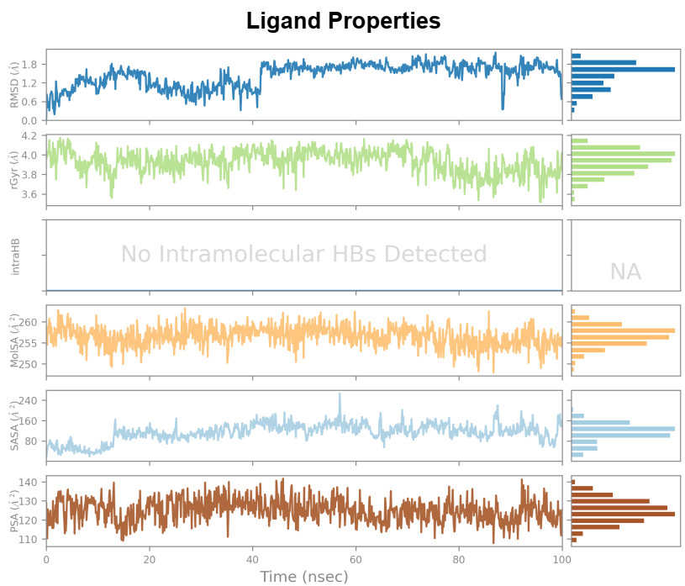

Figure S.3. Thiamine RMSD, Radius of gyration (rGyr), intramolecular hydrogen bonding, molecular surface area, solvent accessible surface area and polar surface area throughout MD simulations.

Table S.1. More ADME parameters for the investigated ligands

Molecule  name | Gastrointestinal absorption (GI) | CYP1A2  inhibitor | CYP2C19 inhibitor | CYP2C9 inhibitor | CYP2D6 inhibitor | CYP3A4 inhibitor | Pgp inhibitor
Gemcitabine | high | no | no | no | no | no | no
Queuine | low | no | no | no | no | no | no
Thiamine | high | no | no | no | no | no | no

Table S.2. More Toxicity parameters for the investigated ligands

Molecule  name | Mouse carcinogenicity | Rat carcinogenicity | Acute oral toxicity | Neuro toxicity | hERG 1-10uM | Respiratory toxicity | Acute dermal toxicity
Gemcitabine | 92% toxic | %70 toxic | %93 toxic | non toxic | non toxic | 83% toxic | %92 toxic
Queuine | 51% (non-toxic) | 45% toxic | 78% toxic | non toxic | non toxic | 79% toxic | %90 toxic
Thiamine | 38% (non-toxic) | 23% (non-toxic) | 26% (non-toxic) | non toxic | non toxic | 70% toxic | 82% toxic

