Supplementary material

Metagenomic Laccase-Catalyzed Crosslinking of Wheat Proteins for Enhanced Soybean Meal Nutritional Value: Applications in Poultry Feed and Food Industry
Tina Rouzbanª, Razieh Goudarzi^{b}, Elaheh Motamedi ^{c}, Marzieh Ghollasi ª*, Mehrshad Zeinalabedini^{b}, Shohreh Ariaeenejad^{b}*

ª Department of Cell and Molecular Biology, Faculty of Biological Sciences, Kharazmi University, Tehran, Iran.
^{b} Department of Systems and Synthetic Biology, Agricultural Biotechnology Research Institute of Iran (ABRII), Agricultural Research Education and Extension Organization (AREEO), Karaj Iran
^{c} Department of Nanotechnology, Agricultural Biotechnology Research Institute of Iran (ABRII), Karaj, Iran

Corresponding authors:
* Shohreh Ariaeenejad, email: shariaee@gmail.com; sh.ariaee@abrii.ac.ir
* Marzieh Ghollasi, email: ghollasi@khu.ac.ir

Table.S1. Table 1. Ingredients and basal diet composition.
Ingredients (%) | Age, days  29-42
Corn | 61.30
Soybean meal (44% CP) | 33.65
Oil | 1.00
Dicalcium phosphate | 1.30
Oyster shell, 38% Ca | 1.30
DL-Methionine | 0.30
L-lysine | 0.20
Common salt | 0.30
NaHCO3 | 0.15
*Micro ingredients premix | 0.50
Sum | 100
Calculated composition
Metabolizable energy (kcal/kg) | 2700
Crude Protein (%) | 18.00
Calcium (%) | 0.90
Available phosphorus (%) | 0.42
Lysin (%) | 0.98
Total Sulfur Amino Acid | 0.79
Sodium (%) | 0.18

* This premix supplied the following per kilogram of diet: vitamin A, 12,000 U; vitamin D3, 5000 U; vitamin E, 75 U; vitamin K3, 3 mg; thiamin, 3 mg; riboflavin, 8 mg; pantothenic acid, 13 mg; niacin, 55 mg; pyridoxine, 5 mg; folic acid, 2 mg; biotin, 0.2 mg; coline, 1600 mg;manganese, 120 mg; iron, 40 mg; copper, 16 mg; iodine, 1.25 mg; zinc, 100 mg; selenium, 0.3 mg.

S2. Determination of PersiLac2 Enzymatic Activity
The enzymatic activity of PersiLac2 was determined spectrophotometrically using 2,2′-azino-bis(3-ethylbenzthiazoline-6-sulfonic acid) (ABTS) as a substrate.
The reaction mixture contained 1 mL of 2 mM ABTS in 0.1 M acetate buffer (pH 5.0) and an appropriate amount of enzyme.
The increase in absorbance was recorded at 420 nm (ε = 36,000 M⁻¹cm⁻¹).
One unit (U) of enzyme activity was defined as the amount of enzyme required to oxidize 1 μmol of ABTS per minute under the assay conditions.

S3. Detailed Characteristics of the Metagenomic Laccase PersiLac2
1. Biological Source and Identification
The laccase enzyme PersiLac2 was identified from a soil-derived metagenomic library constructed from forest soil collected in northern Iran. The corresponding gene was cloned into the pET21a expression vector and expressed in Escherichia coli BL21 (DE3). The enzyme was purified using Ni-NTA affinity chromatography.
2. Molecular Weight
Nucleotide sequence of PersiLac2 was submitted to Gen bank Database with submission ID: 2456260 and the predicted molecular weight of PersiLac2 based on its amino acid sequence is approximately 40 kDa, which was confirmed by SDS-PAGE analysis.
3. Enzymatic Properties
Property | Value
Optimum pH | 5
Optimum Temperature | 45–50°C
Preferred Substrate | ABTS
K_{m} (for ABTS) | 0.23 mM
V_{max} (for ABTS) | 322.5 μmol·min⁻¹·mg⁻¹
k_{cat} | 412 s⁻¹
Catalytic Efficiency (k_{cat}/K_{m}) | 1791.3 s⁻¹·mM⁻¹
4. Expression and Purification
Expression of the enzyme was performed in E. coli with IPTG induction (1 mM, 16 h, 25°C). Purification using His-tag affinity chromatography yielded a single band on SDS-PAGE, confirming high purity.

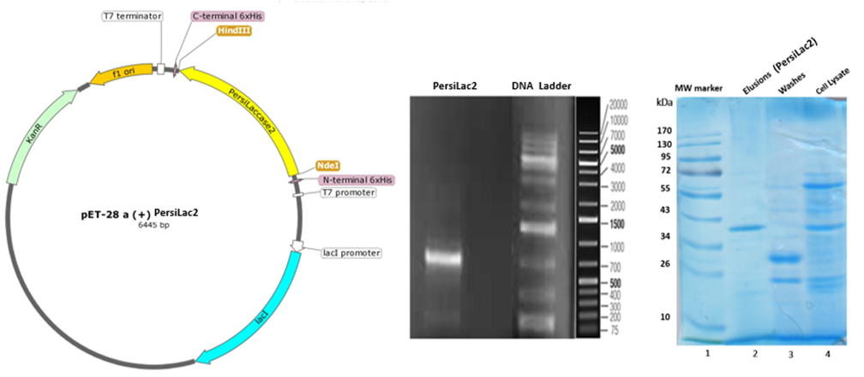
(b)
(a)
Fig. 1.
Fig. S1. (a) Schematic illustration map of the pET-28a (+) expression vector used in this study. The location of the inserted PersiLac2 gene and NdeI-HindIII restriction sites used is shown. (b) Purification was performed by Ni2-NTA chromatography. Fractions were resolved by SDS-PAGE using 12% polyacrylamide gels.

