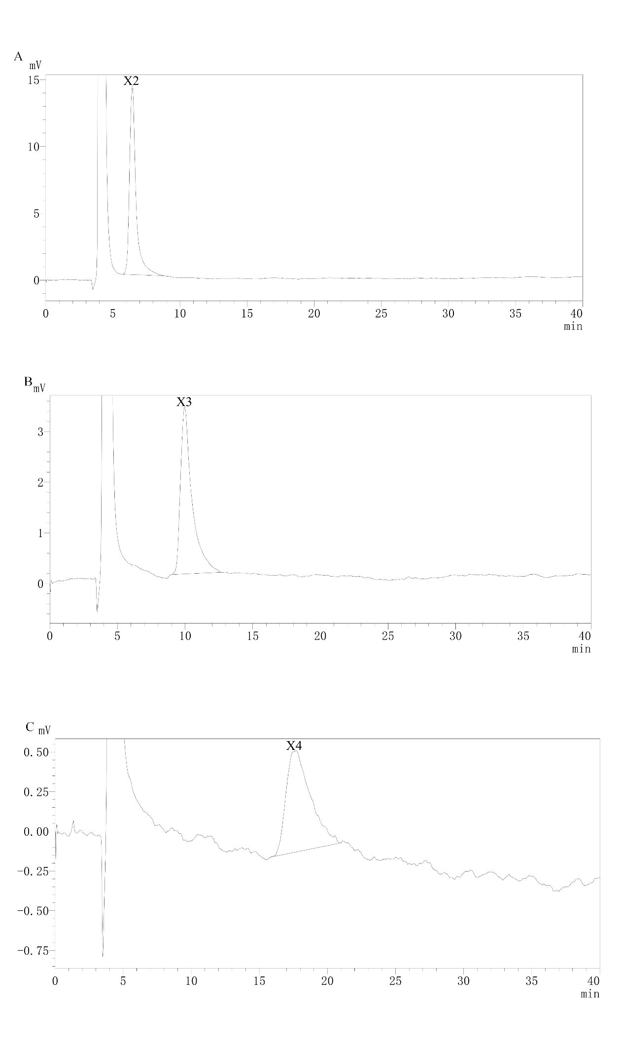
Supplementary Fig. S1 The HPLC chromatograms of individual standards (X2, X3, and X4)

Supplementary Fig. S2 HPLC mixed standards (X1–X4)

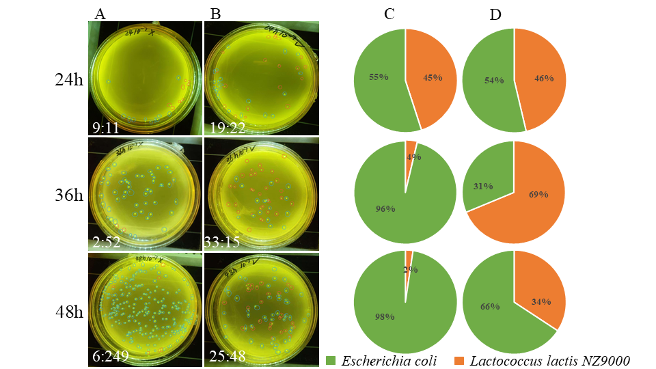
Supplementary Fig. S3 Effect of xylan hydrolysis products (prebiotics) of Lc-Xyn81 on the co-culture of intestinal microbiota.
Note:Column A&C represents the control group, and column B&D represents the experimental group with added prebiotics. Blue circles indicate Escherichia coli, and red circles indicate Lactobacillus species. The bottom left corner of column A&B shows the ratio of E. coli to Lactobacillus (eg;9:11 = L. lactis NZ9000: Escherichia coli). Columns C&D are pie charts of the percentage proportions of the two strains.

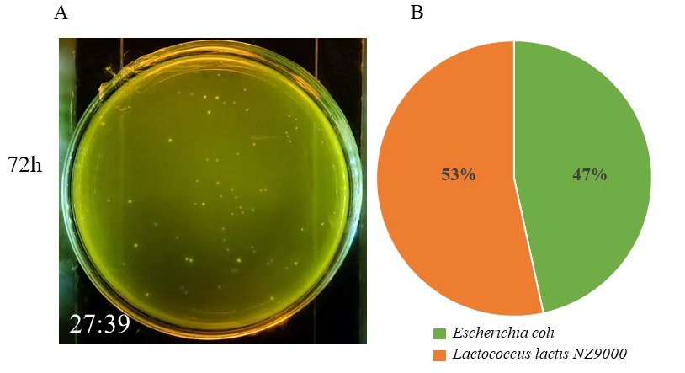
Supplementary Fig. S4 Effect of untreated xylan on the co-culture of intestinal microbiota
Note：The ratio of Escherichia coli to L. lactis NZ9000 is labeled at the bottom left corner of Column A (27:39 = L. lactis NZ9000: Escherichia coli), and Column B presents a pie chart showing the percentage composition of the two strains.
After co-culturing untreated xylan with Escherichia coli and Lactobacillus for 72 hours, the culture broth was diluted to 10⁻⁷ and spread on agar plates. It was observed that the number of Lactobacillus was slightly higher than that of E. coli, but the overall difference was not significant. In Supplementary Figure S1, the ratio of E. coli to Lactobacillus was 25:48 after 48 hours of co-culture, while the ratio changed to 27:39 at 72 hours. These results indirectly indicate that xylan can interfere with the growth of both Lactobacillus and E. coli. This supplementary data further validates the curve of "E. coli + L. lactis NZ9000 + untreated xylan" presented in Figure 7.

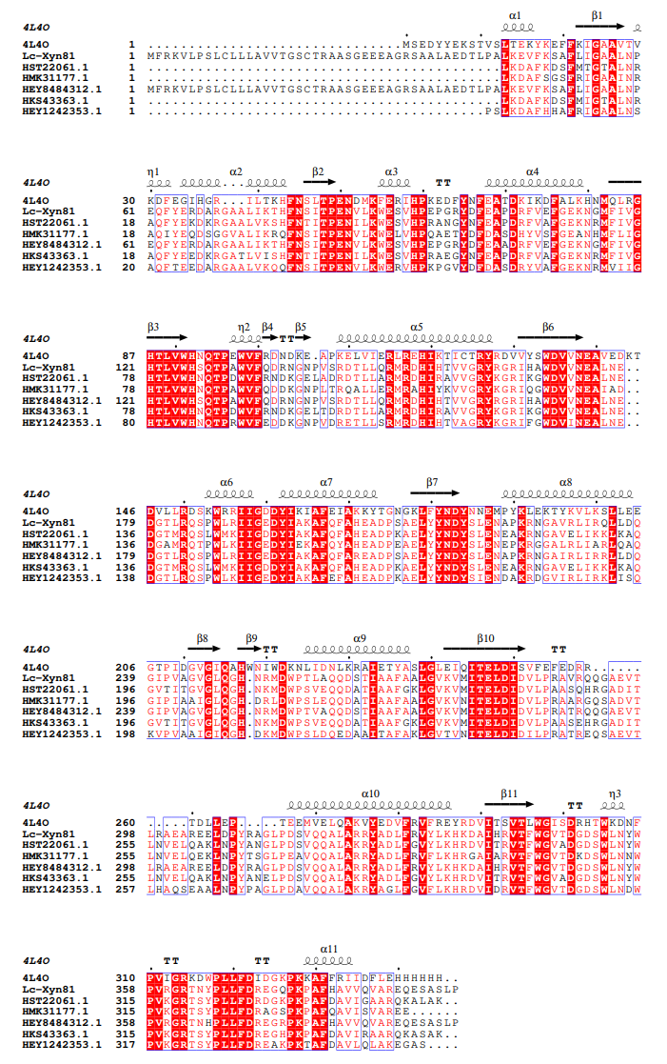
Supplementary Fig. S5 Multiple sequence alignment
Supplementary Table S1 Molecular docking parameters of Lc-Xyn81 and xylooligosaccharides
xylooligosaccharides | Molecular docking parameters
X2 | center_x = 7.945  center_y = 0.0  center_z = 0.0  size_x = 32.25  size_y = 39.0  size_z = 45.75
X3 | center_x = 4.142  center_y = 0.0  center_z = 0.0  size_x = 35.25  size_y = 42.75  size_z = 44.25
X4 | center_x = 8.034  center_y = -1.61  center_z = 2.828  size_x = 27.0  size_y = 38.25  size_z = 36.75
X5 | center_x = 5.668  center_y = 0.0  center_z = 1.12  size_x = 40.0  size_y = 42.0  size_z = 54.0

Supplementary Table S2 HPLC Data Summary Table
 |  | Retention time (min) | Peak height | Peak area | peak area percentage (%) | Concentration(mg/ml)
Mixed standards | X1 | 5.61 | 2113 | 45102 | 22.34 | 0.50
Mixed standards | X2 | 6.45 | 3335 | 95185 | 47.63 | 0.50
Mixed standards | X3 | 9.94 | 737 | 35876 | 19.98 | 0.50
Mixed standards | X4 | 17.60 | 167 | 18551 | 10.03 | 0.50
sample | X1 | - | - | - | - | -
sample | X2 | 6.45 | 3317 | 102568 | 13.44 | 0.54
sample | X3 | 9.96 | 4240 | 256977 | 33.68 | 3.58
sample | X4 | 14.07 | 4908 | 403452 | 52.87 | 10.87

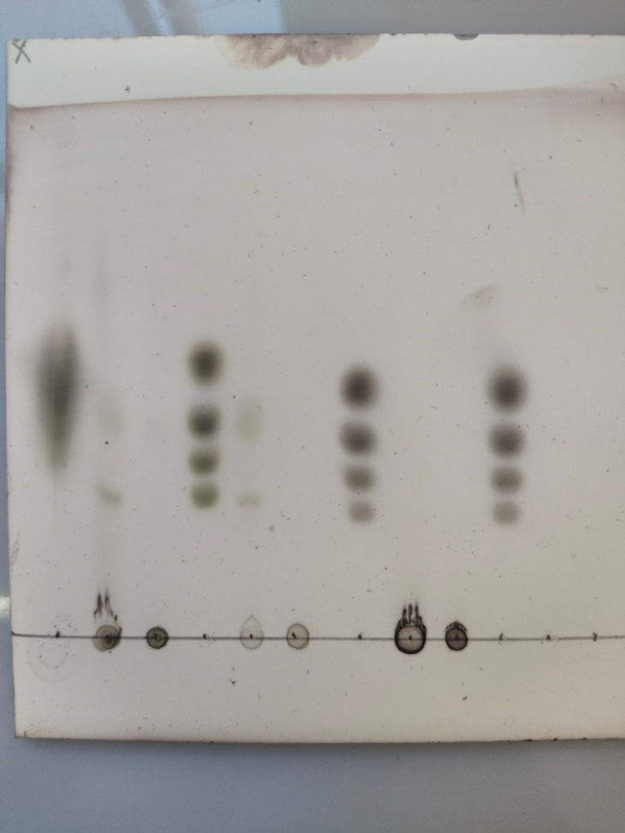
Blots or gels images
Original photo
Original photo
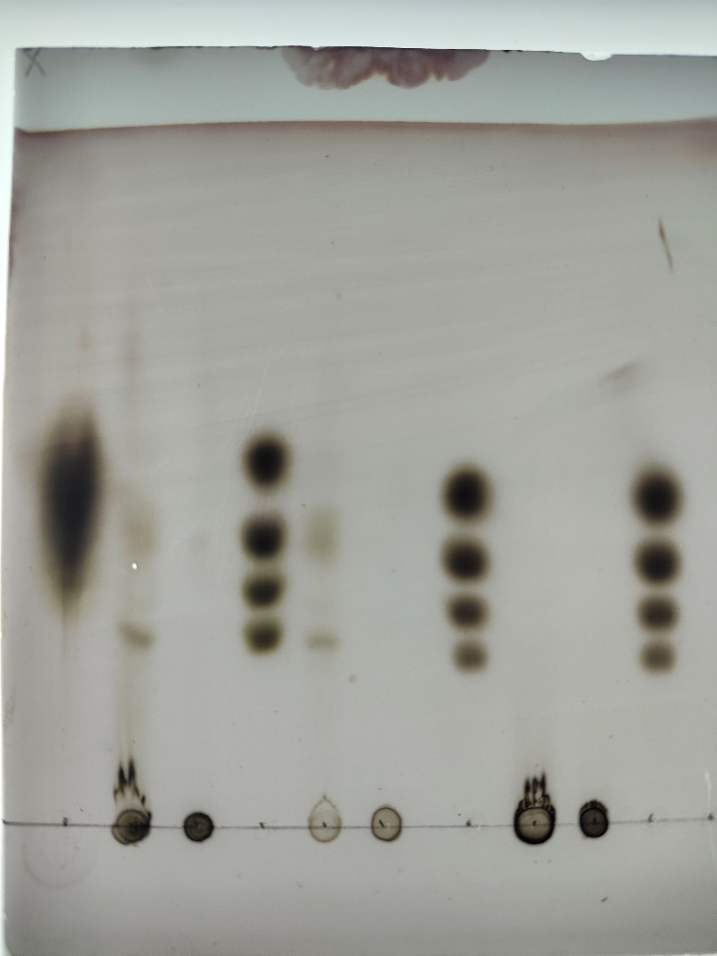
M
M
M
M
1
2
3
4
5
6
M:X1~X4.

1: Corncob xylan+LC-Xyn81

2: Corncob xylan+ LC-Xyn81( Inactivated enzyme)

3: Beechwood xylan +LC-Xyn81

4:Beechwood xylan + LC-Xyn81( Inactivated enzyme)

5: Bagasse xylan+LC-Xyn81

6:Bagasse xylan + LC-Xyn81( Inactivated enzyme)

Because the first standard sample did not perform well, the lanes 1, 2, 3 and 4 shared the second standard sample.
No oligosaccharide of xylose was detected in lane 5 and lane 6, so it was not included in the main text.

The above are TLC images without editing.
The following are TLC images with editing.

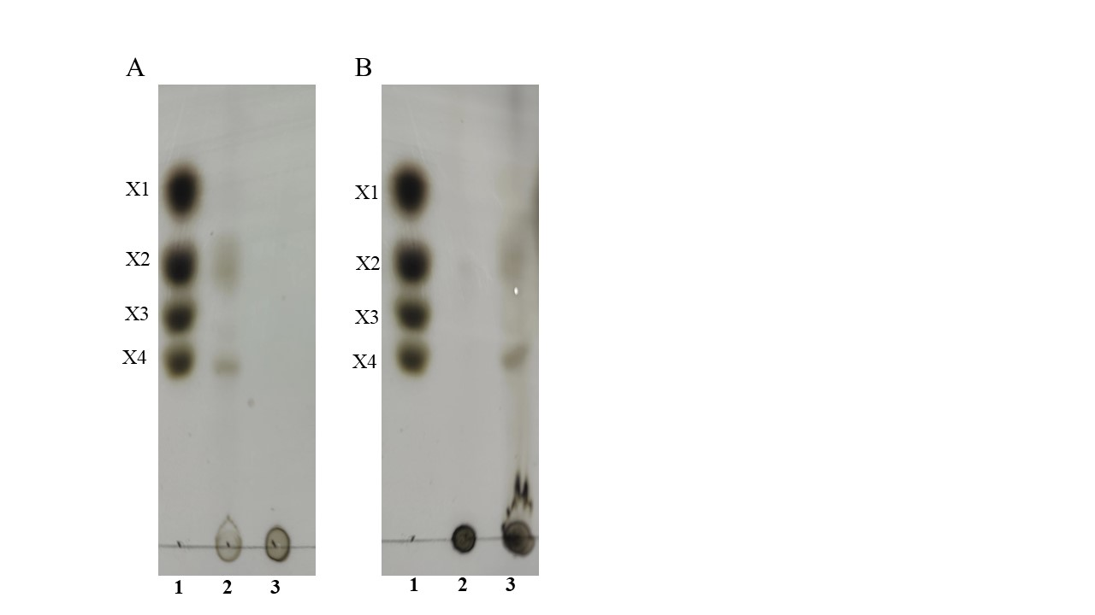

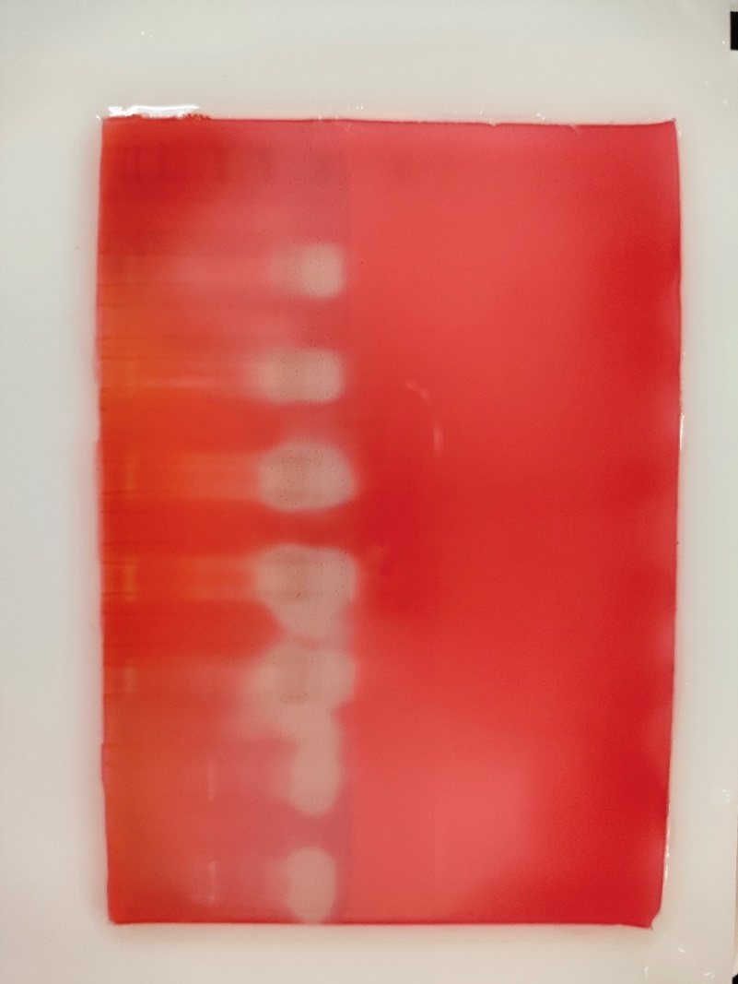
1
2
3
Other xylanases
5
4
1, 2, 3, 4 and 5 lanes all added LC-Xyn81, but the amount of xylanase added to each lane was different.

1：6 µl LC-Xyn81
2: 8 µl LC-Xyn81
3: 10 µl LC-Xyn81
4、5：15 µl LC-Xyn81

2
1

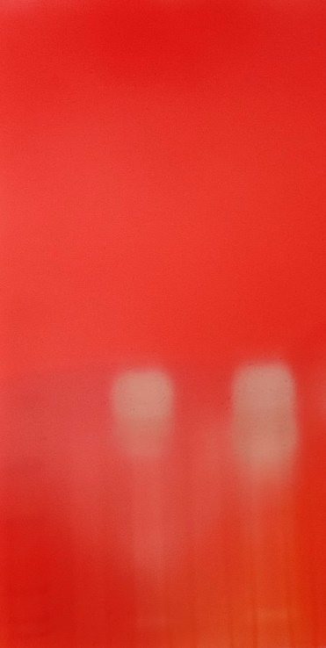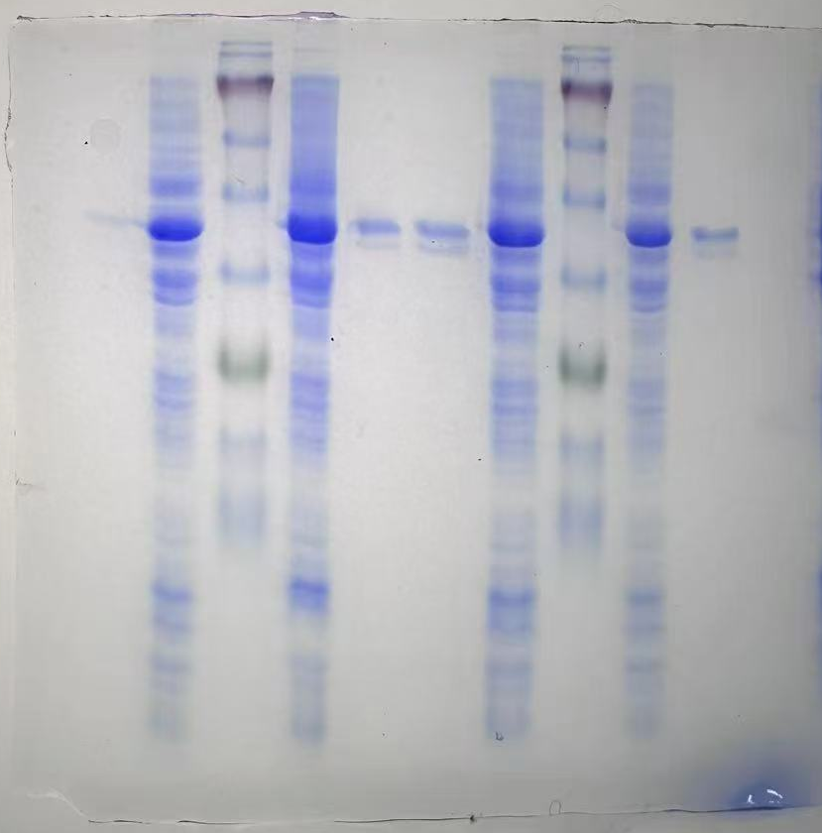

The above are zymogram and protein gel images without editing.
The following are zymogram and protein gel images with editing.

