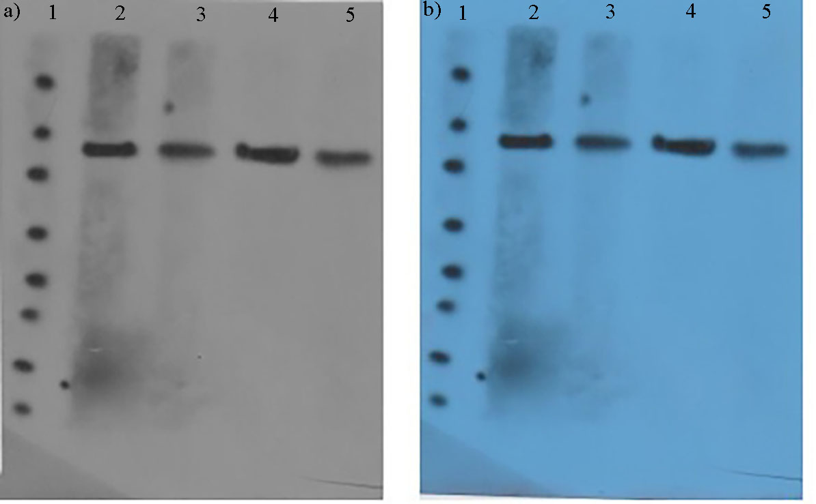

Supplementary Figure 1. Western blot analysis in a) gray scale and b) colored uncropped image. The effect of bisabolol oxide A-loaded nanoparticles (55.44 μg/mL) on the expression of β-catenin (line 2 and 3) and EGFR (line 4 and 5) in DU-145 cells. Line 1 is related to protein marker.
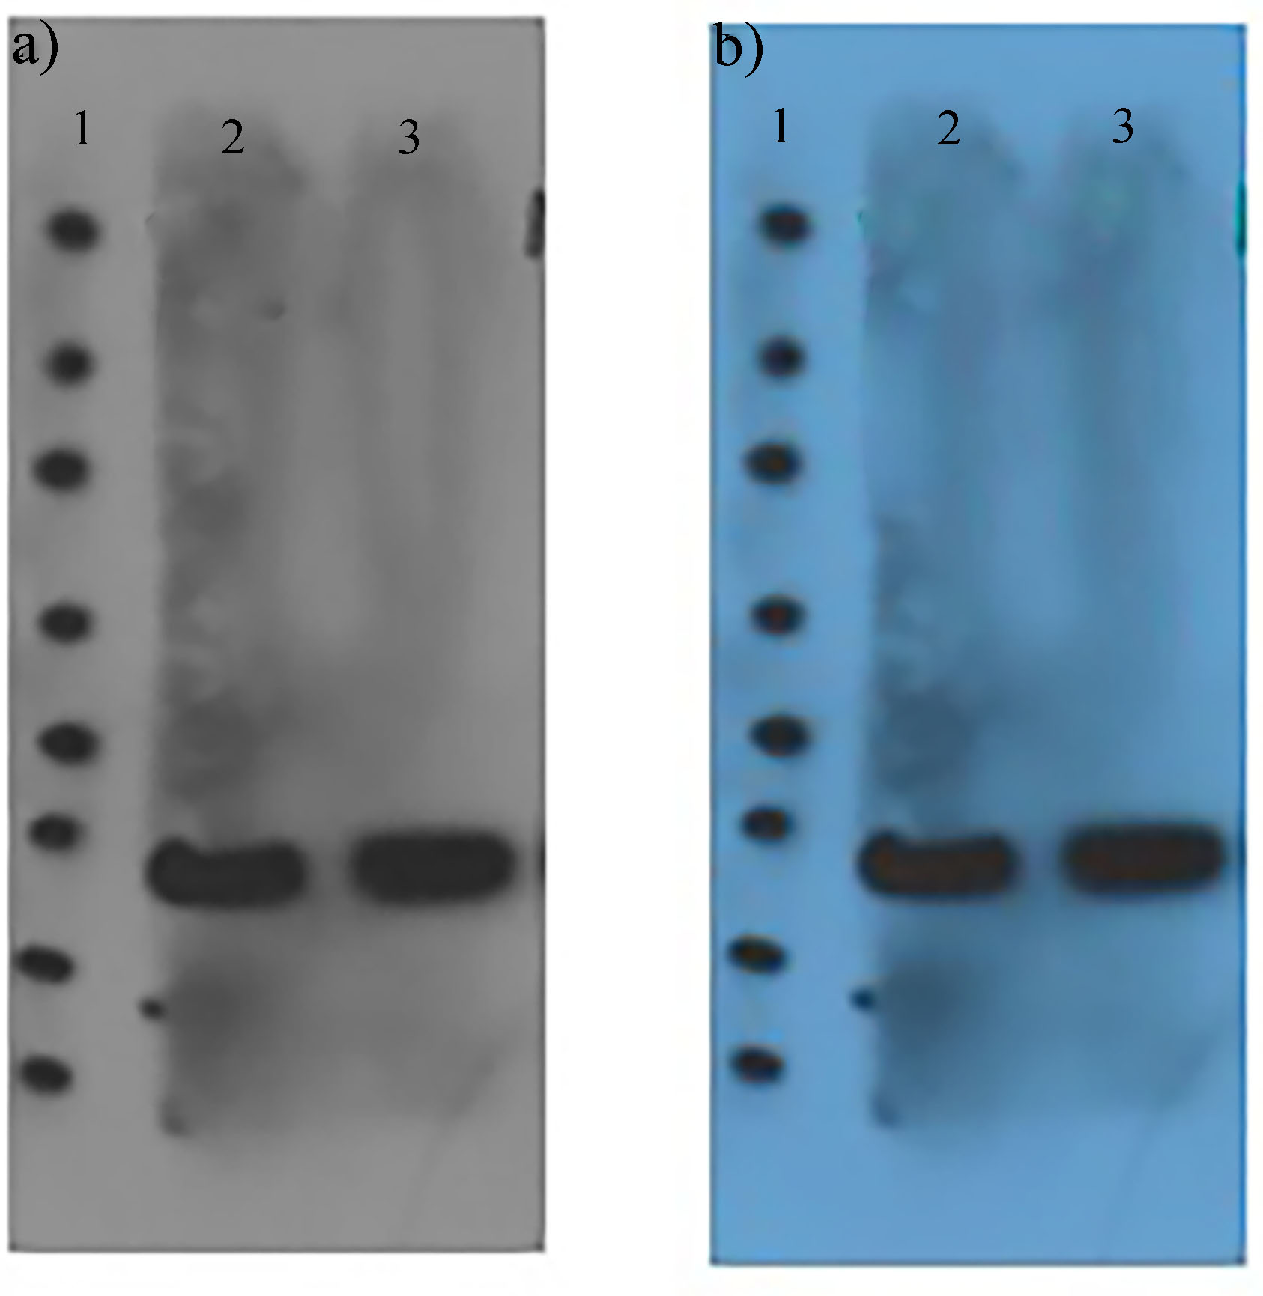
Supplementary Figure 2. Western blot analysis in a) gray scale and b) colored uncropped image. The effect of bisabolol oxide A-loaded nanoparticles (55.44 μg/mL) on the expression of GAPDH (line 2 and 3) in DU-145 cells. Line 1 is related to protein marker.

