Supplementary Material S9 Phylogenetic placement of generated NLR candidates among natural and experimentally characterised NLR proteins

S9.1 Sequence selection and NB-ARC domain extraction
Protein sequences for the generated candidates were obtained using the ORF-prediction and translation procedure described in Section 2.7. Of the 35 generated sequences classified as Complete NLRs by NLR-Annotator, 27 yielded protein sequences containing a high-confidence NB-ARC domain and passed the subsequent alignment-quality criteria. The reference panel comprised six natural Alnus glutinosa NLR homologs from the RefSeq assembly GCF_958979055.1 and four experimentally characterised plant NLRs: ZAR1, Sr35, ROQ1, and RPP1. Random and Non-NLR controls were not included because the phylogenetic analysis was restricted to generated candidates and reference NLRs that passed the predefined homologous NB-ARC domain and alignment-quality criteria.
NB-ARC domains were identified using hmmsearch in HMMER v3.3.2 against the Pfam PF00931 profile, with a domain E-value threshold of 1 × 10⁻⁵. For each protein, the best-scoring domain envelope was retained, and envelopes shorter than 150 amino acids were excluded. Identical NB-ARC sequences were collapsed using CD-HIT v4.8.1 with an identity threshold of 1.00. The final dataset contained 27 generated candidates, six natural A. glutinosa NLR homologs, and four experimentally characterised NLRs.

S9.2 Maximum-likelihood phylogenetic analysis
The retained NB-ARC amino-acid sequences were aligned using MAFFT v7.520 under the L-INS-i strategy (--localpair --maxiterate 1000). Ambiguously aligned and gap-rich positions were removed using trimAl v1.4.1 with the -gappyout option. Sequences containing more than 50% gaps after trimming were excluded. The final alignment contained 37 sequences and 168 amino-acid positions.
A maximum-likelihood tree was inferred using IQ-TREE v2.2.2.6. ModelFinder selected LG+F+R4 as the best-fit amino-acid substitution model under the Bayesian information criterion. Branch support was estimated using 1,000 SH-like approximate likelihood-ratio test replicates and 1,000 ultrafast bootstrap replicates. Because no unambiguous close outgroup was available, the tree was midpoint-rooted. Node labels are presented as SH-aLRT/UFBoot, and values are displayed only for branches meeting both thresholds of SH-aLRT ≥80% and UFBoot ≥95%. Branch lengths represent amino-acid substitutions per site.

S9.3 Phylogenetic placement of generated candidates
The maximum-likelihood tree contained 27 generated candidates, six natural Alnus glutinosa NLR homologs, and four experimentally characterised plant NLRs (Supplementary Figure S9.1). MGS-HCT_G070, MGS-HCT_G012, and MGS-HCT_G093 were positioned near the RPM1-like reference, while MGS-HCT_G058, MGS-HCT_G081, and MGS-HCT_G026 occurred within the broader branch containing the RGA4 reference. MGS-HCT_G008 and MGS-HCT_G091 were associated with the RPV1-like reference branch, and multiple candidates, including MGS-HCT_G019, MGS-HCT_G074, MGS-HCT_G015, MGS-HCT_G027, MGS-HCT_G082, and MGS-HCT_G059, were placed within the broader group containing the RUN1-like and TMV resistance protein N-like references.
Several branches containing both generated candidates and natural A. glutinosa homologs met the predefined support thresholds, including branches with SH-aLRT/UFBoot values of 85.0/97, 90.1/98, 89.2/98, and 94.8/99. Overall, the generated NB-ARC sequences were distributed across several clades containing natural A. glutinosa homologs and did not form a single candidate-only cluster. The four experimentally characterised NLRs formed a separate supported cross-species reference branch. These placements are consistent with NLR-family NB-ARC sequence variation but do not demonstrate orthology, identical pathogen-recognition specificity, biochemical activity, or disease-resistance function.
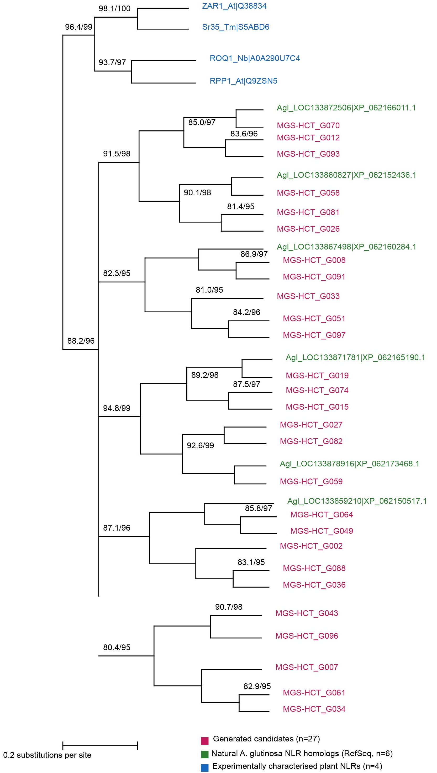
Figure S9.1. Maximum-likelihood phylogeny of NB-ARC domains from generated candidates and reference NLRs.
The tree contains 27 MGS-HCT-generated candidates, six natural Alnus glutinosa RefSeq NLR homologs, and four experimentally characterised plant NLRs, giving 37 sequences in total. NB-ARC domains were aligned using MAFFT v7.520, and ambiguously aligned or gap-rich positions were removed using trimAl v1.4.1, leaving 168 amino-acid positions. The maximum-likelihood tree was inferred using IQ-TREE v2.2.2.6 under the LG+F+R4 substitution model selected by ModelFinder. Node labels show SH-aLRT/UFBoot support values based on 1,000 replicates each and are displayed only when SH-aLRT ≥ 80% and UFBoot ≥ 95%. The tree was rooted at its midpoint, and the scale bar represents 0.2 amino-acid substitutions per site. Generated candidates, natural A. glutinosa homologs, and experimentally characterised NLRs are shown in magenta, green, and blue, respectively. Abbreviations: MGS-HCT, Multi-scale Gated Sparse Encoder–Hybrid Convolutional Transformer; RefSeq, Reference Sequence database of the National Center for Biotechnology Information; NLR, nucleotide-binding leucine-rich repeat; NB-ARC, nucleotide-binding adaptor shared by APAF-1, R proteins, and CED-4; MAFFT, Multiple Alignment using Fast Fourier Transform; SH-aLRT, Shimodaira–Hasegawa-like approximate likelihood-ratio test; UFBoot, ultrafast bootstrap. LG+F+R4 denotes the LG substitution matrix with empirical amino-acid frequencies and a four-category FreeRate model.
Table S9.1. Sequence groups included in the NB-ARC phylogenetic analysis.
Group | n | Identifiers or accessions
Generated candidates | 27 | MGS-HCT_G002, G007, G008, G012, G015, G019, G026, G027, G033, G034, G036, G043, G049, G051, G058, G059, G061, G064, G070, G074, G081, G082, G088, G091, G093, G096, and G097
Natural A. glutinosa NLR homologs | 6 | RPM1-like, XP_062166011.1; RGA4, XP_062152436.1; RPV1-like, XP_062160284.1; RUN1-like, XP_062165190.1; TMV resistance protein N-like, XP_062173468.1; RPP13-like protein 1, XP_062150517.1
Experimentally characterised plant NLRs | 4 | ZAR1, Q38834; Sr35, S5ABD6; ROQ1, A0A290U7C4; RPP1, Q9ZSN5
Note: Generated candidates are identified using study-specific sequence labels and do not have public database accessions. The six A. glutinosa entries are RefSeq-predicted natural NLR homologs and should not be described as experimentally characterised proteins.

