Supplementary Information

Induction and sustainable production of cannabinoids in Cannabis sativa L. callus cultures using Yarrowia lipolytica biogenic silver nanoparticles

Fatemeh Pourbabaei ª, Farshad Darvishi ^{b,}*, Alireza Iranbakhsh ª, Erfan Mohammadi Bolbanabad ^{b}

ª Department of Biology, Science and Research Branch, Islamic Azad University, Tehran, Iran
^{b} Department of Microbiology, Faculty of Biological Sciences, Alzahra University, Tehran, Iran

*Corresponding author.
Farshad Darvishi, Department of Microbiology, Faculty of Biological Sciences, Alzahra University, Tehran, Iran. E-mail address: f.darvishi@alzahra.ac.ir; f.darvishi@ymail.com

Table S1 Primer sequences used for PCR amplification of THCAS, CBDAS, and 18s genes
Amplicon (bp) | Tm (°C) | Sequence (5′–3′) | Primer name
133 | 60 | CGTGGGTTGAAGCCGGAG |  | THCA-F
133 | 59 | CCATAGCCTCCTCCACTAAAGT |  | THCA-R
136 | 60 | GTGCAACAAACCCCGACTTC |  | 18s-F
136 | 60 | ATTTGAATGATGCGTCGCCG |  | 18s-R
173 | 60 | GCACGGGTGGACACTTTAGT |  | CBDA-F
173 | 60 | CCTCCACCACCACGTATAGC |  | CBDA-R

Note: Tm = melting temperature; bp = base pairs.

Table S2 Reaction components used for real-time PCR
Reagent | Volume (μL)
cDNA | 1.0
2× Real-Time PCR Master Mix with SYBR Green I | 7.5
Forward Primer | 0.2
Reverse Primer | 0.2
dH₂O | 6
Final Volume | 15

Note: µL = microliters; SYBR Green I is pre-mixed in the Master Mix (BIOFACT).

Table S3 Thermal cycling program for real-time PCR
Step | Time | Temperature (°C) | Cycles
Initial denaturation | 15 min | 95 | 1
Denaturation | 15 s | 94 | 40
Annealing | 40 s | 59 | 40
Extension | 40 s | 72 | 40

Note: PCR was performed for 40 cycles after initial denaturation.

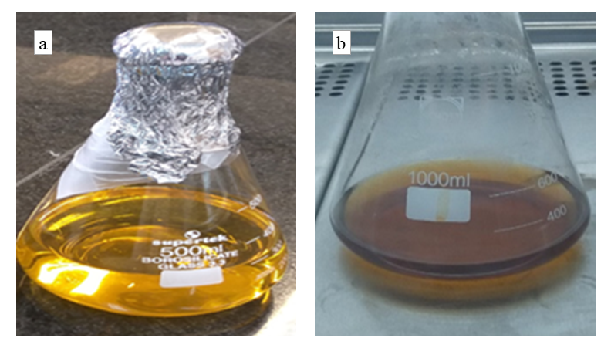

Fig. S1 Color change in YPD medium during the biosynthesis of silver nanoparticles by Yarrowia lipolytica. (a) Initial appearance of YPD medium containing 1 mM silver nitrate before inoculation. (b) Brown coloration of the medium after nanoparticle biosynthesis by the yeast, indicating the successful reduction of silver ions.

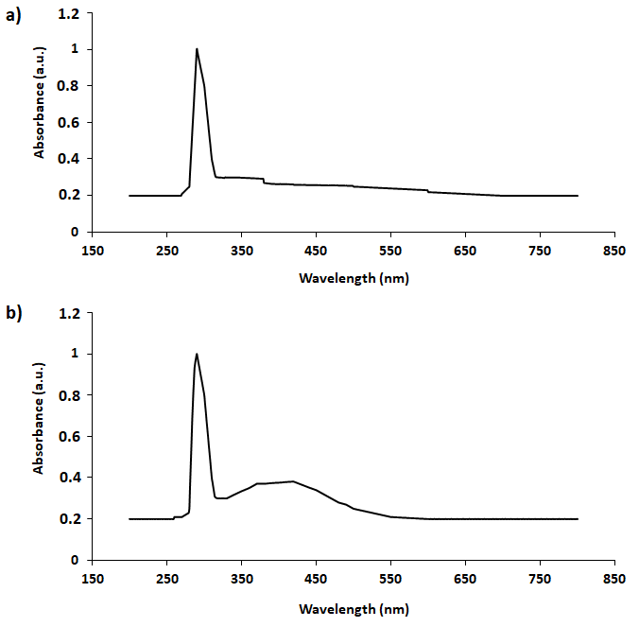
Fig. S2 Spectrophotometric analysis of silver nanoparticle biosynthesis by Yarrowia lipolytica. (a) Absorbance spectrum of YPD medium containing 1 mM silver nitrate without yeast inoculation (control). (b) Absorbance spectrum of the medium after inoculation with Yarrowia lipolytica, showing a distinct peak around 420 nm that indicates silver nanoparticle formation.

