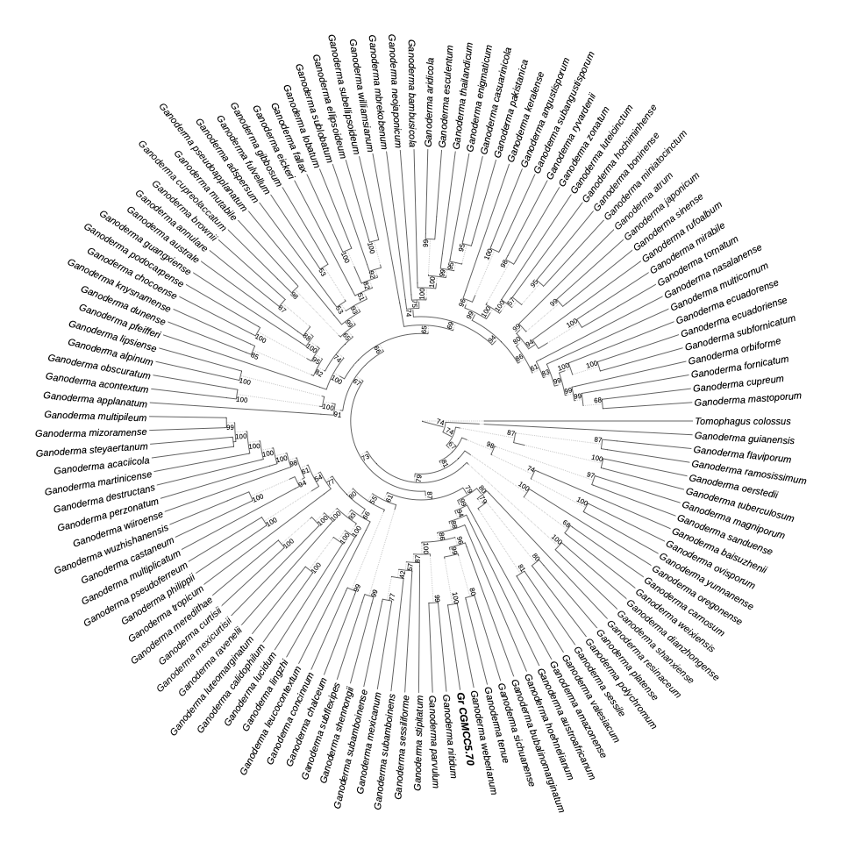
Figure S1. Maximum-likelihood phylogeny of the genus Ganoderma inferred from the concatenated ITS–LSU–rpb2–tef1 alignment (5,041 bp; 122 reference species plus strain CGMCC 5.70, shown in bold) in IQ-TREE 2 under partition-specific best-fit models, with Tomophagus colossus as the outgroup. Numbers at nodes are ultrafast bootstrap support values (%, 1,000 replicates). Strain CGMCC 5.70 is sister to G. weberianum (100%) within the G. resinaceum–G. weberianum lineage. GenBank accession numbers of all reference sequences are listed in Supplementary Table S1.

