Support Information
CRISPR/Cas9 induced disruption of oca2 and tyr genes associated with pigmentation in Danio rerio
Kriti Kumari, Gowhar Iqbal, S. S. Priyanka, N. C. Nidarshan, Kiran D Rasal*, Arvind A. Sonwane, Manoj P. Brahmane, Megha Bedekar, Paramita Banerjee Sawant, Mukunda Goswami
ICAR-Central Institute of Fisheries Education, Maharashtra, Mumbai, 400 061, India
Correspondence: Kiran Rasal, kiranrasal@cife.edu.in
Division of Fish Genetics and Biotechnology,
ICAR-Central Institute of Fisheries Education, Mumbai, 400061, India.

Supplementary Material 1
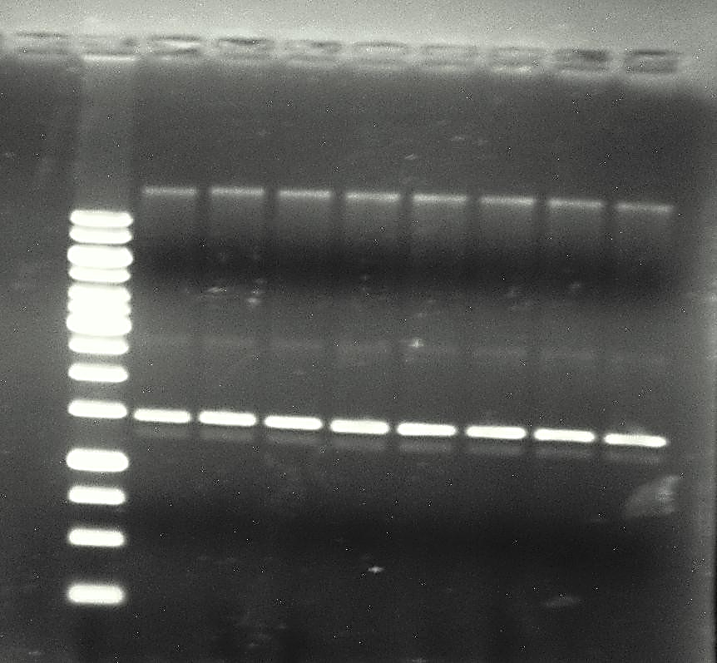
M
1
2
3
4
5
6
7
8

Figure_5 Agarose gel electrophoresis of isolated plasmid DNA. Lanes 1 - 8: Isolated plasmids from selected colonies; Lane M: Generular 1kb+ ladder (Thermo Fisher Scientific)
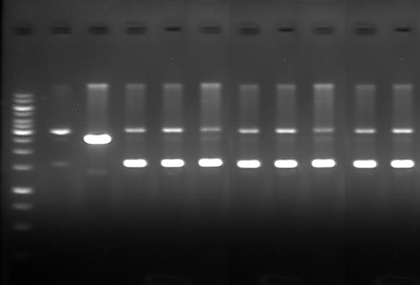
1 2 3 4 5 6 7 8 9 10 M

1 2 3 4 5
6 7 8
9 10 M

Figure_6 Gel image showing SalI digestion screening. Lane 1–8: Undigested plasmids; Lane 9: SalI-digested plasmid; Lane 10: control (Pt7vector); Lane M: Generular 1kb+ ladder (Thermo Fisher Scientific)
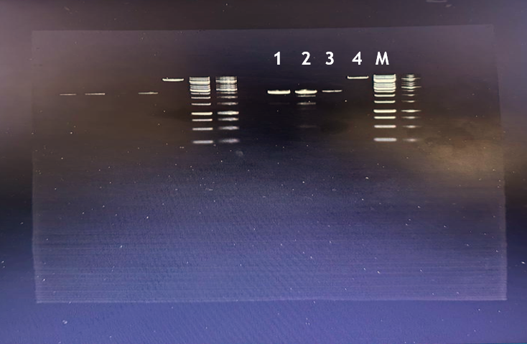

3
1
2
M

Figure_9 Linearized gRNA plasmid DNA (~2.6 kb); Lane 1: tyrosinase; Lane 2: oculocutaneous albinism II; Lane 3: tyrosinase; Lane 4: Negative control (undigested) Lane M: 1kb ladder (Thermo Fisher Scientific)

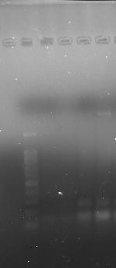
M
1 2

Figure_10 Purified gRNA transcript (~100 bp). Lane 1 and 2: tyrosinase and oculocutaneous
albinism II transcript; Lane M: 100bp ladder (Thermo Fisher Scientific)
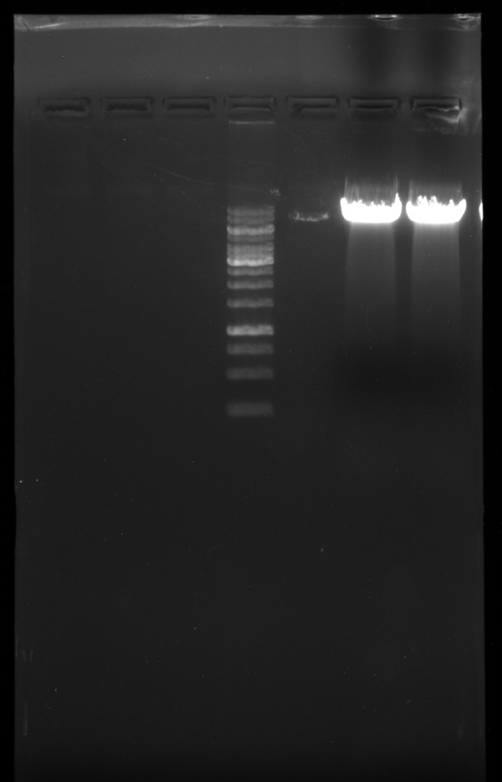
1 2
M

Figure_11 Linearized Cas9 plasmid DNA (~7.3kb). Lane 1: cas9; Lane M: Generular 1kb+ ladder (Thermo Fisher Scientific, USA)

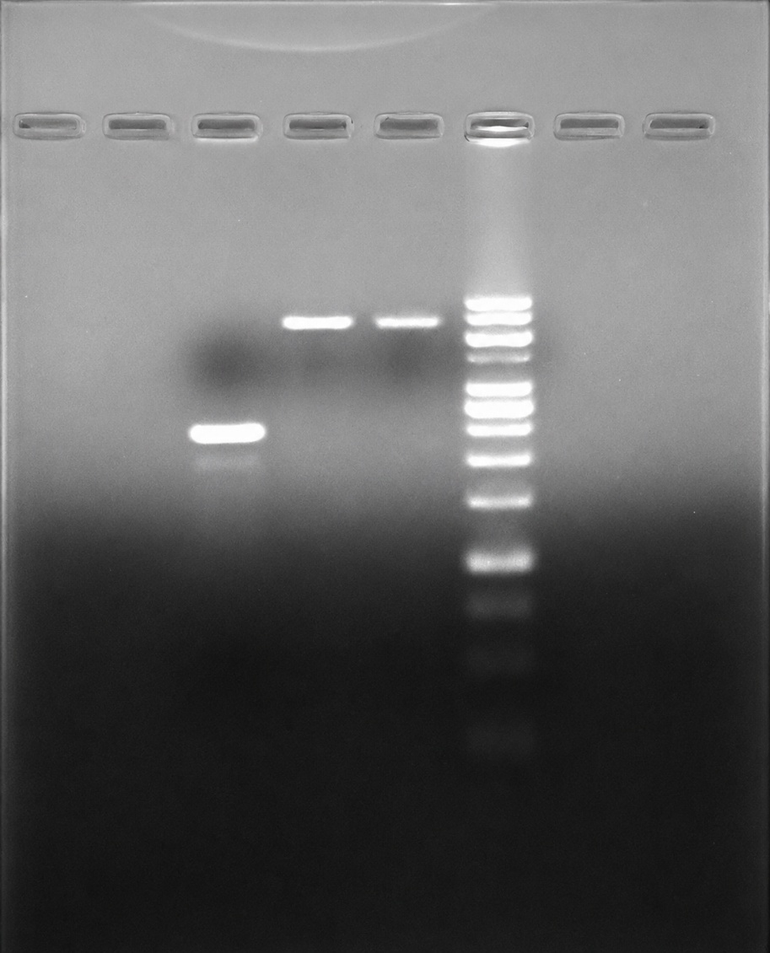
1 2 3 M

Figure_12 In vitro transcribed Cas9 template (~4.5 kb), Lane 1: transcribed cas9; Lane 2 and 3: non- transcribed Cas9; Lane M: GeneRuler 1kb+ ladder (Thermo Fisher Scientific, USA)

