Support Information
CRISPR/Cas9 induced disruption of oca2 and tyr genes associated with pigmentation in Danio rerio
Kriti Kumari, Gowhar Iqbal, S. S. Priyanka, N. C. Nidarshan, Kiran D Rasal*, Arvind A. Sonwane, Manoj P. Brahmane, Megha Bedekar, Paramita Banerjee Sawant, Mukunda Goswami
ICAR-Central Institute of Fisheries Education, Maharashtra, Mumbai, 400 061, India
Correspondence: Kiran Rasal, kiranrasal@cife.edu.in
Division of Fish Genetics and Biotechnology,
ICAR-Central Institute of Fisheries Education, Mumbai, 400061, India.

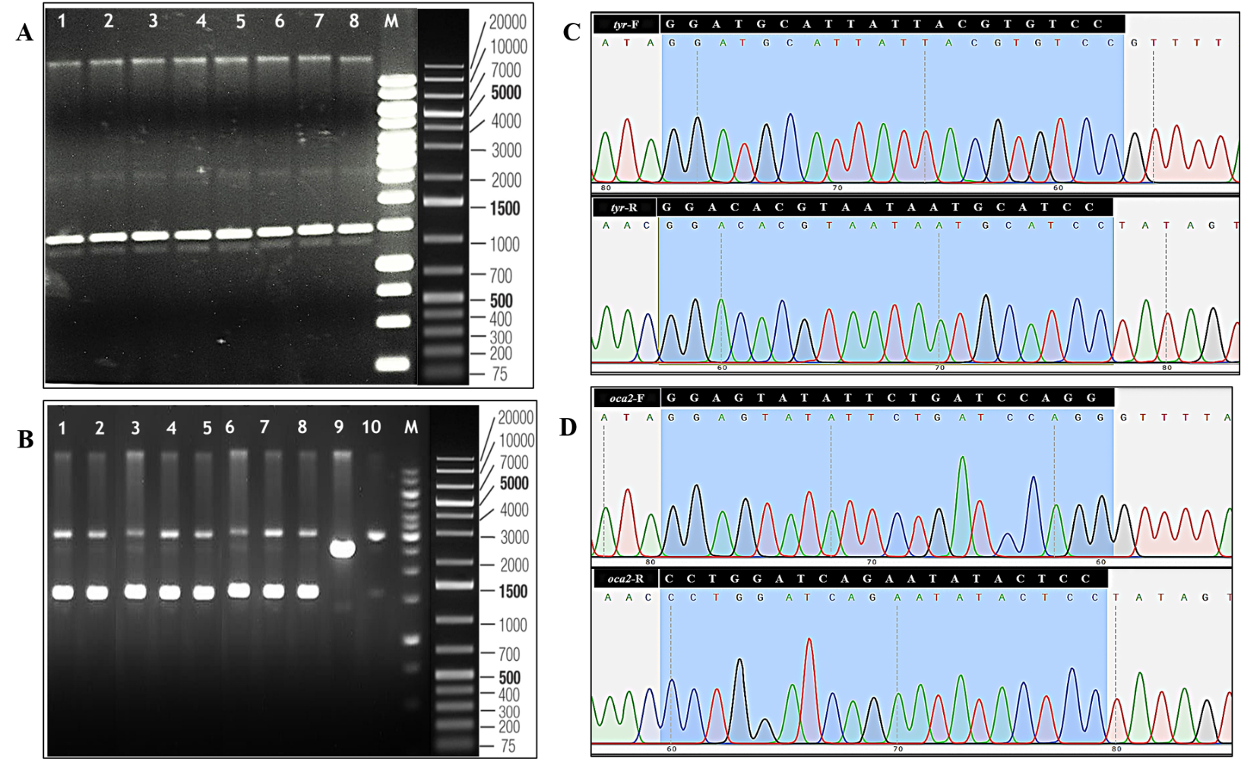
Supplementary Material 5
Figure_1 A Agarose gel electrophoresis of isolated plasmid DNA. Lanes 1 - 8: Isolated plasmids from selected colonies; Lane M: GeneRuler 1 kb+ ladder (Thermo Fisher Scientific). B Gel image showing SalI digestion screening. Lane 1-8: Undigested plasmids; Lane 9: SalI-digested plasmid; Lane 10: control (pT7 vector); Lane M: GeneRuler 1 kb+ ladder (Thermo Fisher Scientific). C Chromatogram of Sanger sequencing confirming the insert sequence. The sequence highlighted in blue shows the inserted oligo region, tyrosinase forward sequence (tyr-F), and tyrosinase reverse sequence (tyr-R). D Chromatogram of Sanger sequencing confirming the insert sequence. The sequence highlighted in blue shows the inserted oligo region, oculocutaneous albinism II forward sequence (oca2-F), and oculocutaneous albinism II reverse sequence (oca2-R).
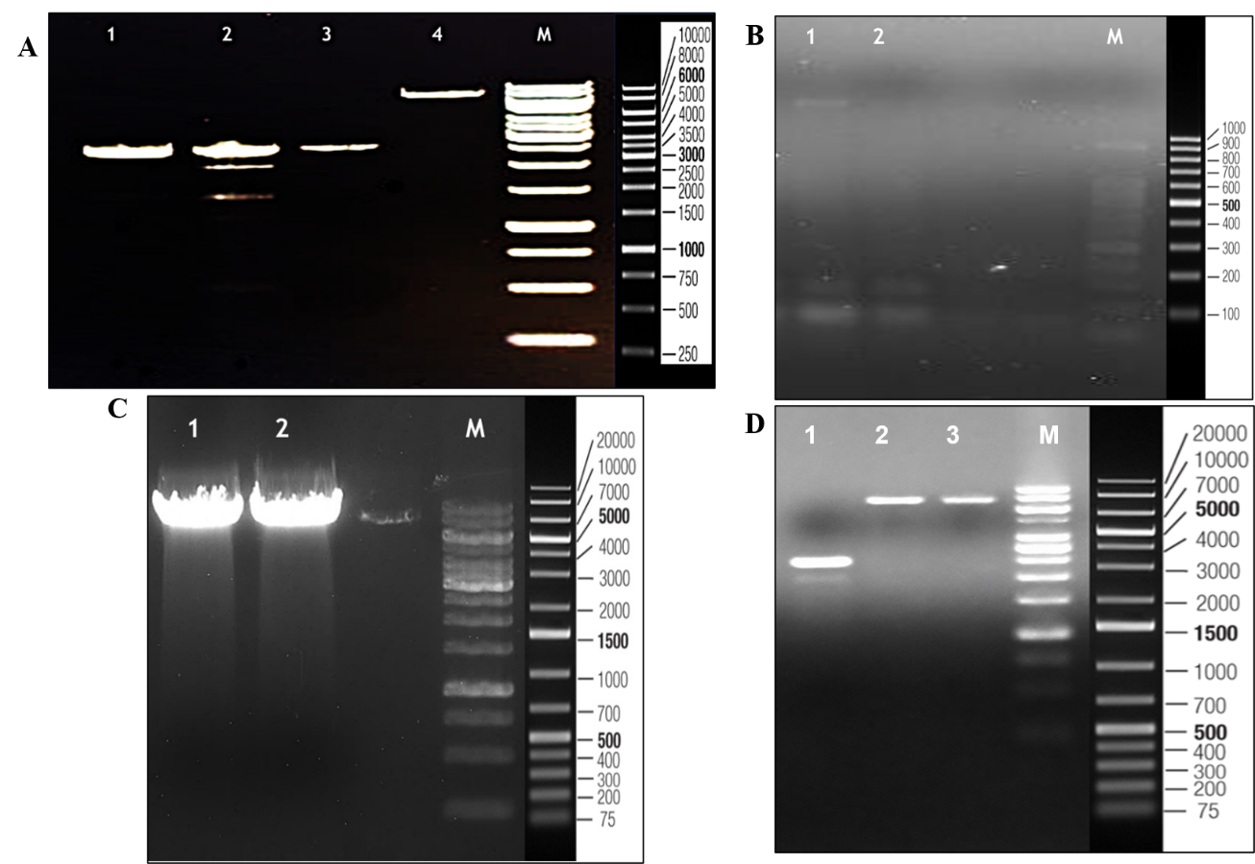

Figure_2 A Linearized gRNA plasmid DNA (~2.6 kb); Lane 1: tyrosinase; Lane 2: oculocutaneous albinism II; Lane 3: tyrosinase; Lane 4: Negative control (undigested); Lane M: 1kb ladder (Thermo Fisher Scientific). B Purified gRNA transcript (~100 bp). Lane 1 and 2: tyrosinase and oculocutaneous albinism II transcript; Lane M: 100bp ladder (Thermo Fisher Scientific). C Linearized Cas9 plasmid DNA (~7.3 kb). Lane 1: cas9; Lane 2: Cas9; Lane M: GeneRuler 1kb+ ladder (Thermo Fisher Scientific, USA). D In vitro transcribed Cas9 template (~4.5 kb), Lane 1: transcribed cas9; Lane 2 and 3: non- transcribed Cas9; Lane M: GeneRuler 1kb+ ladder (Thermo Fisher Scientific, USA).

