Support Information
CRISPR/Cas9 induced disruption of oca2 and tyr genes associated with pigmentation in Danio rerio
Kriti Kumari, Gowhar Iqbal, S. S. Priyanka, N. C. Nidarshan, Kiran D Rasal*, Arvind A. Sonwane, Manoj P. Brahmane, Megha Bedekar, Paramita Banerjee Sawant, Mukunda Goswami
ICAR-Central Institute of Fisheries Education, Maharashtra, Mumbai, 400 061, India
Correspondence: Kiran Rasal, kiranrasal@cife.edu.in
Division of Fish Genetics and Biotechnology,
ICAR-Central Institute of Fisheries Education, Mumbai, 400061, India.

Supplementary Material 6
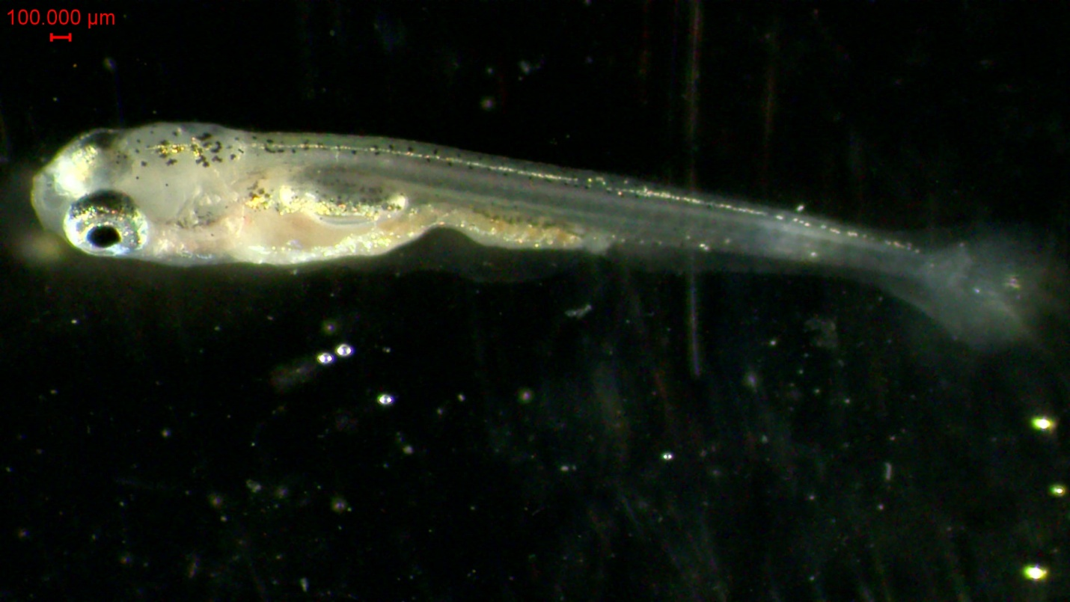
- Fo generation of wild-type (WT)Danio rerio at 4 days post-fertilization

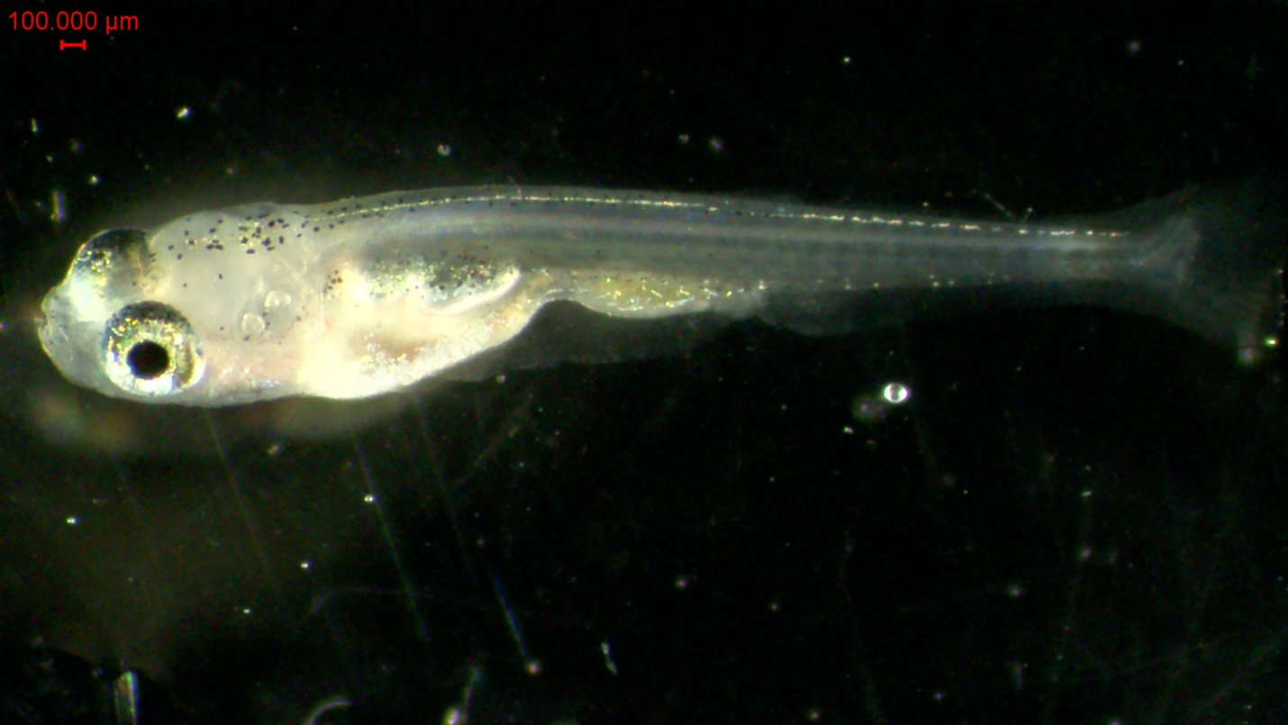
- Fo generation of tyrosinase-injected (T1) Danio rerio at 4 days post-fertilization

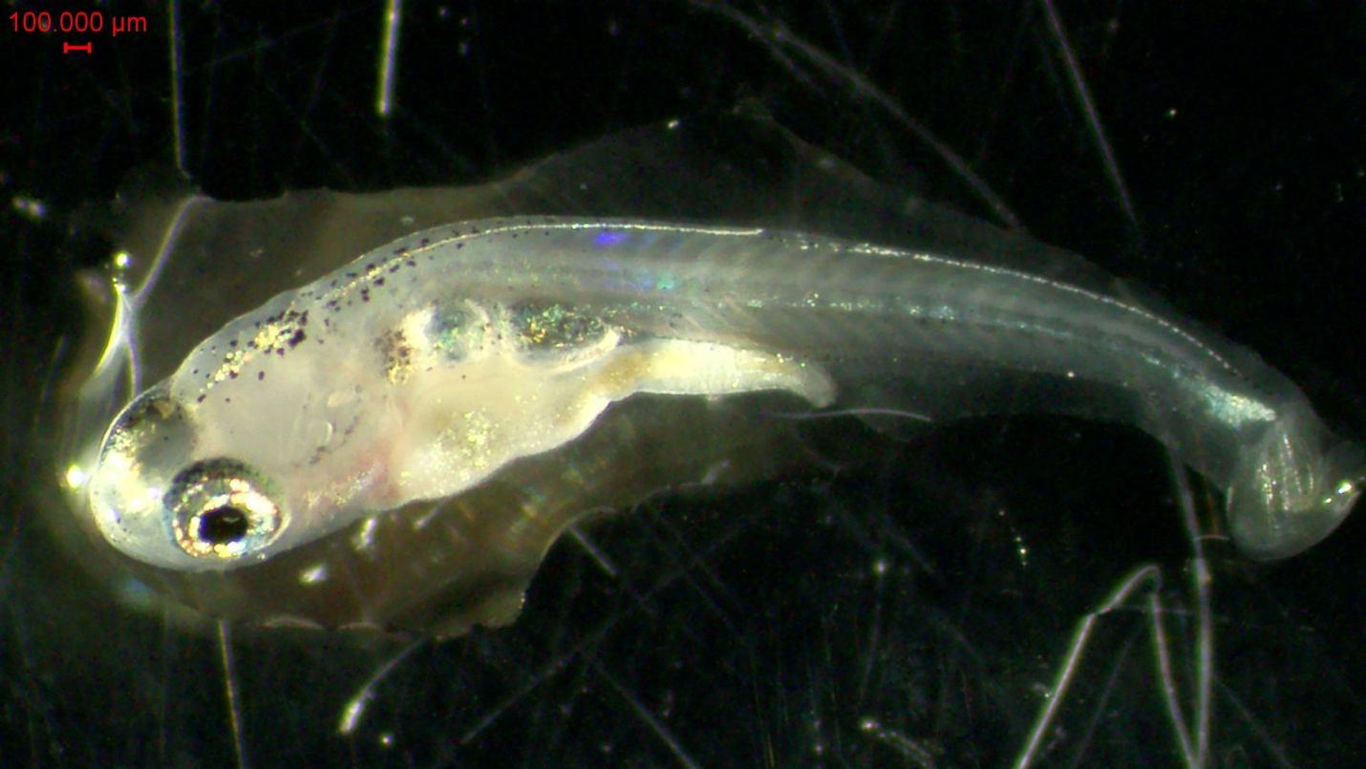
- Fo generation of oculocutaneous albinism II injected (T2) Danio rerio at 4 days post-fertilization
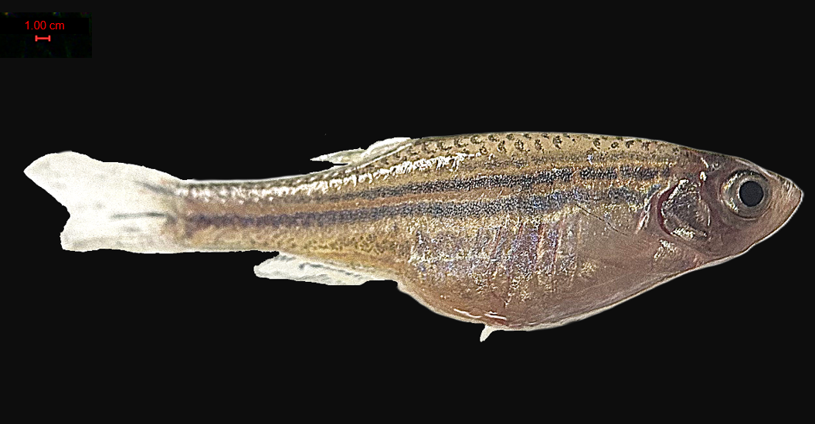
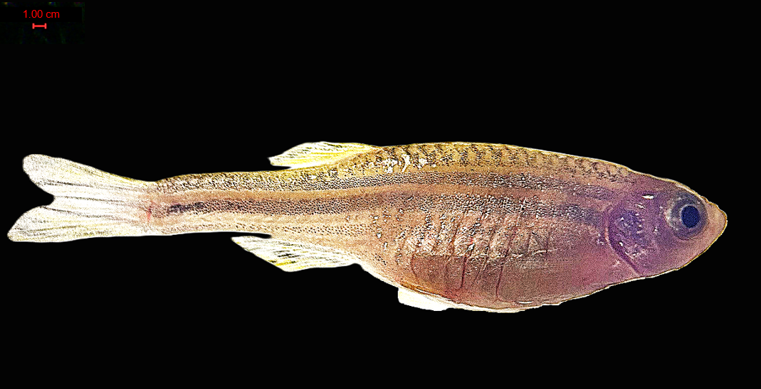
- Fo generation of wild-type (WT) Danio rerio at 60 days post-fertilization
- Fo generation of tyrosinase-injected (T1) Danio rerio at 60 days post-fertilization
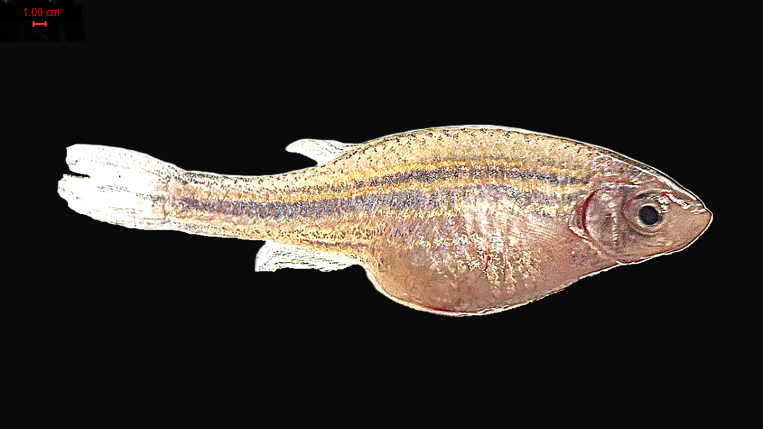
- Fo generation of oculocutaneous albinism II injected (T2) Danio rerio at 60 days post-fertilization
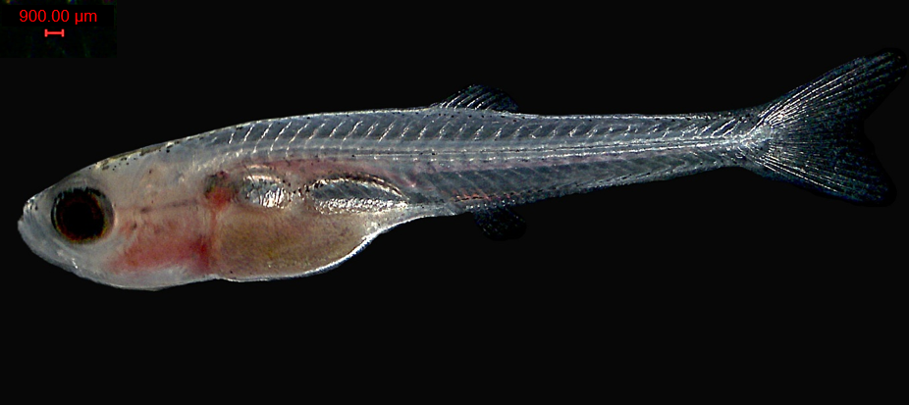
- F1 generation of wild-type (WT) Danio rerio at 30 days post-fertilization
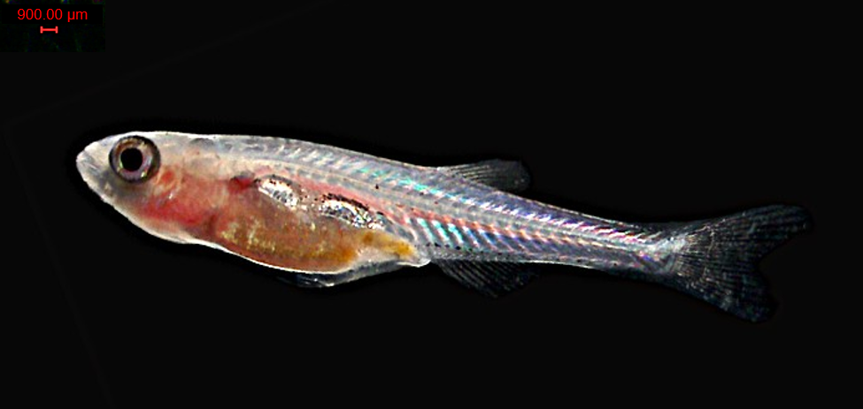
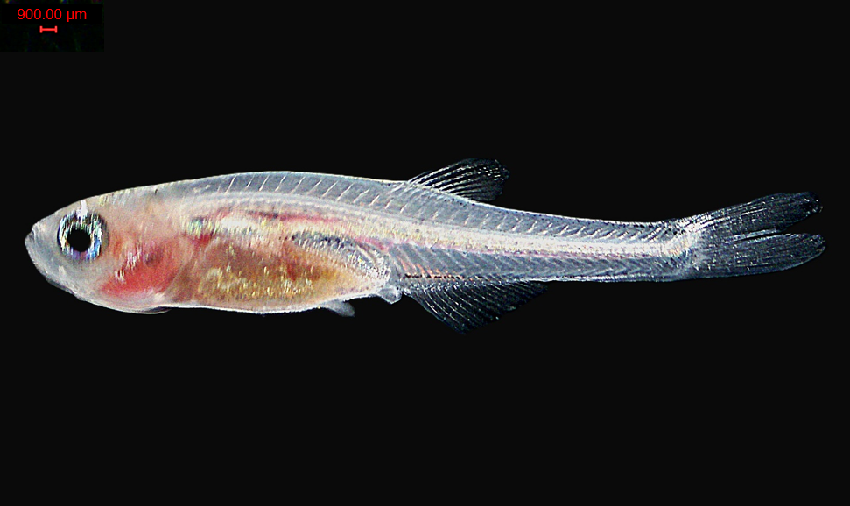
- F1 generation of tyrosinase-injected (T1) Danio rerio at 30 days post-fertilization

- F1 generation of tyrosinase-injected (T1) Danio rerio at 30 days post-fertilization

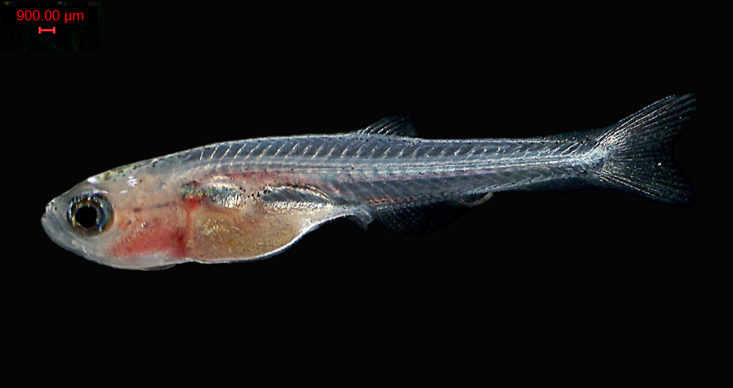
- F1 generation of oculocutaneous albinism II injected (T2) Danio rerio at 30 days post-fertilization
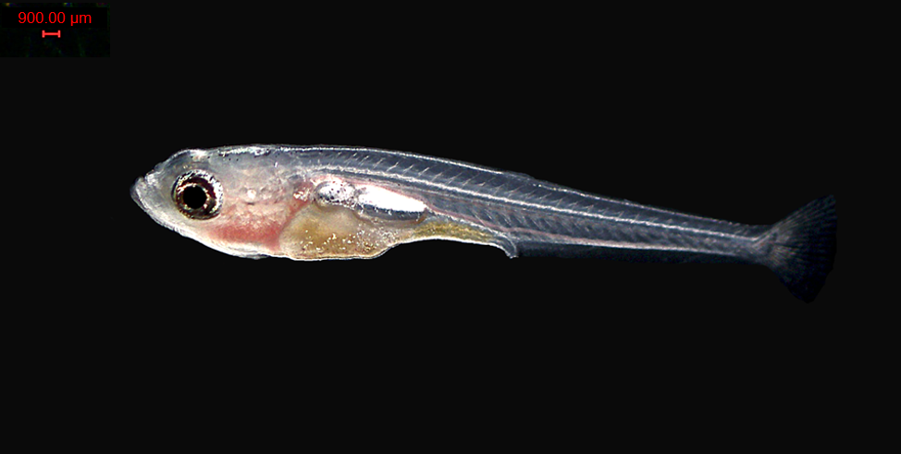
11. F1 generation of oculocutaneous albinism II injected (T2) injected Danio rerio at 30 days post-fertilization

