Additional File 2: Phylogenetic placements of undescribed Cryptococcus species

(i) Cryptococcus sp. 1

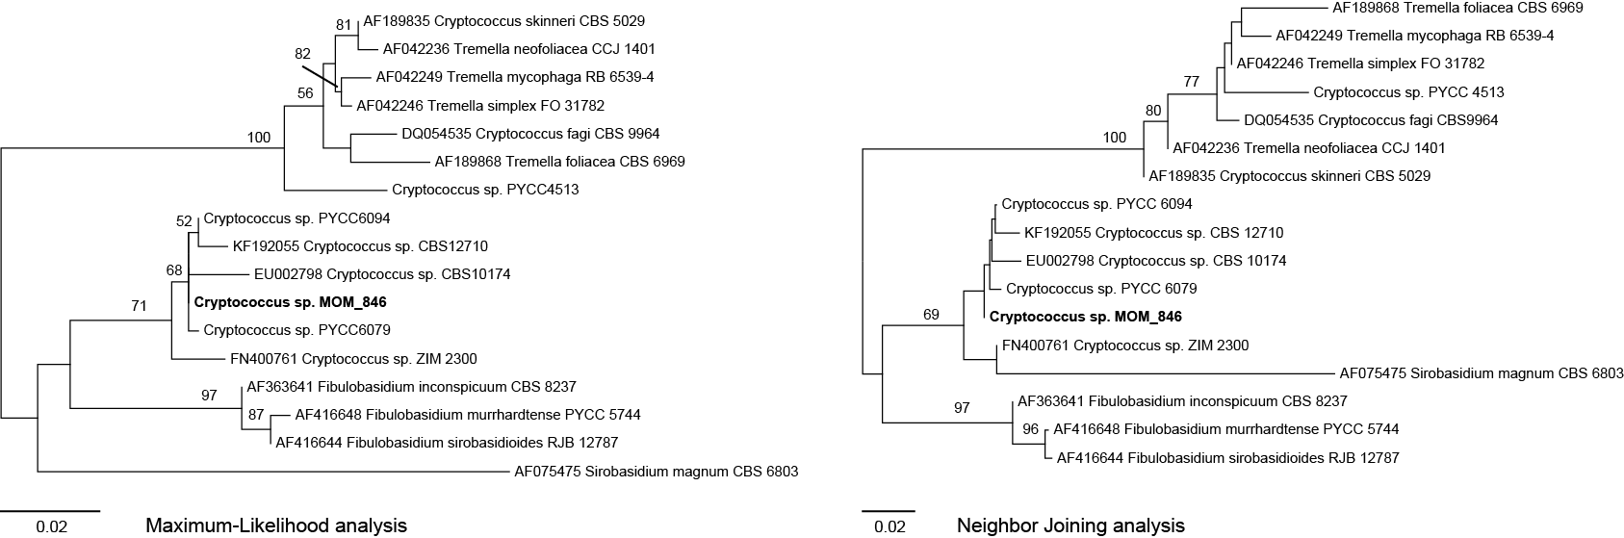

Isolate: MOM_846
GenBank: HG421439
Strain: DSM 27418
Phylogenetic placement: Sirobasidium-Fibulobasidium clade, Tremellales, Tremellomycetes, Agaricomycotina, Basidiomycota
Closest match: Cryptococcus sp. PYCC 6079 (http://pycc.bio-aware.com) with 99% similarity, including 2 nucleotides substitutions and 1 gap

(ii) Cryptococcus sp. 2

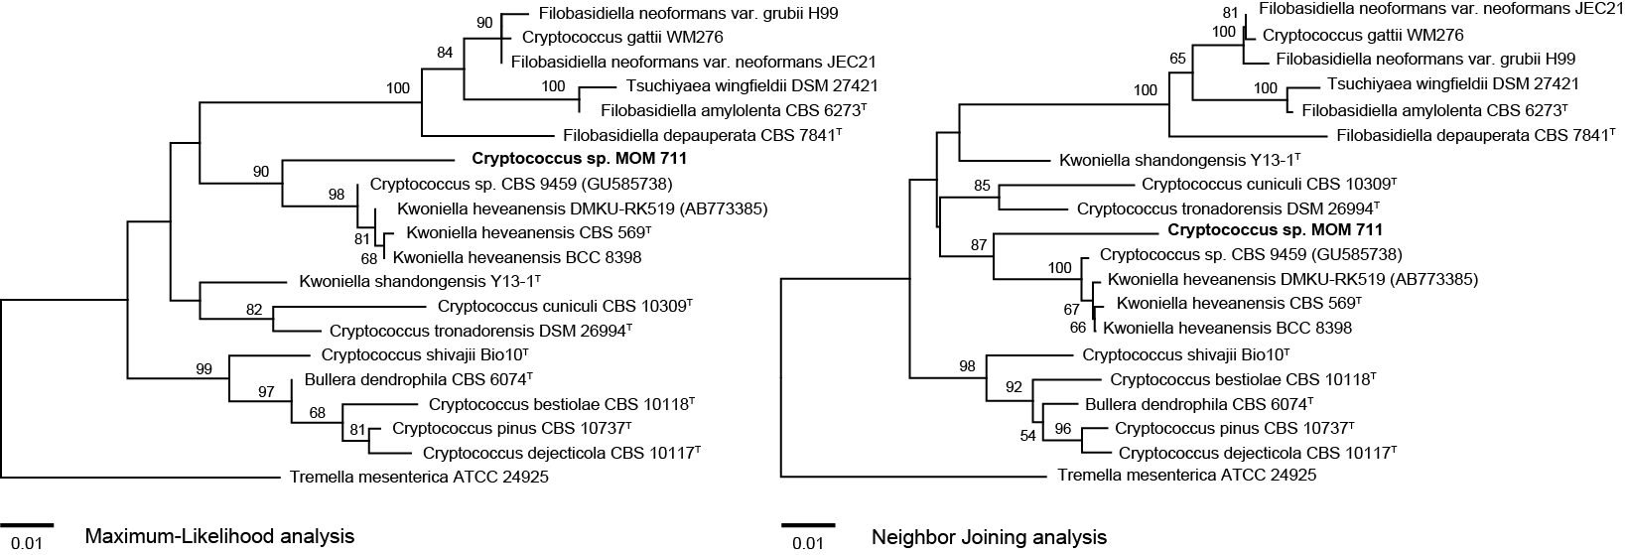

Isolate: MOM_711
GenBank: HG421441
Strain: DSM 27419
Phylogenetic placement: Kwoniella-Filobasidiella clade, Tremellales, Tremellomycetes, Agaricomycotina, Basidiomycota
Closest match: Cryptococcus sp. CBS 9459 (GU585738) with 95% similarity, including 26 nucleotides substitutions and 2 gaps

(iii) Cryptococcus sp. 3

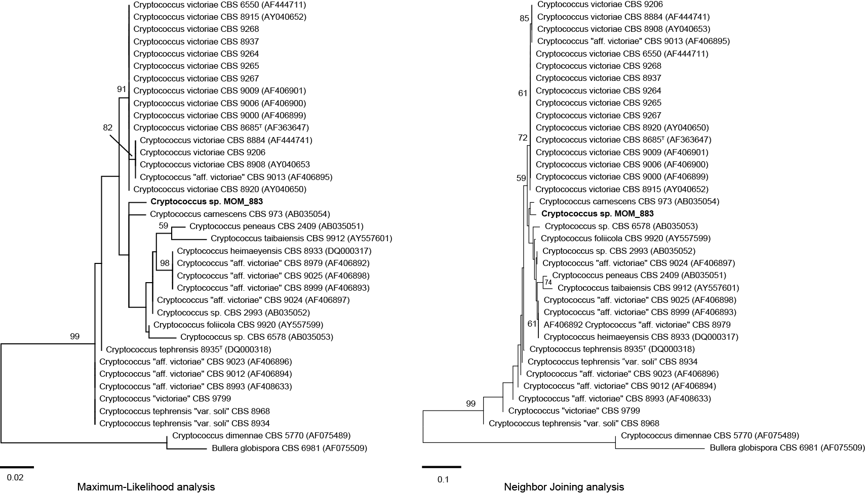

Isolate: MOM_883
GenBank: KM408428
Strain: DSM 29302
Phylogenetic placement: Victoriae clade, Tremellales, Tremellomycetes, Agaricomycotina, Basidiomycota (Text S2, Figure 1)
Closest match: Cryptococcus carnescens CBS 973 (AB035054) with 98% similarity, including 10 nucleotides substitutions
Further isolates in this study: MOM_743, MOM_747, MOM_748, MOM_808, MOM_836, MOM_838, MOM_839

