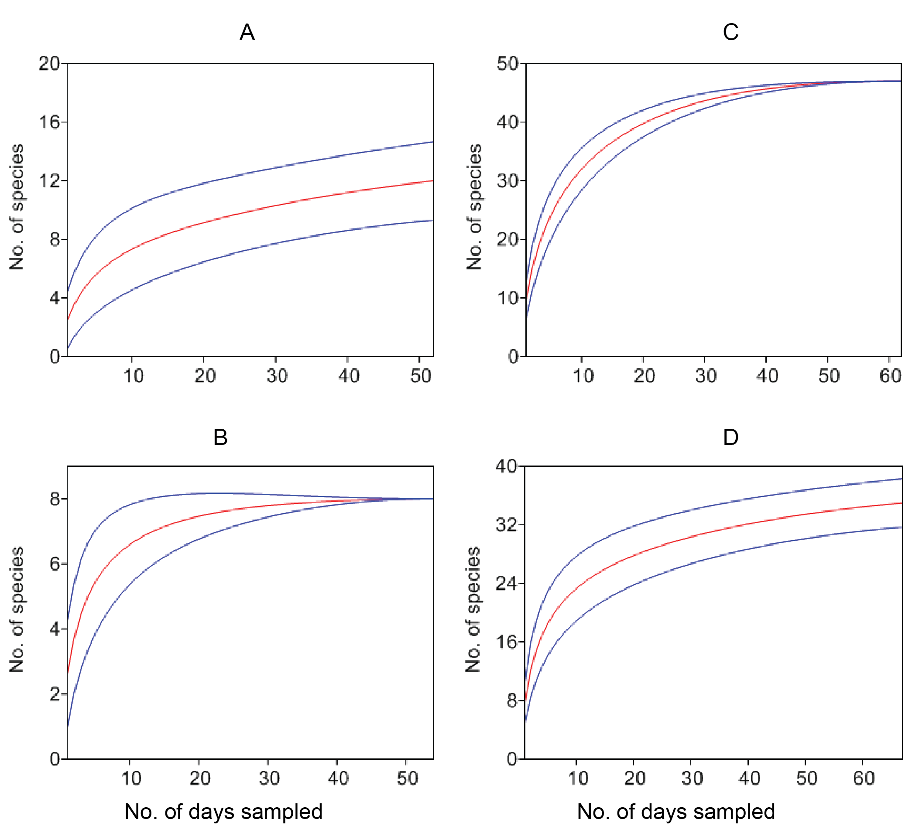
Additional file 2. Sample based rarefaction curves of plant species consumed by Bale monkeys among four study groups. Samples were collected in the continuous forest (Continuous A, N = 52 days (A); Continuous B, N = 54 days (B) and forest fragments (Patchy fragment, N = 62 days (C); Hilltop fragment, N = 67 days (D). The red (rarefaction) curves represent the cumulative number of plant species consumed by the study groups and blue curves represent the 95% confidence intervals.

