Supplementary materials
Figure S1 Bivariate relationships between seven leaf traits. Lines represent Model II regressions.
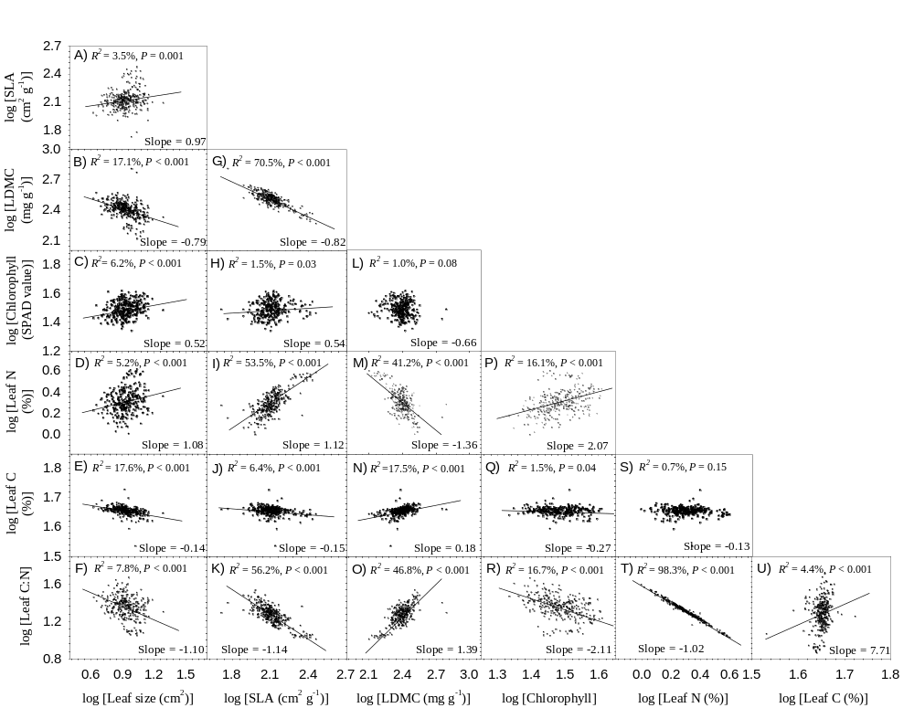
Figure S1

Table S1 Geographic information about sampling locations
Location | Altitude (m) | Latitude | Longitude | Temperature  (°C) | Precipitation  (mm)
Lianyungang | 31 | 34°44'N | 119°20'E | 14.9 | 1025
Huaian | 40 | 33°37'N | 119°04'E | 15.1 | 1049
Zhenjiang | 15 | 32°08'N | 119°33'E | 16.2 | 1101
Changzhou | 16 | 31°49'N | 119°56'E | 16.5 | 1077
Nantong | 21 | 31°49'N | 121°05'E | 16.2 | 1089
Shanghai | 3 | 31°06'N | 121°34'E | 17.4 | 1112
Hangzhou | 10 | 30°19'N | 120°23'E | 17.6 | 1324
Zhoushan | 4 | 30°00'N | 122°03'E | 17.1 | 1286
Shaoxing | 44 | 29°54'N | 120°30'E | 17.6 | 1374
Ningbo | 12 | 29°50'N | 121°32'E | 17.8 | 1394
Quzhou | 70 | 28°55'N | 118°55'E | 17.9 | 1503
Taizhou | 73 | 28°33'N | 121°21'E | 18.4 | 1654
Shangrao | 74 | 28°27'N | 117°55'E | 18.2 | 1779
Yingtan | 53 | 28°12'N | 117°00'E | 18.9 | 1878
Jingdezhen | 39 | 29°16'N | 117°10'E | 18.4 | 1695
Nanchang | 44 | 28°42'N | 115°52'E | 18.6 | 1520
Jiujiang | 38 | 29°44'N | 116°01'E | 18.1 | 1310
Anqing | 19 | 30°28'N | 117°04'E | 17.5 | 1322
Ningguo | 54 | 30°40'N | 118°59'E | 16.4 | 1292
Hefei | 35 | 31°48'N | 117°18'E | 16.6 | 1031
Luan | 73 | 31°44'N | 116°30'E | 16.4 | 1133
Huainan | 43 | 32°37'N | 117°06'E | 16.8 | 982

