A quasi-experimental approach using telemetry to assess migration-strategy specific differences in the decision-making processes at stopover

Heiko Schmaljohann^{1,2,$,}* and Thomas Klinner^{2,}*
¹Institute for Biology und Environmental Sciences (IBU), Carl von Ossietzky University of Oldenburg, Carl-von-Ossietzky-Straße 9-11, D-26129 Oldenburg, Germany
²Institute of Avian Research, An der Vogelwarte 21, 26386 Wilhelmshaven, Germany

$ author of correspondence: heiko.schmaljohann@uol.de
* These authors contributed equally to this work.

Content

Figure S1. Air temperature, rain, wind speed and wind direction on Helgoland.

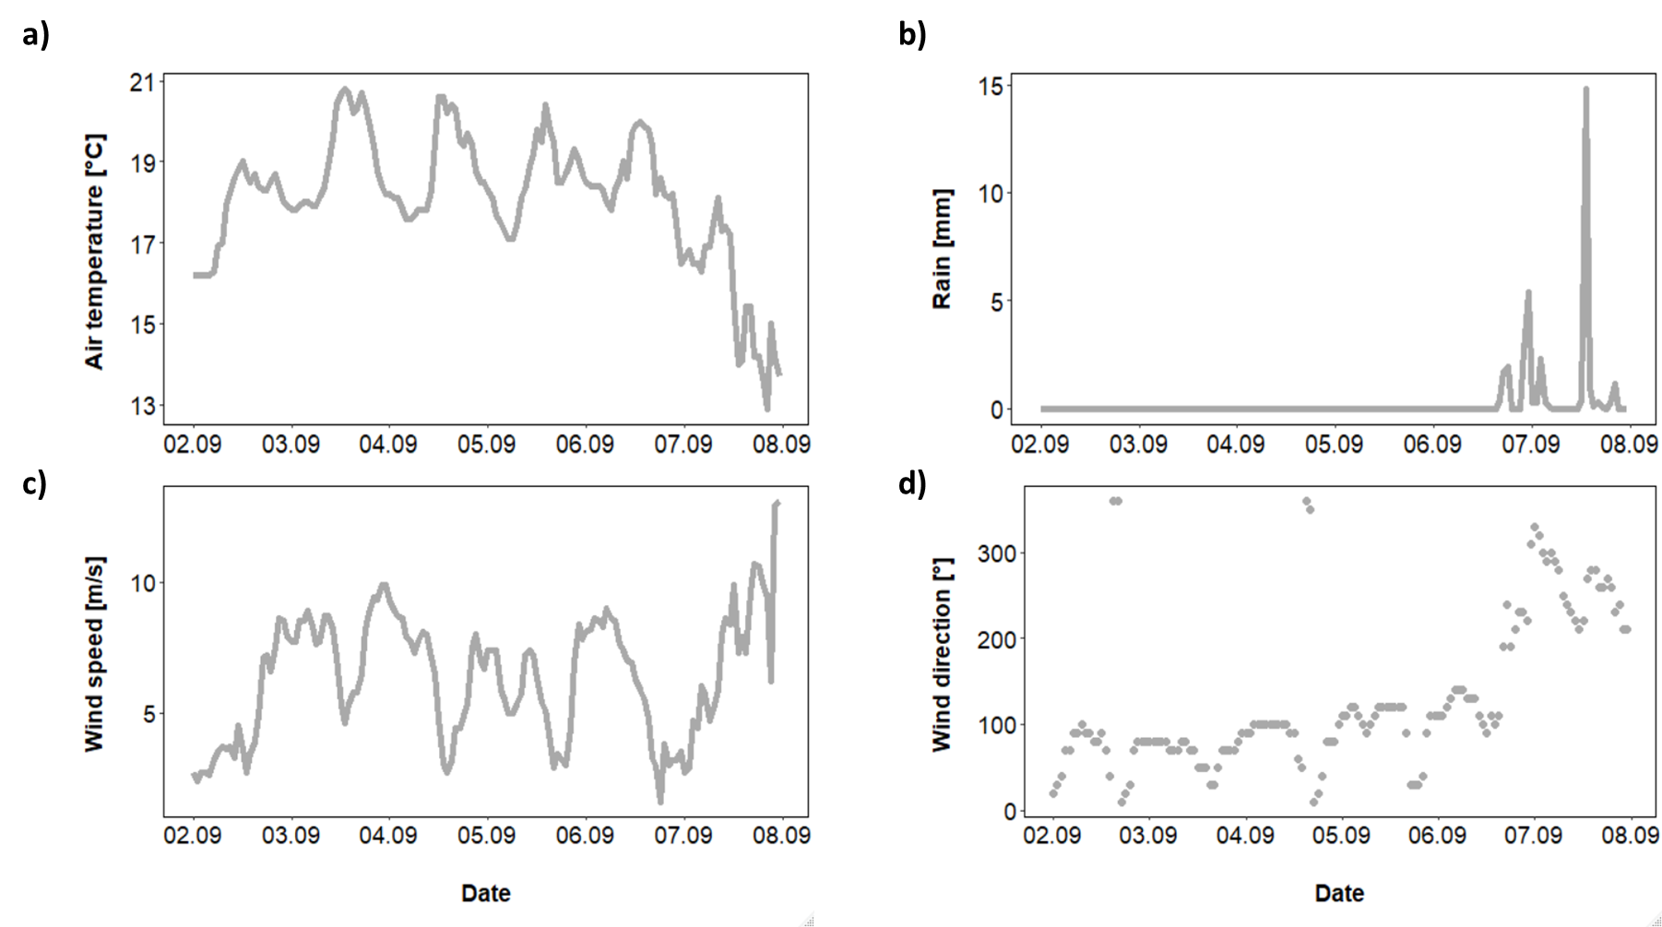
Figure S1 Air temperature, rain, wind speed and wind direction on Helgoland at the beginning of September in 2018. Hourly data were obtained from an automated weather station operated by the German Meteorological Office on Helgoland (DWD; https://opendata.dwd.de/climate_environment/CDC/observations_germany/climate/hourly/).

