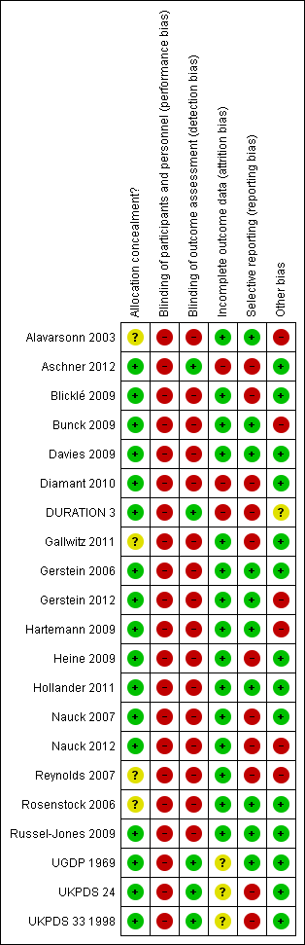
Risk of bias summary: review authors judgements about each risk of bias item for each included study

Electronics Database

PUBMED
((((((("Diabetes Mellitus, Type 2"[Mesh]) OR "Diabetes Mellitus"[Mesh])) NOT (((("Diabetes Insipidus"[Mesh] OR "Diabetes Insipidus, Neurogenic"[Mesh] OR "Diabetes Insipidus, Nephrogenic"[Mesh]) OR "Glucose Intolerance"[Mesh]) OR "Diabetes, Gestational"[Mesh]) OR "Diabetes Mellitus, Type 1"[Mesh]))) AND (("Hypoglycemic Agents"[Mesh]) OR ("Insulin"[Mesh] OR "Insulin, Lente"[Mesh] OR "Insulin Aspart"[Mesh] OR "Insulin Lispro"[Mesh] OR "Insulin, Short-Acting"[Mesh] OR "Insulin, Long-Acting"[Mesh])))) AND (((((((((((((((("Diabetes Complications"[Mesh]) OR "Mortality"[Mesh]) OR "Coronary Disease"[Mesh])) OR "Stroke"[Mesh]) OR "Peripheral Vascular Diseases"[Mesh]) OR "Diabetic Nephropathies"[Mesh]) OR "Diabetic Neuropathies"[Mesh]) OR "Diabetic Retinopathy"[Mesh]) OR "Kidney Diseases"[Mesh]) OR "Hypoglycemia"[Mesh]) OR ("Death, Sudden"[Mesh] OR "Death, Sudden, Cardiac"[Mesh]))) OR (microvascular disease)) OR (cardiovascular)) OR (macrovascular))
LIMITS : Randomized Controlled Trial /Controlled clinical Trial /Systematic reviews / Meta-analysis
from January 1st, 1950 to April 1st, 2013

COCHRANE
Diabetes Mellitus, Type 2 OR Diabetes Mellitus
NOT
Diabetes Insipidus OR Diabetes Insipidus, Neurogenic OR Diabetes Insipidus, Nephrogenic OR Glucose Intolerance OR Diabetes, Gestational OR Diabetes Mellitus, Type 1
AND
Hypoglycemic Agents OR Insulin OR Insulin, Lente OR Insulin Aspart OR Insulin Lispro OR Insulin, Short-Acting OR Insulin, Long-Acting OR Insulin Isophane OR insuline ultralente
AND
Diabetes Complications OR Mortality OR Coronary Disease OR Stroke OR Peripheral Vascular Diseases OR Diabetic Nephropathies OR Diabetic Neuropathies OR Diabetic Retinopathy OR Kidney Diseases OR Hypoglycemia OR Death, Sudden OR Death, Sudden, Cardiac OR microvascular disease OR cardiovascular OR macrovascular
AND
Randomized Controlled Trial OR Controlled clinical Trial OR Systematic reviews OR Meta-analysis

EMBASE
1.Diabetes Mellitus, Type 2"[Mesh]) 2. Diabetes Mellitus"[Mesh]))
3. 1 OR 2
4. Diabetes Insipidus"[Mesh] 5. Diabetes Insipidus, Neurogenic 6. Diabetes Insipidus, Nephrogenic[Mesh]
7. Glucose Intolerance"[Mesh] 8. Diabetes, Gestational"[Mesh] 9. Diabetes Mellitus, Type 1"[Mesh])))
10. OR (4-9)
11.3 NOT 10
12.Hypoglycemic Agents"[Mesh] 13.Insulin"[Mesh] 14.Insulin, Lente"[Mesh] 15.Insulin Aspart"[Mesh]
16.Insulin Lispro"[Mesh] 17.Insulin, Short-Acting"[Mesh] 18.Insulin, Long-Acting"[Mesh]
19. Insulin Isophane 20. insuline ultralente
21. OR (12-20)
22.11 and 21
23.Diabetes Complications"[Mesh] 24.Mortality"[Mesh] 25.Coronary Disease"[Mesh]
26.Stroke"[Mesh] 27.Peripheral Vascular Diseases"[Mesh] 28.Diabetic Nephropathies"[Mesh]
29.Diabetic Neuropathies"[Mesh] 30.Diabetic Retinopathy"[Mesh] 31.Kidney Diseases"[Mesh]
32.Hypoglycemia"[Mesh] 33.Death, Sudden"[Mesh] 34.Death, Sudden, Cardiac"[Mesh]
35.microvascular disease 36.cardiovascular disease 37.macrovascular
38.OR (23-37)
39.22 and 38
40.Randomized Controlled Trial/ 41.Controlled clinical Trial/ 42.Systematic reviews/ 43.Meta-analysis
44.OR (40-43)
45.39 and 44
46.limit 45 to human
47.limit 46 to exclude medline journals

