The association of glycemic level and prevalence of tuberculosis: a meta-analysis
Figure S1. Forest plot of observational studies on poorly controlled DM and tuberculosis infection excluded the study with the elderly.
Figure S2. Forest plot of observational studies on glycated haemoglobin A1c concentrations and tuberculosis infection with restricting to the case-control studies.
Figure S3. Forest plot of observational studies on fasting plasma glucose concentrations and tuberculosis infection with restricting to the case-control studies.

Figure S1. Forest plot of observational studies on poorly controlled DM and tuberculosis infection excluded the study with the elderly.
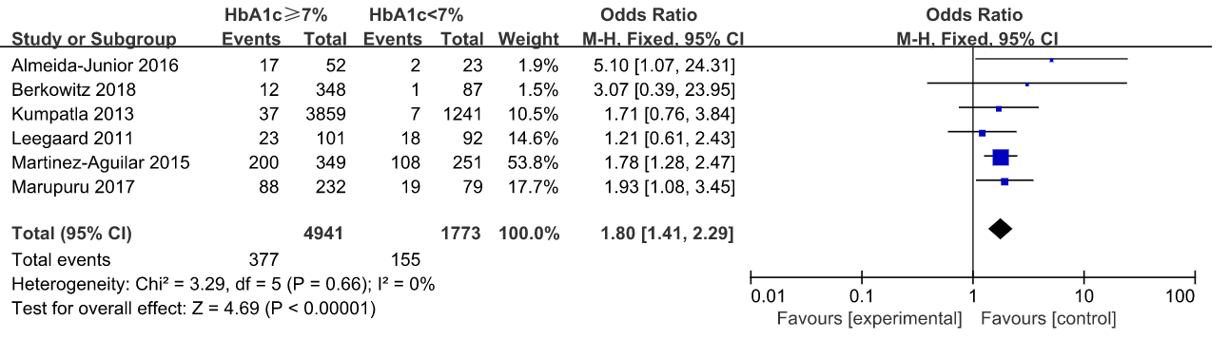
Abbreviations: DM: diabetes mellitus, HbA1c: glycated haemoglobin A1c, CI: confidence interval.

Figure S2. Forest plot of observational studies on glycated haemoglobin A1c concentrations and tuberculosis infection with restricting to the case-control studies.
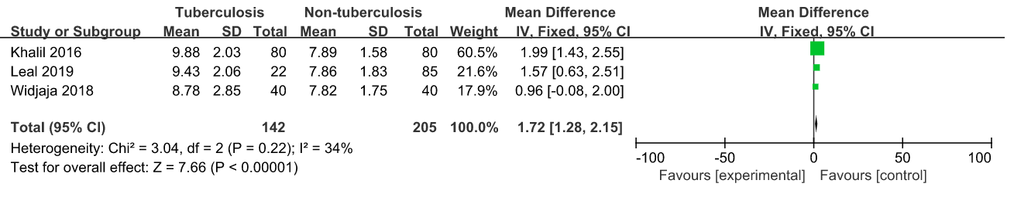
Abbreviations: CI: confidence interval.

Figure S3. Forest plot of observational studies on fasting plasma glucose concentrations and tuberculosis infection with restricting to the case-control studies.
