Supplementary

Appendix S1. Searching strategy
Figure S1. Preferred Reporting Items for Systematic Reviews and Meta-Analyses (PRISMA) 2020 flow diagram
Figure S2. Methodological quality of the studies included in the final analysis based on Risk of Bias for assessing the quality of RCT (n = 14)
Table S1. Clinical outcomes of the trials investigated

Appendix S1 Search strategy

PubMed:
(("biosimilar pharmaceuticals"[MeSH Terms] OR ("biosimilar"[All Fields] AND "pharmaceuticals"[All Fields]) OR "biosimilar pharmaceuticals"[All Fields] OR "biosimilar"[All Fields] OR "biosimilars"[All Fields] OR "biosimilarity"[All Fields]) AND ("insulin"[MeSH Terms] OR "insulin"[All Fields] OR "insulin s"[All Fields] OR "insuline"[All Fields] OR "insulinic"[All Fields] OR "insulinization"[All Fields] OR "insulinized"[All Fields] OR "insulins"[MeSH Terms] OR "insulins"[All Fields])) AND (randomizedcontrolledtrial[Filter])

Cochrane library:
(biosimilar) AND ("insulin") in Trials (Word variations have been searched)

Embase:
insulin AND biosimilar AND 'randomized controlled trial'
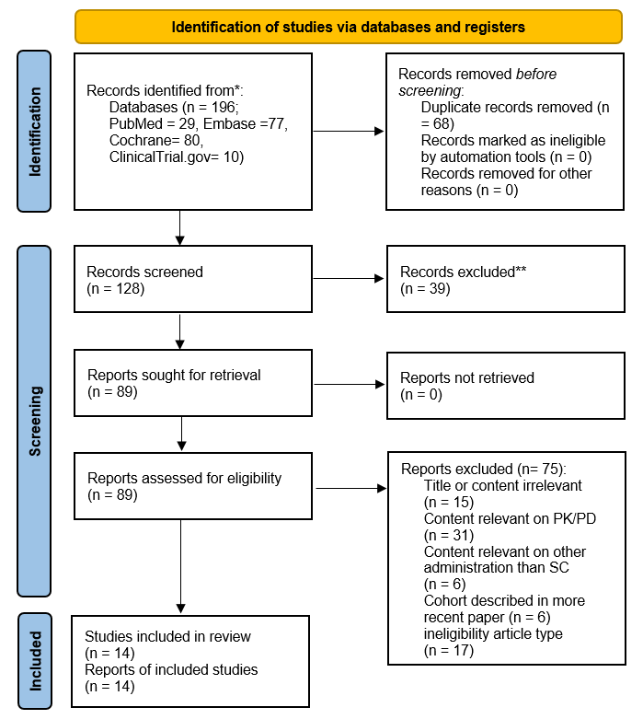
*Consider, if feasible to do so, reporting the number of records identified from each database or register searched (rather than the total number across all databases/registers).
**If automation tools were used, indicate how many records were excluded by a human and how many were excluded by automation tools.
Figure S1. Preferred Reporting Items for Systematic Reviews and Meta-Analyses (PRISMA) 2020 flow diagram.

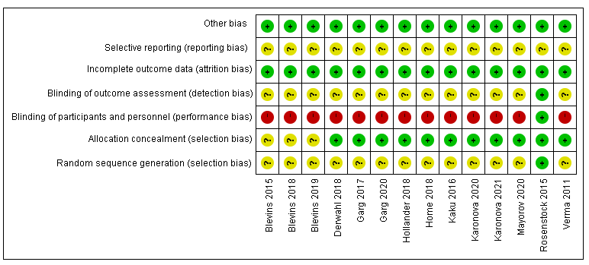
Figure S2. Methodological quality of the studies included in the final analysis based on Risk of Bias for assessing the quality of RCT (n = 14)

Table S1. Clinical outcomes of the trials investigated
Study, Year | Change of HbA1C (%)  24 -26 wks  MD (SE) | Change of HbA1C (%)  52 wks  MD (SE) | FPG (laboratory or SMBG)  24-52 wks  mmol/L  MD (SE) | SMBG (7-or 8- points)  24-52wks  MD (SE)mmol/L  MD (SE) | HbA1C < 7%  (d/N) |  | hypoglycemia  (at least one event)  (%) |  | Severe hypoglycemia (d/N) |  | AIA_positive  (%)
 |  |  |  |  | BSM | REF | BSM | REF | BSM | REF | BSM | REF
Long-acting insulin biosimilar
Verma, 2011 [17] | 0.22 (0.17) | NA | 1.03 (0.74) | NA | 34/107 | 36/108 | 43/107 | 45/108 | 3/107 | 3/107 | NA | NA
Kaku, 2016 [18] | 0.04 (0.07) | NA | 0.55 (0.40) | NA | NA | NA | 124/131 | 116/129 | 5/131 | 3/129 | NA | NA
Blevins, 2015 [19] | 0.11 (0.07) | NA | 0.17 (0.28) | NA | 81/268 | 67/267 | 230/268 | 235/267 | 11/268 | 11/267 | 107/268 | 105/267
Rosenstock, 2015 [20] | 0.05 (0.08) | NA | -0.06 (0.24) | NA | 180/376 | 197/380 | 297/376 | 296/380 | 4/376 | 4/380 | 56/376 | 40/380
Blevins, 2018 [21] | -0.03 (0.07) | 0.04 (0.08) | -0.9 (0.38) | 0.23 (0.14) | NA | NA | 154/280 | 170/278 | 11/280 | 13/278 | NA | NA
Home, 2018 [22] | 0.03 (0.11) | -0.02 (0.13) | 0.48 (0.65) | NA | 61/241 | 68/258 | 184/241 | 204/258 | 40/241 | 45/258 | 177/241 | 195/258
Hollander, 2018 [23] | 0.02 (0.08) | NA | 0.19 (0.25) | NA | 112/241 | 107/245 | 140/263 | 137/263 | 4/263 | 4/263 | 91/262 | 76/262
Blevins, 2019 [24] | 0.06 (0.13) | NA | 0.31 (0.26) | 0.35 (0.20) | NA | NA | 75/277 | 66/283 | 62/277 | 52/283 | 70/276 | 76/282
Karonova, 2020 [25] | 0.11  (0.15) | NA | -1.3 (0.81) | NA | NA | NA | 72/90 | 73/90 | 4/90 | 9/90 | 26/90 | 27/90
Short-acting insulin biosimilar
Garg, 2017 [26] | 0.05 (0.07) | 0.08 (0.08) | 0.05 (0.39) | -0.03 (0.20) | NA | NA | 250/253 | 254/254 | 34/253 | 34/254 | 100/253 | 109/254
Derwahl, 2018 [27] | -0.06 (0.07) | NA | 0.05 (0.25) | -1.91 (0.19) | 107/253 | 102/252 | 173/253 | 188/252 | 6/253 | 4/252 | 68/253 | 66/252
Garg, 2020 [28] | -0.02  (0.07) | NA | -0.32 (0.35) | NA | NA | NA | 291/301 | 285/296 | 12/301 | 10/296 | 95/296 | 104/292
Karonova, 2021 [29] | 0 (0.13) | NA | -0.1 (0.62) | NA | 26/132 | 19/132 | 97/132 | 91//132 | 2/132 | 1/132 | 29/132 | 29/132
Pre-mixed insulin biosimilar
Mayorov, 2020 [30] | -0.01 (0.17) | NA | -0.57 (0.58) | NA | NA | NA | 50/105 | 51/105 | 0/105 | 0/105 | 9/105 | 4/105

