Additional file 2
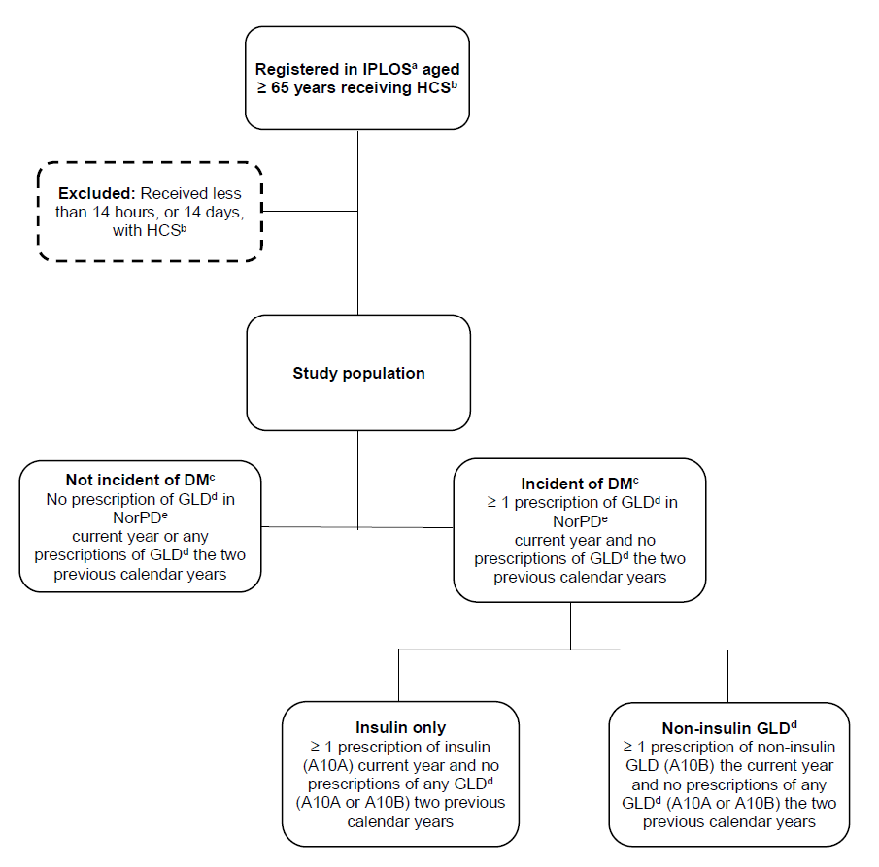

Supplementary Figure 1: Flowchart of the study cohort recruited from IPLOS and linked to data from the Norwegian Prescription Database (NorPD), showing definition of incident users.

ª IPLOS = the Norwegian Information System for the Nursing and Care Sector, ^{b} HCS = Home care service, ^{c} DM = Diabetes mellitus, pharmacologically treated, ^{d} GLD = Glucose lowering drug, ^{e} NorPD = Norwegian Prescription Database.
Prescriptions with ATC code A10A (insulins and analogues) is defined as insulin, prescriptions with ATC code A10B (blood glucose lowering drugs, exclusive insulins) is defined as non-insulin glucose lowering drugs (non-insulin GLD) and prescriptions with either ATC code A10A or A10B is defined as glucose lowering drugs (GLD).

