Additional file 1:
Search Strategy

PubMed:
#1 "sexual behavior"[MeSH Terms] OR "sexual dysfunction, physiological"[MeSH Terms] OR "sexual dysfunctions, psychological"[MeSH Terms]OR (psychological sexual dysfunction[MeSH Terms]) OR ("sexual function"[Title/Abstract] OR "Sexual Functioning"[Title/Abstract] OR "Sexual Disorders"[Title/Abstract] OR "sexual problems"[Title/Abstract] OR "sexual dysfunction"[Title/Abstract] OR "Sexual Satisfaction"[Title/Abstract] OR "Sexual Behavior"[Title/Abstract] OR "Sexual Gratification"[Title/Abstract] OR "Orgasm"[Title/Abstract] OR "Sexual Pleasure"[Title/Abstract] OR "Sexual desire"[Title/Abstract] OR "arousal"[Title/Abstract] OR "excitement"[Title/Abstract] OR "lubrication"[Title/Abstract] OR "sexual pain"[Title/Abstract] OR "dyspareunia"[Title/Abstract])
#2 (("diabetes, gestational"[MeSH Terms]) OR ("GDM"[Title/Abstract] OR "Gestational diabetes mellitus"[Title/Abstract] OR "gestation"[Title/Abstract] OR "diabetes, pregnancy-induced"[Title/Abstract] OR "pregnancy induced diabetes"[Title/Abstract])))
#3 ("observational studies"[Title/Abstract] OR "descriptive"[Title/Abstract] OR "descriptive-analytic"[Title/Abstract] OR cross sectional[Title/Abstract] OR "case-control"[Title/Abstract] OR "cohort"[Title/Abstract])
#4 #1 AND #2 AND #3
Cochrane:
#1 "sexual function" OR "Sexual Functioning" OR "Sexual Disorders" OR "sexual problems" OR "sexual dysfunction" OR "Sexual Satisfaction" OR "Sexual Behavior" OR "Sexual Gratification" OR "Orgasm" OR "Sexual Pleasure" OR "Sexual desire" OR "arousal" OR "excitement" OR "lubrication" OR "sexual pain" OR "dyspareunia"
#2 MeSH descriptor: [Sexual Behavior] explode all trees
#3 MeSH descriptor: [Sexual Dysfunction, Physiological] explode all trees
#4 MeSH descriptor: [Sexual Dysfunctions, Psychological] explode all trees
#5 #1 OR #2 OR #3 OR #4
#6 "GDM" OR "Gestational diabetes mellitus" OR "gestation" OR "diabetes, pregnancy-induced" OR "pregnancy induced diabetes"
#7 MeSH descriptor: [Diabetes, Gestational] explode all trees
#8 #6 OR #7
#9 #5 AND #8

Web of Science:
#1 TS=("sexual function" OR "Sexual Functioning" OR "Sexual Disorders" OR "sexual problems" OR "sexual dysfunction" OR "Sexual Satisfaction" OR "Sexual Behavior" OR "Sexual Gratification" OR "Orgasm" OR "Sexual Pleasure" OR "Sexual desire" OR "arousal" OR "excitement" OR "lubrication" OR "sexual pain" OR "dyspareunia")
#TS= ("GDM" OR "Gestational diabetes mellitus" OR "gestation" OR "diabetes, pregnancy-induced" OR "pregnancy induced diabetes")
#3 TS= (("observational studies" OR "descriptive" OR "descriptive-analytic" OR cross sectional OR "case-control" OR "cohort"))
#4 #1 AND #2 AND #3
Scopus:
#1 ( TITLE-ABS-KEY ( "sexual function" OR "Sexual Functioning" OR "Sexual Disorders" OR "sexual problems" OR "sexual dysfunction" OR "Sexual Satisfaction" OR "Sexual Behavior" OR "Sexual Gratification" OR "Orgasm" OR "Sexual Pleasure" OR "Sexual desire" OR "arousal" OR "excitement" OR "lubrication" OR "sexual pain" OR "dyspareunia" )
#2 TITLE-ABS-KEY ("GDM" OR "Gestational diabetes mellitus" OR "gestation" OR "diabetes, pregnancy-induced" OR "pregnancy induced diabetes")
#3 TITLE-ABS-KEY ("observational studies" OR "descriptive" OR "descriptive-analytic" OR cross AND sectional OR "case-control" OR "cohort")
#4 #1 AND #2 AND #3
Table 1 Assessment of quality of included studies
Total  score | Outcome |  |  | Comparability |  | Selection |  |  |  | Cross-Sectional Studies
Total  score | Statistics |  | Outcome assessment (max**) | Confounding controlled (max**) |  | Ascertainment of exposure (max**) | Non-respondents | Sample size | Representativeness of the sample | Cross-Sectional Studies
7 | ☆ |  | ☆ | - |  | ☆☆ | ☆ | ☆ | ☆ | Souza et al.  2013 [23]
7 | ☆ |  | ☆ | - |  | ☆☆ | ☆ | ☆ | ☆ | Ribeiroet al.  2012 [24]
9 | ☆ |  | ☆ | ☆☆ |  | ☆☆ | ☆ | ☆ | ☆ | Zare et al.  2021 [27]
7 | ☆ |  | ☆ | - |  | ☆☆ | ☆ | ☆ | ☆ | Ozcan et al.  2018 [28]
5 | - |  | - | - |  | ☆☆ | ☆ | ☆ | ☆ | Tabande et al.  2016 [25]
Total  score | Exposure |  |  | Comparability |  | Selection |  |  |  | Case–Control Studies
Total  score | Non-response rate | Same methods of ascertainment  for cases and controls | Assessment of exposure | Controls for other risk factors | Controls for age | Definition of controls | Selection of controls | Representativeness | Definition of exposure | Case–Control Studies
6 | - | ☆ | ☆ | - | - | ☆ | ☆ | ☆ | ☆ | Nunes et al. [26]  2019

Table 2 Meta-analysis results for secondary outcomes

Variables | Nunes 2019 [26] | Ozcan 2018 [28] | Ribeiro 2012 [24] | Souza 2013 [23] | Zare 2021 [27] | Heterogeneity | Effect Size (95% CI) | P- value
 |  |  |  |  |  | I², P- value | Effect Size (95% CI) | P- value
Sexual desire | 46.3±12.7 vs.  59.2±22.3 | NR | 3.2±1.3 vs.  3.2±1.2 | 3.38±1.49 vs.  3.74±1.92 | 3.38±0.07  vs.  4.74±0.06 | 99%  p <0.001 | SMD -5.14 [-8.14, -2.14] | p <0.001
Arousal | 21.3±27.5 vs.  46.1±25.0 | NR | 3.1±1.8vs.  3.4±1.7 | 3.77±1.32 vs.  4.11±1.7 | 3.75±0.08  vs.  3.85±0.15 | 81%  p =0.002 | SMD -0.58 [-0.95, -0.21] | 0.002
Lubrication* | NR | NR | 3.8±2.2 vs.  3.9±1.9 | 4.06±1.52 vs.  4.54±1.92 | 3.80±0.08  vs.  4.22±1.22 | 0%  p =0.76 | MD -0.41 [-0.59, -0.22] | p <0.001
Orgasm | 33.8±29.6 vs.  51.4±30.6 | NR | 3.4±2.2 vs.  3.6±2.0 | 3.72±1.58 vs.  4.5±2.0 | 2.93±0.07  vs.  3.12±0.13 | 96%  p <0.001 | SMD -0.74 [-1.52, 0.05] | 0.07
Satisfaction | 27.0±26.7 vs.  47.9±23.1 | 2.03±1.13 vs.  5.42±2.05 | 4.0±1.7 vs.  4.0±1.7 | 4.25±1.78 vs.  5.01±2.3 | 3.69±0.07  vs.  5.04±0.09 | 99%  p <0.001 | SMD -3.82 [-6.08, -1.57] | p <0.001
Pain | 49.0±50.2 vs.  73.8±44.1 | NR | 3.5±2.1 vs.  3.8±2.1 | 4.44±1.69 vs.  4.61±2.19 | 4.81±0.11  vs.  4.29±0.14 | 99%  p <0.001 | SMD 0.99 [-1.25, 3.22] | 0.39

CI= Confidence Interval; SMD= Standardized Mean Difference; MD= Mean Difference; NR= Not Reported
* All analysis were based on random effect, except lubrication, which was reported as fixed effect.
Table 3 Meta-regression analysis of variables predicting sexual function

Q(model) | p Value | 95% CI | Regression coefficient (SE) | Number of studies | Continuous variables
0.60 | 0.437 | -2.870 to 1.240 | -0.815 (1.048) | 5 | Mean age of intervention group (year)
9.29 | 0.002 | -0.874 to - 0.190 | -0.532 (0.174) | 5 | Mean age of control group (year)
0.72 | 0.395 | -1.624 to 0.641 | -0.491 (0.578) | 4 | Mean of gestational age
2.31 | 0.128 | -0.035 to 0.004 | -0.015 (0.010) | 5 | Total sample size
0.35 | 0.554 | -0.309 to 0.166 | -0.071 (0.121) | 4 | Percentage of married women
0.67 | 0.414 | -0.171 to 0.070 | -0.050 (0.061) | 4 | Percentage of women with a high school education or higher
Q(model) | p Value | 95% CI | Regression coefficient (SE) | Number of studies | Categorical variables
0.21 | 0.647 | -6.420 to 3.992 | -1.213 (2.656) | 5 | Study Type (Reference: case-control)
Q= Fit Of Model Without Heterogeneity; SE= Standard Error; CI= Confidence Interval

Table 4 Sensitivity analysis using leave-one-out method for all outcomes
Variables | Nunes 2019 [26] | Ozcan 2018 [28] | Ribeiro 2012 [24] | Souza 2013 [23] | Zare 2021 [27] | Before sensitivity Analysis
Total score of sexual function | -2.05 (-4.38 to 0.28)  P= 0.085 | -1.77 (-3.86 to 0.33)  P= 0.098 | -2.22 (-4.23 to -0.21)  P= 0.030 | -2.17 (-4.20 to -0.14) P= 0.037 | -0.82 (-1.52 to -0.12)  P= 0.022 | -1.80 (-3.45 to -0.15)  P= 0.032
Sexual desire | -6.87 (-12.45 to -1.29)  P= 0.016 | NR | -7.04 (-11.66 to-2.42)  P= 0.003 | -6.97(-11.53 to -2.40) P= 0.003 | -0.32 (-0.76 to 0.12)  P= 0.154 | -5.14 (-8.14, -2.14)  p <0.001
Arousal | -0.43 (-0.91 to 0.05)  P= 0.077 | NR | -0.71 (-1.06 to -0.36)  p <0.001 | -0.69 (-1.07 to -0.31)  p <0.001 | -0.47(-1.03 to 0.10)  P= 0.104 | -0.58 (-0.95, -0.21)  P= 0.002
Lubrication* | NR | NR | -0.42 (-0.61to -0.23) p <0.001 | -0.40 (-0.60 to -0.21)  p <0.001 | -0.31 (-0.89 to 0.262)  P= 0.287 | -0.41 (-0.59, -0.22)  p <0.001
Orgasm | -0.79 (-1.83 to 0.26)  P= 0.141 | NR | -0.95 (-1.81 to -0.08)  P= 0.033 | -0.84 (-1.84 to 0.16) P= 0.101 | -0.40 (-0.69 to 0.11) P= 0.006 | -0.74 (-1.52, 0.05)  P= 0.07
Satisfaction | -4.67 (-8.13 to -1.22)  P=0.008 | -4.33 (-7.25 to -1.41)  P= 0.004 | -4.84 (-7.77 to -1.93) P=0.001 | -4.75 (-7.69 to -1.82) P=0.001 | -0.81 (-1.58 to -0.05)  P= 0.038 | -3.82 (-6.08, -1.57)  p <0.001
Pain | 1.50 (-1.61 to 4.61) P=0.346 | NR | 1.37 (-1.71 to 4.44) P= 0.385 | 1.34 (-1.71 to 4.40)  P= 0.389 | -0.29 (-0.60 to 0.02) P= 0.063 | 0.99 (-1.25, 3.22)  P= 0.39
NR= Not Reported
-Results are reported as effect size, including the 95% confidence interval (CI) and P-value.
*All effect sizes (95% CI) are presented as standardized mean difference (SMD), except for lubrication, which is reported as mean difference (MD) with a 95% CI.

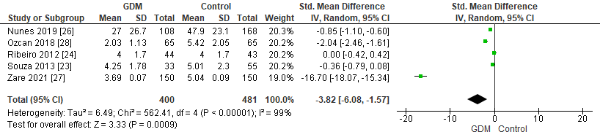
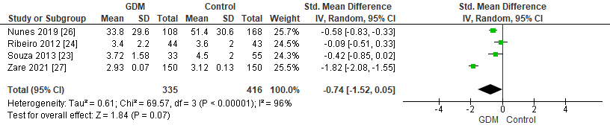
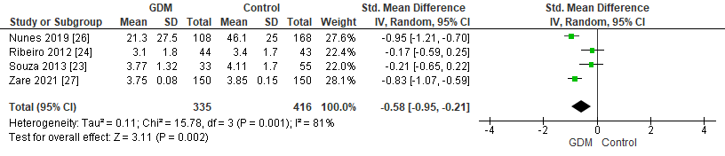
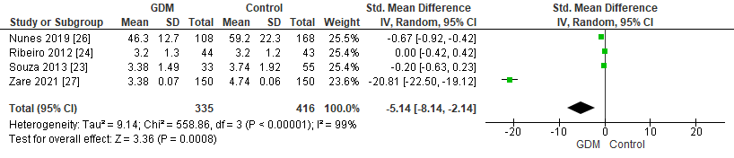
D
E
B
A
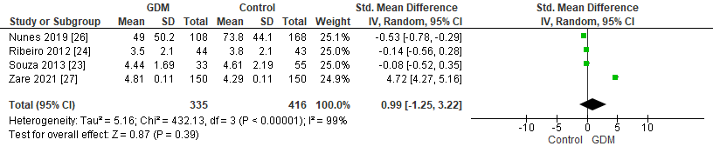
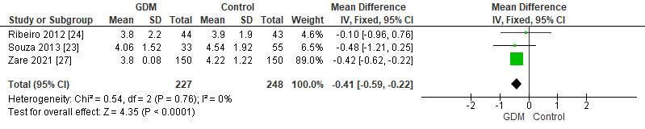
F
C

Fig. 1 Forest Plot of sexual desire (A), sexual arousal (B), vaginal lubrication (C), ability to reach orgasm (D), sexual satisfaction (E), and sexual pain (F) scores in women with gestational diabetes mellitus (GDM) compared to non-GDM women.

