Suppplementary Information

Table S1 Search strategies for PubMed
#1 Hypothyroidism [MeSH Terms]
#2 "hypothyr*"[Title/Abstract] OR "thyroid deficien*"[Title/Abstract] OR "thyroid insufficien*"[Title/Abstract]
#3 #1 OR #2
#4 Thyroxine [MeSH Terms]
#5 "thyroxin*"[Title/Abstract] OR "thyroid hormone"[Title/Abstract] OR "levothyro*"[Title/Abstract] OR "l thyroxin*"[Title/Abstract] OR "levoxyl"[Title/Abstract] OR "Synthroid"[Title/Abstract] OR "Unithroid"[Title/Abstract] OR "tetraiodothyronine"[Title/Abstract] OR "eltroxin*"[Title/Abstract]
#6 #4 OR #5
#7 bone density [MeSH Terms]
#8 "bone densit*"[Title/Abstract] OR "bone mineral densit*"[Title/Abstract] OR "BMD"[Title/Abstract] OR "bone mineral content"[Title/Abstract] OR "bone metaboli*"[Title/Abstract] OR "bone turnover"[Title/Abstract] OR "bone marker"[Title/Abstract]
#9 #7 OR #8
#10 #3 AND #6 AND #9

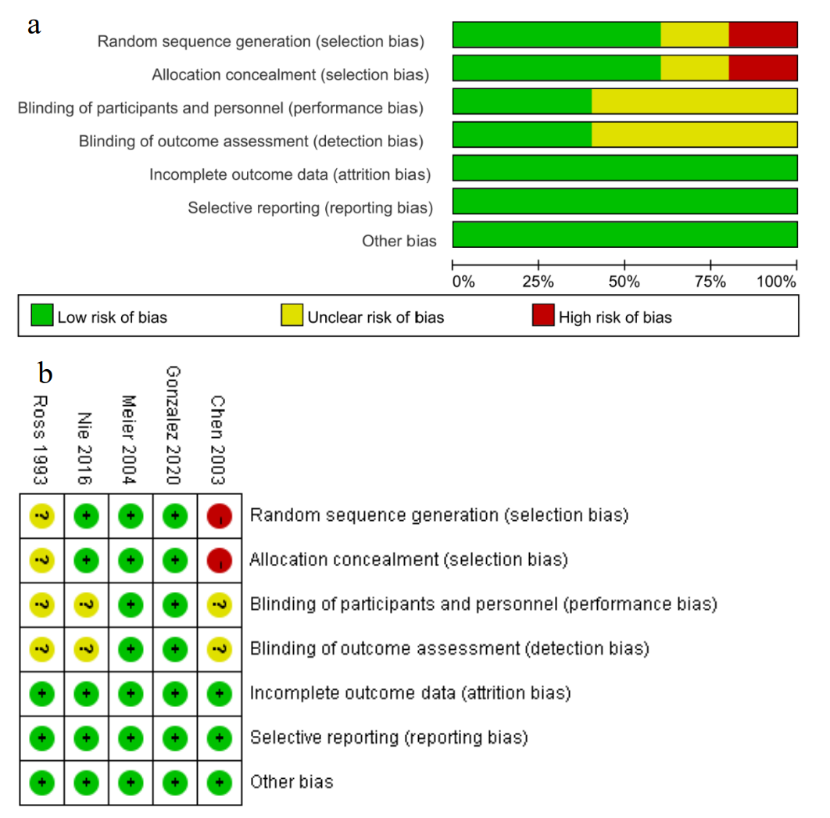
Fig S1. Risk of bias for randomized controlled trails focused on subclinical hypothyroidism. (a) Risk of bias graph: the authors' judgements about each risk of bias item presented as percentages across included studies. (b) Risk of bias summary: the authors' judgements about each risk of bias item for each included study.

