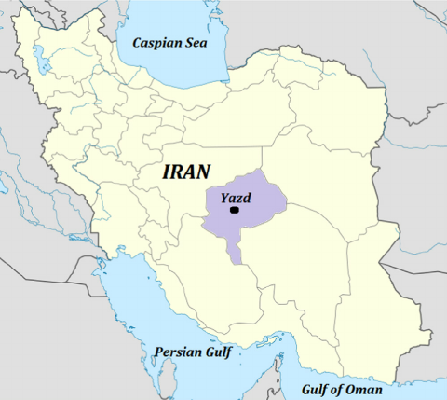

Supplementary Figure 1. Yazd province map*.

* The presented map has been obtained from this address: https://www.researchgate.net/figure/Location-of-Yazd-city-on-the-map-of-Iran-Yazd-province-is-shown-in-highlight_fig2_263088654

