Supplementary Materials Files
To: Mediating effect of TyG index on the Association between Glucose-Lipid Metabolism-Related Dietary Pattern and T2DM: a Propensity Score-Matched analysis
by ShuShu Li ^{1, 2, †}, Rong Xia ^{3, 4, †}, Xing Gong ^{3, †}, Chao Wang ³, Hechun Liu ¹, Huibin Dong ², Zhangyao Su ¹, Yucheng Liang ¹, Shoulin Wang ^{3,*}, and Tao Yang ^{1,*}
Legends:
Table S1. Factor loadings of food groups in dietary patterns were identified using principal component analysis and reduced rank regression.
Table S2. Sensitivity analysis of the association between dietary patterns and HOMA-TyG index for the model adjustment derived from by LASSO regression.
Table S3. Odds ratios (OR) and 95% Confidence Interval (CI) between DP and prevalent T2DM in the subgroup of gender and age.
Table S4. Beta coefficients (β) and 95% Confidence Interval (CI) between DP and TyG index in subgroup of gender and age.
Table S5. Mediation effects of HOMA-β on the association between DPs s with the prevalence of T2DM.
Table S6. Mediation effects of HOMA-IR on the association between DPs and prevalence of T2DM.
Table S7. Sensitivity analysis of the mediation effect of TyG index on the association between DP and T2DM for the model adjustment derived from by LASSO regression.
Figure S1. Directed acyclic graph (DAG) for dietary pattern scores and risk of type 2 diabetes mellitus (T2DM) in a community-based study from Eastern China in 2019 – 2020.
Figure S2. Correlations between factors and response variables obtained from dietary patterns (DPs) derived from principal component analysis and reduced rank regression. TC, total cholesterol; TG, total triglycerides; LDLC, low-density lipoprotein cholesterol; HDLC, high-density lipoprotein cholesterol; BMI: body mass index; HbA1c, Hemoglobin A1c.
Figure S3. Dose-response association between principal component analysis (PCA)-derived dietary patterns (PCA-derived DP) and the homeostasis model assessment of insulin resistance (A ~ C) [HOMA-IR, n=1330. DP 1 (panel A), DP 2 (panel B), DP 3 (panel C)], triglyceride-glucose index (D ~ F) [TyG index, n=1330. DP 1 (panel D), DP 2 (panel E), DP 3 (panel F)], and homeostasis model assessment of beta cell function (G ~ I) [HOMA-%β, n=1330. DP 1 (panel G), DP 2 (panel H), DP 3 (panel I)]. T2DM, type 2 diabetes mellitus. Estimated differences and 95% confidence interval derived from restricted cubic spline regression, with knots placed at the 1st, 50th and 99th percentiles of the distribution of DP scores. Models were adjusted for age, gender, household income, education, occupation, physical exercise, drinking, smoking, family history of diabetes, obesity, metabolic syndrome.

Table S1. Factor loadings of food groups in dietary patterns were identified using principal component analysis and reduced rank regression.
Food Group | PCA |  |  |  | RRR
Food Group | DP 1 | DP 2 | DP 3 |  | DP 1 | DP 2 | DP 3
Rice | 0.02 | 0.73 | -0.26 |  | 0.04 | 0.56 | 0.10
Wheat | 0.17 | 0.63 | 0.06 |  | 0.11 | 0.33 | 0.09
Fresh vegetables | 0.14 | -0.61 | 0.21 |  | 0.09 | 0.18 | 0.02
Fresh fruits | 0.05 | -0.33 | 0.44 |  | 0.16 | 0.02 | 0.00
Chicken | 0.78 | 0.12 | 0.18 |  | 0.57 | 0.01 | 0.02
Meat | 0.77 | 0.05 | 0.19 |  | 0.25 | 0.04 | 0.02
Egg | 0.03 | -0.1 | 0.09 |  | 0.13 | 0.02 | 0.17
Fish | 0.06 | -0.02 | 0.61 |  | 0.00 | 0.08 | 0.27
Soybeans | 0.16 | -0.06 | 0.51 |  | 0.01 | 0.01 | 0.25
Dairy products | -0.17 | 0.19 | 0.67 |  | 0.00 | 0.01 | 0.34
Preserved foods | 0.52 | -0.12 | -0.32 |  | 0.39 | 0.01 | 0.01
PCA, principal component analysis; RRR, reduced rank regression; DP: dietary patterns.

Table S2. Sensitivity analysis of association between DPs and HOMA-TyG index for the model adjustment derived from by LASSO regression.
Quartile 1 (Reference) | Quartile 2 | Quartile 3 | Quartile 4 | P for Trend §
PCA-DP 1
Prevalent T2DM ª | 1.42 (1.04, 1.96) * | 1.44 (1.04, 1.99) * | 2.03 (1.47, 2.83) ** | < 0.001
HOMA-%β ^{b} | -6.60 (-19, 5.4) | 1.90 (-10, 14) | -0.23 (-12, 12) | 0.694
HOMA-IR ^{b} | 0.06 (-1.0, 1.1) | 0.85 (-0.21, 1.9) | 1.10 (0.04, 2.2) * | 0.017
TyG index ^{b} | 0.01 (-0.07, 0.09) | 0.08 (0.00, 0.16) * | 0.12 (0.04, 0.20) *** | < 0.001
RRR-DP 1 |  |  |  | < 0.001
Prevalent T2DM ª | 1.28 (0.74, 2.20) | 1.55(1.17, 2.06) * | 2.38 (1.72, 3.29) ***
HOMA-%β ^{b} | -9.20 (-29, 11) | -5.6(-16, 5.0) | -8.90 (-21, 3.2) | 0.166
HOMA-IR ^{b} | 0.13 (-1.9, 1.6) | 0.16(-0.77, 1.1) | 0.91 (-0.14, 2.0) | 0.123
TyG index ^{b} | 0.11 (-0.02, 0.24) | 0.08(0.01, 0.15) * | 0.15 (0.07, 0.22) *** | < 0.001
§: Trends were examined using the Cochran-Armitage trend test; *P < 0.05, **P < 0.01, **P < 0.001.
PCA-DP1, principal component analysis derived dietary patter 1; RRR-DP1, reduced rank regression derived dietary patter 1.
a, data were presented as adjusted Odds Ratios (OR) and 95% confidence interval (CI).
b, data were presented as adjusted beta coefficients (β) and 95% confidence interval (CI).
Model: Includes adjustment of gender, marriage status, physical activity, family history of diabetes, BMI, dyslipidemia. Adjusted OR and 95% CI were obtained using multiple logistic regression. Adjusted β and 95% CI were obtained using generalized linear model. P for trend values for the medians of each quartile of scores included in the multiple generalized linear regression models.

Table S3. Odds ratios (OR) and 95% Confidence Interval (CI) between DP1 and prevalent T2DM in the subgroup of gender and age.
Age | gender |  | PCA |  |  |  | RRR
Age | gender |  | OR | 95% CI | P |  | OR | 95% CI | P
< 60 | Male | Quantitative | 2.06 | 1.59, 2.73 | <0.001 |  | 14.02 | 4.72, 45.0 | <0.001
< 60 |  | Q2 vs Q1 | 1.32 | 0.70, 2.48 | 0.387 |  | 1.24 | 0.43, 3.54 | 0.689
< 60 |  | Q3 vs Q1 | 4.03 | 1.88, 9.03 | <0.001 |  | 2.5 | 1.38, 4.56 | 0.003
< 60 |  | Q4 vs Q1 | 5.67 | 2.44, 14.2 | <0.001 |  | 6.42 | 2.84, 15.5 | <0.001
< 60 | Female | Quantitative | 1.53 | 1.11, 2.16 | 0.012 |  | 15.03 | 4.10, 61.3 | <0.001
< 60 |  | Q2 vs Q1 | 1.18 | 0.45, 3.15 | 0.736 |  | 1.33 | 0.24, 6.40 | 0.728
< 60 |  | Q3 vs Q1 | 1.01 | 0.41, 2.50 | 0.985 |  | 1.45 | 0.67, 3.21 | 0.350
< 60 |  | Q4 vs Q1 | 1.97 | 0.83, 4.76 | 0.126 |  | 5.89 | 2.39, 15.3 | <0.001
≥60 | Male | Quantitative | 1.14 | 0.89, 1.49 | 0.305 |  | 2.38 | 0.84, 6.90 | 0.107
≥60 |  | Q2 vs Q1 | 1.05 | 0.55, 1.97 | 0.888 |  | 1.06 | 0.32, 3.40 | 0.917
≥60 |  | Q3 vs Q1 | 0.88 | 0.46, 1.68 | 0.706 |  | 1.22 | 0.67, 2.21 | 0.514
≥60 |  | Q4 vs Q1 | 1.56 | 0.79, 3.08 | 0.201 |  | 1.49 | 0.77, 2.90 | 0.243
≥60 | Female | Quantitative | 1.13 | 0.87, 1.47 | 0.346 |  | 1.96 | 0.75, 5.22 | 0.171
≥60 |  | Q2 vs Q1 | 2.28 | 1.14, 4.66 | 0.022 |  | 1.66 | 0.59, 4.64 | 0.333
≥60 |  | Q3 vs Q1 | 1.47 | 0.75, 2.93 | 0.265 |  | 1.47 | 0.81, 2.68 | 0.208
≥60 |  | Q4 vs Q1 | 1.9 | 0.98, 3.77 | 0.061 |  | 1.33 | 0.70, 2.55 | 0.380
Q1, quartile 1; Q2, quartile 2; Q3, quartile 3; Q4, quartile 4.

Table S4. Beta coefficients (β) and 95% Confidence Interval (CI) between DP1 and TyG index in subgroup of gender and age.
Age | gender |  | PCA |  |  |  | RRR
Age | gender |  | β | 95% CI | P |  | β | 95% CI | P
< 60 | Male | Quantitative | 0.08 | 0.02, 0.13 | 0.004 |  | 0.23 | 0.01, 0.45 | 0.045
< 60 |  | Q2 vs Q1 | 0.07 | -0.08, 0.21 | 0.394 |  | 0.18 | -0.06, 0.42 | 0.149
< 60 |  | Q3 vs Q1 | 0.15 | -0.02, 0.32 | 0.089 |  | 0.12 | -0.02, 0.26 | 0.085
< 60 |  | Q4 vs Q1 | 0.29 | 0.11, 0.48 | 0.002 |  | 0.23 | 0.05, 0.41 | 0.014
< 60 | Female | Quantitative | 0.08 | 0.00, 0.15 | 0.042 |  | 0.42 | 0.14, 0.71 | 0.004
< 60 |  | Q2 vs Q1 | 0.13 | -0.10, 0.36 | 0.276 |  | -0.13 | -0.51, 0.26 | 0.516
< 60 |  | Q3 vs Q1 | 0.09 | -0.13, 0.30 | 0.425 |  | 0.06 | -0.12, 0.24 | 0.519
< 60 |  | Q4 vs Q1 | 0.22 | 0.02, 0.43 | 0.034 |  | 0.29 | 0.09, 0.49 | 0.005
≥ 60 | Male | Quantitative | 0.04 | -0.02, 0.09 | 0.207 |  | 0.08 | -0.15, 0.31 | 0.505
≥ 60 |  | Q2 vs Q1 | 0 | -0.14, 0.14 | 0.973 |  | 0.16 | -0.10, 0.42 | 0.241
≥ 60 |  | Q3 vs Q1 | 0.06 | -0.08, 0.20 | 0.403 |  | 0.05 | -0.08, 0.18 | 0.434
≥ 60 |  | Q4 vs Q1 | 0.07 | -0.08, 0.22 | 0.358 |  | 0.05 | -0.10, 0.20 | 0.491
≥ 60 | Female | Quantitative | 0.00 | -0.06, 0.05 | 0.884 |  | 0.07 | -0.12, 0.27 | 0.462
≥ 60 |  | Q2 vs Q1 | -0.07 | -0.21, 0.07 | 0.344 |  | 0.1 | -0.12, 0.31 | 0.374
≥ 60 |  | Q3 vs Q1 | 0.02 | -0.11, 0.16 | 0.727 |  | 0.07 | -0.05, 0.20 | 0.227
≥ 60 |  | Q4 vs Q1 | -0.02 | -0.16, 0.11 | 0.765 |  | 0.06 | -0.08, 0.19 | 0.414
Q1, quartile 1; Q2, quartile 2; Q3, quartile 3; Q4, quartile 4.

Table S5. Mediation effects of HOMA-β on the association of DPs with prevalence of T2DM.
DPs | Direct Effect | Mediated Effect | Total Effect | Proportion Mediated (%)
Principal component analysis
DP 1 | 5.70 (1.43, 9.37) * | -0.02 (-0.16, 1.87) | 5.68 (1.63, 9.46) ** | -0.39
DP 2 | -0.99 (-3.75, 1.67) | 0.00 (-0.43, 0.46) | -0.99 (-3.75, 1.66) | -0.39
DP 3 | -2.34 (-5.08, 0.7) | -0.02 (-1.52, 0.03) | -2.36 (-5.21, 0.48) | 0.87
Reduced rank regression
DP 1 | 32.72 (23.68, 39.3) *** | 0.19 (-0.05, 2.72) | 32.90 (24.16, 39.73) *** | 0.57
DP 2 | -20.81 (-32.61, -6.73) *** | 0.18 (-1.25, 3.16) | -20.63 (-32.46, -6.33) *** | -0.87
DP 3 | -23.76 (-37.43, -3.03) * | -0.10 (-0.87, 4.81) | -23.85 (-37.39, -3.29) * | 0.36
§: Trends were examined using the Cochran-Armitage trend test; *P < 0.05, **P < 0.01, **P < 0.001.
Model 3: Includes adjustment of age, gender, household income, education, occupation, physical exercise, drinking, smoking, family history of diabetes, obesity, metabolic syndrome.

Table S6. Mediation effects of HOMA-IR on the association of DPs with prevalence of T2DM.
DPs | Direct effects | Mediated Effect | Total Effect | Proportion Mediated (%)
Principal component analysis
DP 1 | 0.10 (0.03, 4.26) ** | 0.43 (-1.58, 2.12) | 0.53 (-1.4, 5.02) | 80.33
DP 2 | -0.02 (-1.22, 0.08) | 0.22 (-0.24, 2.53) | 0.20 (-0.52, 1.91) | -
DP 3 | -0.06 (-2.26, -0.01) * | -0.88 (-1.87, 2.12) | -0.94 (-2.04, 0.77) | 94.1
Reduced rank regression
DP 1 | 0.76 (0.29, 21.49) *** | 4.47 (-0.17, 16.48) | 5.23 (0.42, 28.01) * | 85.51
DP 2 | -0.39 (-15.2, -0.08) * | 5.05 (-8.57, 8.81) | 4.66 (-22.14, 8.51) | -
DP 3 | -0.40 (-17.3, 0.00) | -2.26 (-17.73, 1.03) | -2.66 (-30.5, 0.81) | 85.07
§: Trends were examined using the Cochran-Armitage trend test; *P < 0.05, **P < 0.01, **P < 0.001.
Model: Includes adjustment of age, gender, household income, education, occupation, physical exercise, drinking, smoking, family history of diabetes, obesity, metabolic syndrome.
The proportion mediated (%) of DP 2 associated with HOMA-IR was not shown because the indirect and total effect was in opposite direction.

Table S7. Sensitivity analysis of mediation effect of TyG index on the association between DP and T2DM for the model adjustment derived from by LASSO regression.
Responses | Direct effects | Mediated Effect | Total Effect | Proportion  Mediated (%)
Principal component analysis
DP 1 | 4.29 (0.87, 7.89) * | 0.68 (-0.85, 2.17) | 4.97 (1.23, 8.85) * | 13.78
DP 2 | -1.24 (-3.62, 1.42) | 0.24 (-0.91, 1.35) | -1.01 (-3.55, 1.83) | -23.54
DP 3 | -1.23 (-3.57, 1.25) | -0.85 (-1.89, 0.09) | -2.08 (-4.76, 0.57) | 40.82
Reduced rank regression
DP 1 | 25.40 (17.31, 32.22) *** | 7.07 (3.2, 11.06) *** | 32.48 (24.34, 39.34) *** | 21.78
DP 2 | -15.44 (-26.18, -2.42) * | -5.45 (-11.28, 1.14) | -20.89 (-32.05, -6.85) *** | 26.10
DP 3 | -18.83 (-33.14, 0.84) | -6.85 (-15.01, 3.08) | -25.69 (-40.38, -3.87) * | 26.68
*P < 0.05, **P < 0.01, **P < 0.001.
Model: Includes adjustment of gender, marriage status, physical activity, family history of diabetes, BMI, dyslipidemia.

Figure S1. Directed acyclic graph (DAG) for dietary pattern scores and risk of type 2 diabetes mellitus (T2DM) in a community-based study from Eastern China in 2019 – 2020.
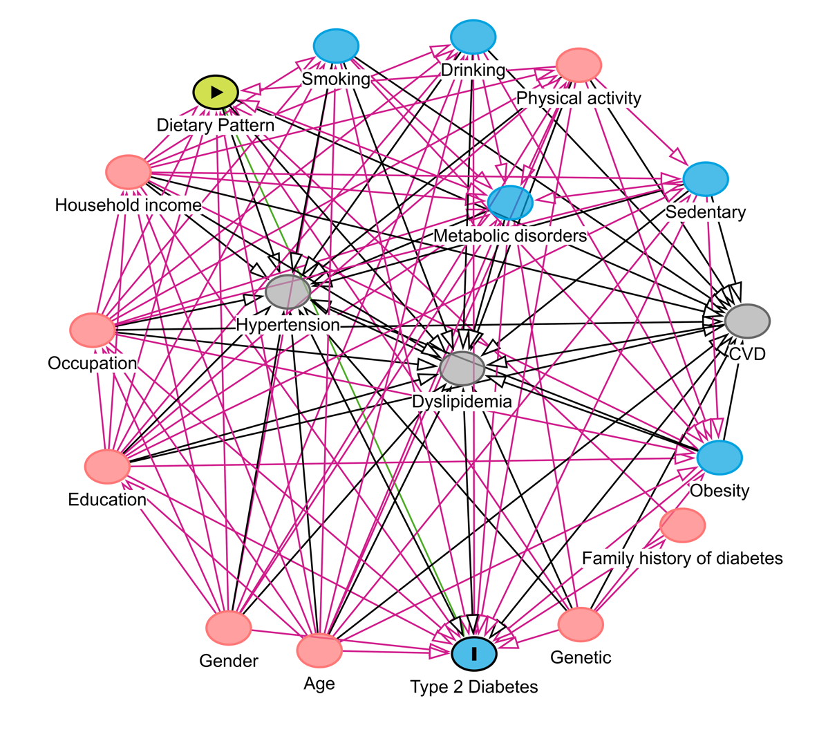
Figure S2. Correlations between factors and response variables obtained from dietary patterns (DPs) derived from principal component analysis and reduced rank regression. TC, total cholesterol; TG, total triglycerides; LDLC, low-density lipoprotein cholesterol; HDLC, high-density lipoprotein cholesterol; BMI: body mass index; HbA1c, Hemoglobin A1c.
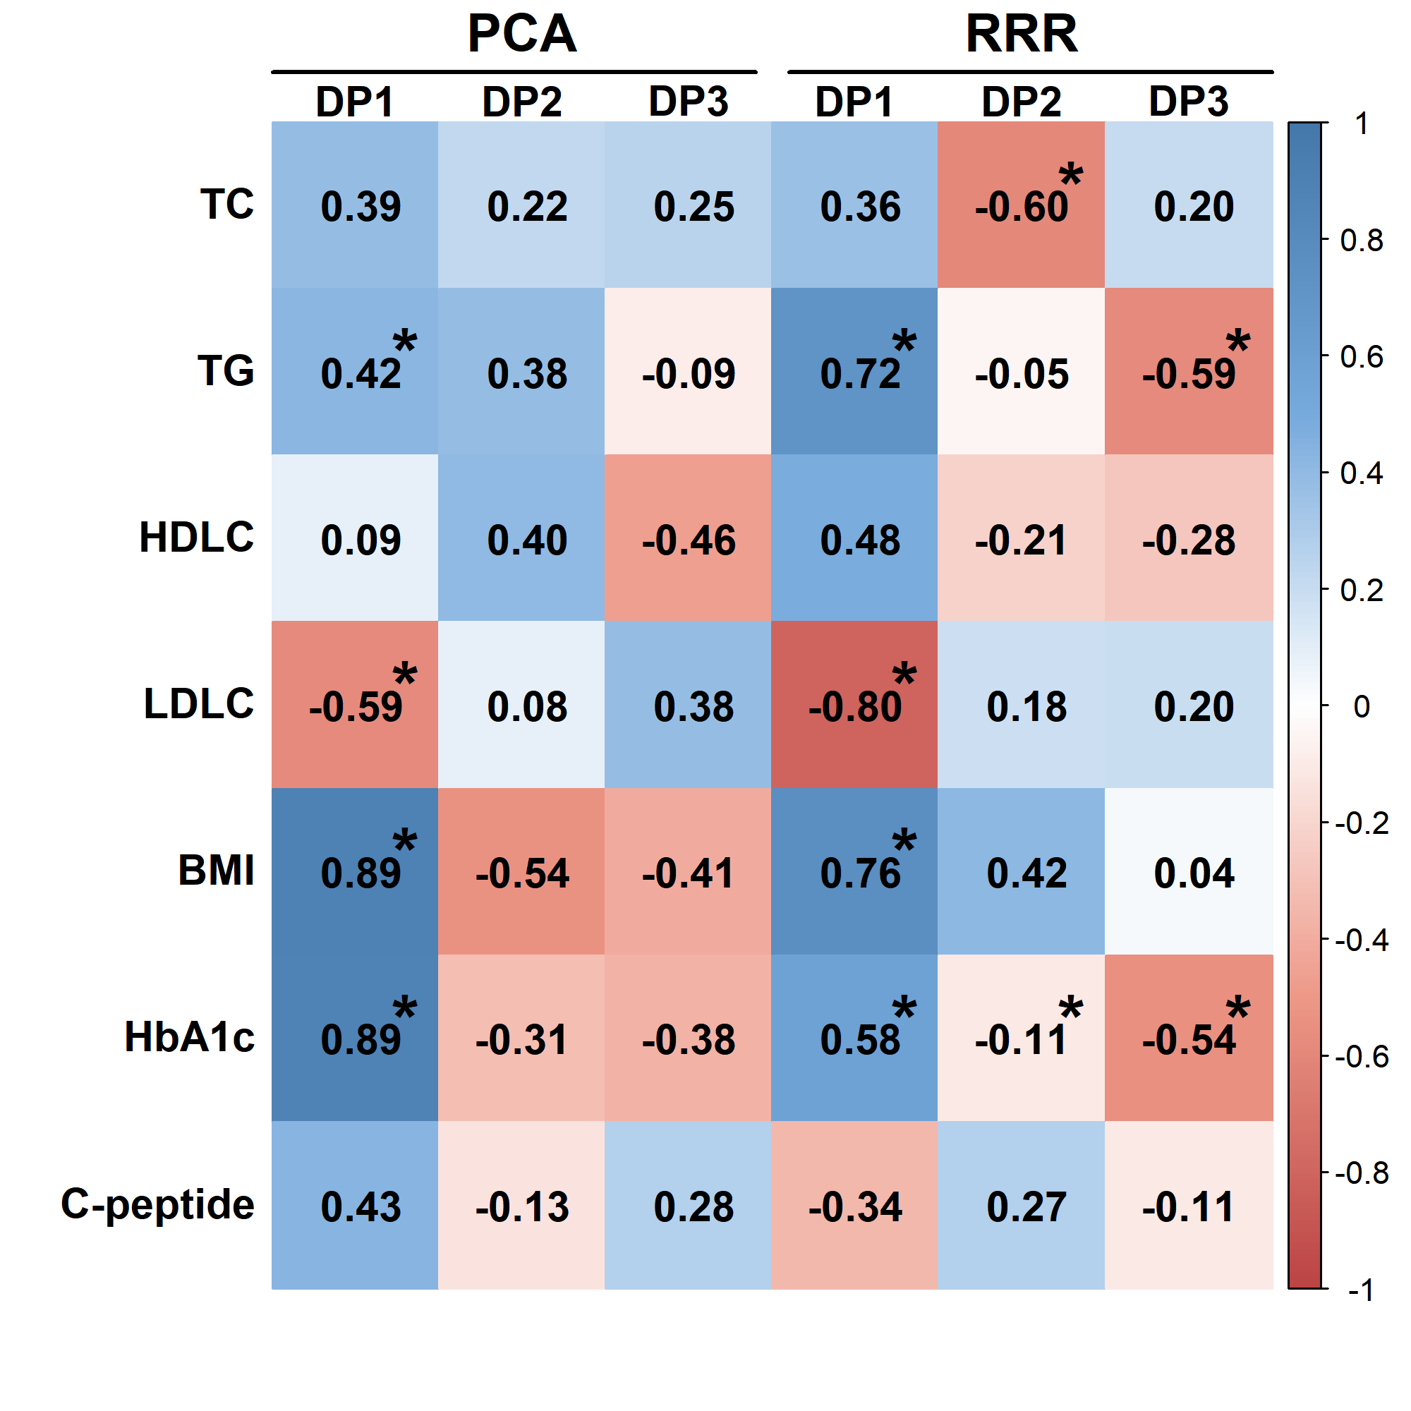
Figure S3. Dose-response association between principal component analysis (PCA)-derived dietary patterns (PCA-derived DP) and the homeostasis model assessment of insulin resistance (A ~ C) [HOMA-IR, n=1330. DP 1 (panel A), DP 2 (panel B), DP 3 (panel C)], triglyceride-glucose index (D ~ F) [TyG index, n=1330. DP 1 (panel D), DP 2 (panel E), DP 3 (panel F)], and homeostasis model assessment of beta cell function (G ~ I) [HOMA-%β, n=1330. DP 1 (panel G), DP 2 (panel H), DP 3 (panel I)]. T2DM, type 2 diabetes mellitus. Estimated differences and 95% confidence interval derived from restricted cubic spline regression, with knots placed at the 1st, 50th and 99th percentiles of the distribution of DP scores. Models were adjusted for age, gender, household income, education, occupation, physical exercise, drinking, smoking, family history of diabetes, obesity, metabolic syndrome.
